NANCEGOLLAN
VILLAGE SHOW
(Established 1998)
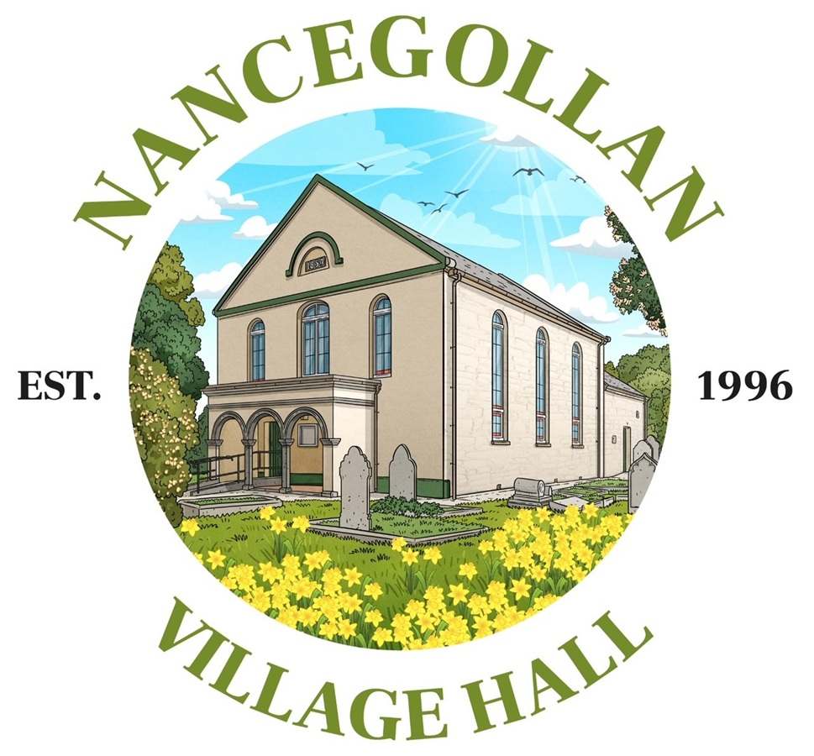
Saturday 30th May 2026
2.30pm – 5pm
50p Admission
Free Parking | Refreshments | Raffle
Presentation of Trophies: 4.30pm
www.nancegollanvillagehall.co.uk
Registered Charity No. 1078294

SPECIAL PRIZES - TO BE HELD FOR ONE YEAR

Most Points Eggs Memorial Cup Nancegollan Village Hall
Most Points Cookery Perpetual Shield Nancegollan Village Hall
Most Points Preserves Praze Village Shop
Most Points Handicraft Salver Nancegollan Garage
Most Points Photography Perpetual Shield West Cornwall Engine Services
Most Points Cornish Section Salver Mr & Mrs C. Palmer
Most Points Art Perpetual Shield Nancegollan Village Hall
Most Points Literary
Most Points Knitting Nancegollan Village Hall
Best Exhibit New from Old Perpetual Salver Ms Sonja Bright
Best Exhibit Cookery Mr D. Roberts
Best Exhibit Yeast Nancegollan Village Hall
Best Exhibit Preserves Perpetual Cup W. & R. E. Tripp
Best Exhibit Cornish Section
Best Exhibit Eggs Salver Nancegollan Village Hall
Best Exhibit Handicraft Memorial Cup Mrs P. Jeffery
Best Exhibit Art Perpetual Shield Mr & Mrs R. Oliver
Best Exhibit Literary Mr & Mrs P. Jackson
Most Points in Show Perpetual Cup Crowan Parish Council
Judges’ Favourite Children’s Perpetual Cup Mr & Mrs A. Chance
Children’s Trophies Nancegollan Village Hall
Certificates Nancegollan Village Hall

Exhibits can be staged at the Village Hall between 2 & 4pm Friday 29th May and between 8 & 10am Saturday 30th May. All exhibits must be staged by 10am on the day of the show; doors will then close until 2.30pm. Judging will commence at 10.30am sharp. No person shall enter more than one exhibit in each class. No entries will be taken on the day of the show. Exhibits in all classes MUST NOT have been exhibited at previous Nancegollan Village Shows. NO exhibits to be removed from the Hall until after the prize giving. The committee promises to take care of all exhibits but will not be held responsible for loss or damage.

The Judge’s decision is final.
All Trophies to be returned by 1st May.

ALL ENTRIES MUST HAVE BEEN MADE BY THE EXHIBITOR

BAKING
Class 1. Victoria Sandwich – Jam & butter cream filling
Class 2. Coffee & Walnut Cake
Class 3. Boiled Fruit Cake
Class 4. Moist Lemon Loaf – recipe Supplied
Class 5. Bakewell Tart – out of the tin
Class 6. Pineapple Upside Down Cake
Class 7. Apple Tea Loaf Cake – recipe supplied
Class 8. Cake made from Vegetable ingredients
Class 9. Gluten Free Cake – your own choice; display the recipe
Class 10. Slow Cooker Ginger Cake - recipe supplied
Class 11. 4 pieces of Chocolate Brownie
Class 12. 4 x Chocolate Chip Biscuits
Class 13. 4 x Fruit Scones
Class 14. 6 x Cheese Straws
Class 15. 4 x Sausage Rolls
Class 16. Vegetable Quiche – out of the dish
Class 17. Best Show Disaster!
BREAD / ROLLS
Class 18. 2lb White Loaf – not made in a bread maker
Class 19. White Loaf – made in a bread maker
Class 20. 2lb Brown Loaf – not made in a bread maker
Class 21. Soda Bread
Class 22. 4 x Bread Rolls – White
Class 23. 4 x Bread Rolls – Brown
Class 24. Savoury Focaccia Bread
PRESERVES
Class 25. Jar of Marmalade – covered with cellophane top
Class 26. Jar of Lemon Curd – covered with cellophane top
Class 27. Jar of Jam – covered with cellophane top
Class 28. Jar of Jelly – covered with cellophane top
Class 29. Jar of Set Honey – screw top
Class 30. Jar of Chutney – screw top
CORNISH
Class 31. Heavy Cake
Class 32. Launceston Cake – recipe supplied
Class 33. 4 x Saffron Buns
Class 34. 4 x Yeast Buns
Class 35. 4 x Cornish Splits – joined
Class 36. 4 x Cornish Fairings
Class 37. Seed Cake
Class 38. Pasty – 8’’ - Traditional
Class 39. Cream tea for one – scones only to be judged

EGGS
Class 40. 3 Large White
Class 41. 3 Large Brown
Class 42. 3 Large Any Other Colour
Class 43. 1 Large Egg – contents to be broken by judge
Class 44. 3 Bantam’s Eggs
Class 45. 3 Bantam’s Eggs, brown
Class 46. 1 Bantam Egg – contents to be broken by judge
Class 47. 3 Waterfowl Eggs
Class 48. 1 Waterfowl Egg – contents to be broken by judge
Class 49. 6 Eggs – any matching colour and size
Class 50. 1 Mis-shaped Large or Bantam Egg

HANDICRAFT – Needlecraft
Items must NOT have been exhibited in any previous Nancegollan Village Shows
Class 51. Item of Cross Stitch – please state the size on your entry form
Class 52. Item of Slow Stitching – please state the size on your entry form
Class 53. A Miniature Quilt – max size: 22-inch square
Class 54. An item of Applique, any subject – max size: A4 (8.3 x 11.7 inches)
Class 55. 4 x Coasters
Class 56. A Tote Bag
Class 57. A Soft Toy
Class 58. An Item of Clothing
Class 59. A Cushion Cover (no pad)
Class 60. A Tea Cosy
Class 61. A Quilted Table Mat
Class 62. An Item of Handmade Jewellery
Class 63. Greetings Card - paper
Class 64. Postcard - needlecraft
Class 65. A Collage, any subject; any medium – A4 size (8.3 x 11.7 inches)

HANDICRAFT – Knitting or Crochet
Items must NOT have been exhibited in any previous Nancegollan Village Shows
Class 66. Garment for an Adult
Class 67. Garment for a Baby
Class 68. Garment for a Child
Class 69. A Cot Blanket
Class 70. A Pair of Socks for an adult
Class 71. A Soft Toy
Class 72. A Flower Brooch
Class 73. A Shopping Bag

NEW FROM OLD
Class 74. Item of Handicraft
Class 75. Item of Clothing
Class 76. Make something from an old book
Class 77. Amaze us! Anything goes – maximum 2’ Space

For classes 74 - 77 we want to see your amazing creations! Get creative recycling, upcycling or using the stuff around you to make something new from something old!

ART
Items must NOT have been exhibited in any previous Nancegollan Village Shows
Class 78. Watercolour – Any subject
Class 79. Acrylic – any subject
Class 80. Still Life – any medium
Class 81. A Landscape – any medium
Class 82. A drawing in Charcoal, pencil or ink – (A4)
Class 83. A Poster for a Music Concert (any medium, max A3 size)

Note: The Committee would be grateful if all Art Exhibits could be staged on the Friday prior to the show between 2 and 4pm.
Exhibits 78-81 must have means of hanging for display purposes.

LITERARY
Literary entries must be in no later than 25th May.
Class 84. Write a poem: ‘Springtime’ (A4 page)
Class 85. A Limerick
Class 86. Write a short story incorporating these three words: MUSICIAN, UMBRELLA, DIARY (Max 2 x A4 pages)
Class 87. Write a short story based on the photograph below (Max 2 x A4 pages)

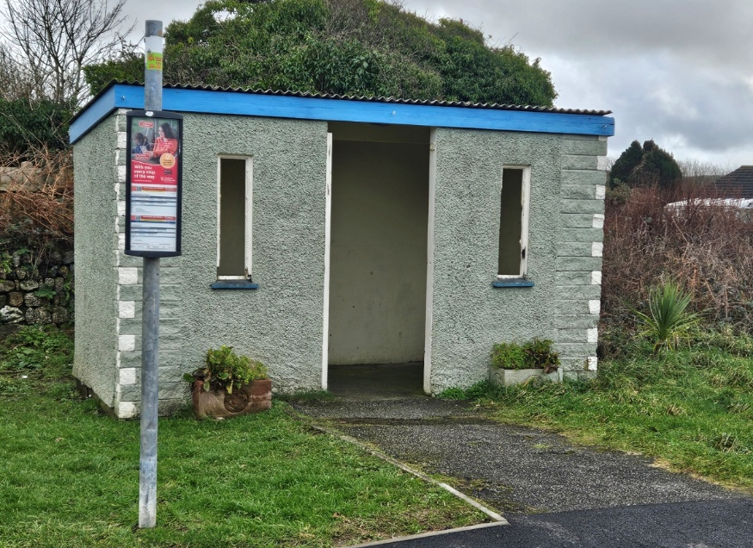

PHOTOGRAPHY
Class 88. Something Beginning with the Letter ‘B’
Class 89. Black & White with a Splash of Colour (Digital Manipulation allowed)
Class 90. A Stormy Scene
Class 91. Close Up / Macro
Class 92. Sunrise or Sunset
Class 93. Hilltop View
Class 94. The Northern Lights (in Cornwall)
Class 95. Animal Portrait
Class 96. Something Orange
Class 97. Still Life
Class 98. Windows
Class 99. Wheels
Class 100. A Single Tree
Note: The maximum size for all entries in the Photography Section is 7’’ x 5’’ unless stated otherwise. Exhibits may be mounted for staging purposes.

CHILDREN’S SECTION

Age in years and months to be clearly stated on each exhibit please.
Children’s classes are free. All entries must have been made by the child.

PRE SCHOOL
Handprint Picture (A4)
Duplo Model
Edible Necklace

5 YEARS & UNDER 8 / 8 YEARS to UNDER 11 YEARS / 11 to 16 YEARS
Class 101. Decorated Gingerbread Man – biscuit can be shop bought
Class 102. 4 x Rock Cakes
Class 103. A Short Story: ‘Storm Goretti’
Class 104. A Book Marker (any medium)
Class 105. Animal made from Fruit or Vegetables
Class 106. A Face Mask using a paper plate
Class 107. A Greetings Card (any medium)
Class 108 Origami Bird or Animal

PHOTOGRAPHY – 7 to under 11 years AND 11 to 16 years
Class 109. Something Beginning with the letter ‘C’
Class 110. My Pet
Class 111. Clouds
Class 112. Stormy Skies
Class 113. Signposts

RECIPES 2026

MOIST LEMON LOAF (Class 4)

190gms plain flour | 1 ½ tsps. Baking Powder | ½ tsp fine salt | 200gms caster sugar
3 large eggs | 1 tsp vanilla extract | 30gms unsalted butter, softened | 80ml fresh lemon juice | 120ml vegetable oil | zest of 2 lemons | 120ml whole milk

Preheat oven to 180*C (160 fan). Grease & line a 900g (2lb) loaf tin with baking paper. Mix together the flour, baking powder & salt. Set aside. In a large bowl beat eggs, sugar and vanilla until well combined. Mix in the softened butter, lemon juice, vegetable oil and lemon zest until smooth. Gradually add the dry ingredients to the wet mixture, alternating with the milk. Pour the batter into the prepared tin and level the top. Bake for 45 – 50 minutes. Leave in the tin for 15 mins.

APPLE TEA LOAF (Class 7)

115gms Self Raising Flour | 115gms butter or margarine | 100gms light brown sugar | 2 eggs | 1 peeled apple chopped into small pieces | 2 tsp ginger | 1 tsp cinnamon | Optional 4 squares of chocolate melted to drizzle on the top

Grease loaf tin. Preheat oven to 150*C. Cream butter with sugar with and electric whisk for at least 2 minutes. Whisk in the 2 eggs. Sieve the flour and cinnamon and ginger into the mixture and fold in. Add the chopped apple by folding in too. Place in the greased tin and bake for 40 – 45 minutes (check after 40). Cool for 10 minutes then remove onto wire rack. When completely cooled drizzle melted chocolate on top if desired

SLOW COOKER GINGER CAKE (Class 10)

150gms butter | 125gms Soft Brown Sugar | 225gms Plain Flour | 85gms Black Treacle
100gms Golden Syrup | 2 x beaten eggs | 60ml milk | 2 ½ tsp Cinnamon | 3 tsp Ginger
1 ½ tsp Baking Powder

Grease the Slow Cooker pot and line the base with baking parchment. Melt sugar, butter, treacle & syrup. Allow to cool a little. Beat eggs, whisk eggs into mixture with spices. Add sieved flour. Add milk until combined. Pour mix into slow cooker Pot. Put a cloth over the pot and the lid over the cloth. Cook on high for approx. 1 ¾ hours (all slow cookers vary)

LAUNCESTON CAKE (Class 32)

6ozs butter | 6ozs sugar | 8ozs flour | 2ozs ground almonds | 3 eggs | 1lb currants | 2ozs lemon peel
½ tbsp black treacle | 1tbsp golden syrup.

Cream sugar and butter, add the treacle, syrup and then the eggs one at a time, beating each one thoroughly before adding the next. Lastly mix tog flour, almonds, currants and lemon peel and fold carefully into mixture. Bake at 180*C for about 90 mins
NANCEGOLLAN VILLAGE SHOW 2026
ENTRY FORM

Entry forms and fees to be sent to: Ms Sonja Bright, 5 The Square, Praze-an-Beeble,
TR14 0JR or hand deliver to Praze Village Shop or email the entry form to sonjaebright@gmail.com Telephone enquiries: 07926 166546.

Closing date for all entries: Monday 25th May. Earlier entries are very much appreciated!
20p per class entered. Children’s classes are FREE.

NAME (BLOCK LETTERS please):

ADDRESS & TELEPHONE NUMBER:

EMAIL ADDRESS:

CLASS | DESCRIPTION & SIZE OF ITEM WHERE ASKED FOR | ENTRY FEE | Sec’s use only
PLEASE READ THE SCHEDULE CAREFULLY!
ONE ENTRY PER CLASS PER PERSON
ALL ENTRIES MUST HAVE BEEN MADE BY THE EXHIBITOR
REFRESHMENTS WILL BE SERVED FROM 2.30PM | PRESENTATION OF CUPS 4.30PM

