Child protection and safeguarding statement
Our House Enrichment and Alternative Programme
[Inspiring Futures Cultural Education Partnership]

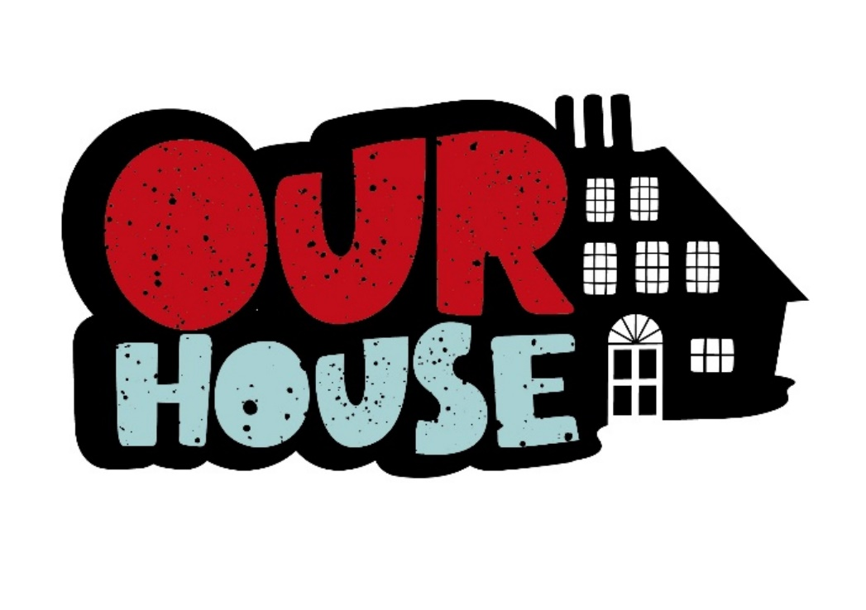

Approved by: | Mark Aspel | Date: 09.09.2025
Last reviewed on: | 09.09.2025
Next review due by: | 01.09.2026

Contents
Important contacts 3
1. Aims 4
2. Legislation and statutory guidance 4
3. Supporting Documents 4
4. Believe Statement 4
5. Recognition Statement 4
6. What We Will Do 4
7. Contact Details 5

Important contacts
Role/organisation | Name | Contact details
Programme Manager (Lead contact)  Lead for Culture and Wellbeing (Education)  Designated safeguarding lead (DSL) | Martin Russell | martin.russell@lbbd.gov.uk  07932 633034
Deputy DSL | Vikki Lowther | vikki.lowther@lbbd.gov.uk  07761 054003
Local authority designated officer (LADO) | Mike Cullern | mike.cullern@lbbd.gov.uk  0208 227 3934

1. Aims
Our House is a creative alternative education offer for young people. Our House is committed to ensuring that our functions are carried out with a view to safeguarding and promoting the welfare of children.
The purpose of this policy statement is:
- to protect children and young people who receive Our House’s services from harm. This includes the children of adults who use our services
  - to provide staff and volunteers, as well as children and young people and their families, with the overarching principles that guide our approach to child protection.
This policy applies to anyone working on behalf of Our House, including senior managers and the board of trustees, paid staff, volunteers, sessional workers, agency staff and students.

2. Legislation and statutory guidance
This policy has been drawn up on the basis of legislation, policy and guidance that seeks to protect children in England. A summary of the key legislation and guidance is available from nspcc.org.uk/childprotection and in line with the Non School Alternative Provision Voluntary National Standards 2025
This policy also complies with our funding agreements.
Our House is committed to following Local Safeguarding Children’s board (LSCB) procedures.

3. Supporting Documents
This policy statement should be read alongside our organisational policies, procedures, guidance and other related documents:
  - Our Behaviour Policy for children attending the setting including measures to prevent bullying (such as cyberbullying and prejudice based or discriminatory bullying), and the policy on the use of reasonable force
  - Our Staff Code of Conduct Policy including processes for dealing with low level concerns, allegations against staff and whistleblowing procedures
These can be found on our website www.our-house.info

4. We Believe That:
- children and young people should never experience abuse of any kind
- we have a responsibility to promote the welfare of all children and young people, to keep them safe and to practise in a way that protects them.

5. We Recognise That:
- the welfare of children is paramount in all the work we do and in all the decisions we take
- working in partnership with children, young people, their parents, carers and other agencies is essential in promoting young people’s welfare
- all children, regardless of age, disability, gender reassignment, race, religion or belief, sex, or sexual orientation have an equal right to protection from all types of harm or abuse
- some children are additionally vulnerable because of the impact of previous experiences, their level of dependency, communication needs or other issues
- extra safeguards may be needed to keep children who are additionally vulnerable safe from abuse

6. We Will Seek to Keep Children and Young People Safe By:
- valuing, listening to and respecting them
- appointing a nominated child protection lead for children and young people, a deputy and a lead board member for safeguarding
- adopting child protection and safeguarding best practice through our policies, procedures and code of conduct for staff and volunteers
- developing and implementing an effective online safety policy and related procedures
- providing effective management for staff and volunteers through supervision, support, training and quality assurance measures so that all staff and volunteers know about and follow our policies, procedures and behaviour codes confidently and competently
- recruiting and selecting staff and volunteers safely, ensuring all necessary checks are made
- recording and storing and using information professionally and securely, in line with data protection legislation and guidance
- sharing information about safeguarding and good practice with children and their families via leaflets, posters, group work and one-to-one discussions
- making sure that children, young people and their families know where to go for help if they have a concern
- using our safeguarding and child protection procedures to share concerns and relevant information with agencies who need to know, and involving children, young people, parents, families and carers appropriately
- using our procedures to manage any allegations against staff and volunteers appropriately
- creating and maintaining an anti-bullying environment and ensuring that we have a policy and procedure to help us deal effectively with any bullying that does arise
- ensuring that we have effective complaints and whistleblowing measures in place
- ensuring that we provide a safe physical environment for our children, young people, staff and volunteers, by applying health and safety measures in accordance with the law and regulatory guidance
- building a safeguarding culture where staff and volunteers, children, young people and their families, treat each other with respect and are comfortable about sharing concerns

Deputy child protection lead(s) Name(s): Phone/email:

7. Contact Details
Designated Safeguarding and Child Protection Lead Name: Martin Russell
Email: martin.russell@lbbd.gov.uk

Deputy child protection lead Name: Vikki Lowther
Email: Vikki.lowther@lbbd.gov.uk

Senior lead for Safeguarding and Child Protection Name: Mark Aspel
Phone/email: mark.aspel@lbbd.gov.uk

NSPCC Helpline 0808 800 5000 We are committed to reviewing our policy and good practice annually.

