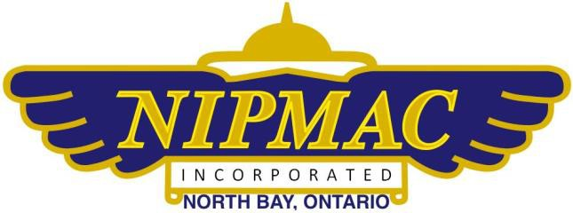

|  |  |
| --- | --- |
| First Name: | Last Name: |
| Address: | City: |
| Province: | Postal Code |
| Phone: | Email: |
| MAAC # | MAAC Expires End of: |
| NIPMAC Annual Fees:   * Renewal Member: $95 ($115 after Dec 31st) * New Member (in year) $95 * New Member (after Aug 31 – applies to dues for the following year) $115 * Student (enrolled full-time program): 50% reduction * Junior (under 18 as of Jan 1): Fee waived * Family: 20% reduction for subsequent members | Amount Paid $:  Cheque to NIPMAC or eTransfer to:  T.NIPMAC@HOTMAIL.COM |
| Pilot Level:  🞎 Learner  🞎 Pilot  🞎 Instructor | Club Interests - Flying Fields:  🞎 Summer 🞎 Winter 🞎 Float 🞎 Indoor  Flying Interests:  🞎 Float 🞎 Fixed Wing 🞎 Rotary Wing 🞎 Glider  Power:  🞎 Liquid Fuel 🞎 Electric |
|  |  |

UTo be a current member, you must (check all that apply):

🞎 be a current member of MAAC

🞎 be a current member of NIPMAC

🞎 attend meetings and supply assistance as requested

I hereby certify that the above information is true and correct. I will abide by the rules and regulations that have been or will be established by NIPMAC, MAAC and Transport Canada.

It is my responsibility to ensure I follow all regulations as set out by Transport Canada, and I am in compliance with all RPAS rules and regulations.

NIPMAC, Club executives nor the land owner is responsible for any non-compliance, fines or incidents occurring from the improper operation, or non-compliance of any Transport Canada regulations by any member, members of other clubs, or guests.

I have read and understand the above, and am in compliance with all NIPMAC, MAAC, and Transport Canada rules and regulations.

Signature: Date:

🞎 New Member 🞎 Renewal