Liberty Collies Puppy Application Questionnaire

Gleason, TN 38229
- Full Name:______________________________________________
- Address:________________________________________________
- City:_______________________________________ State:________________ Zipcode:__________
- Email:__________________________________________ Phone Number (____)______-__________
- Have you ever owned a collie? _________________________________________________________
- Do you understand the grooming requirements for a double coated dog? ________________________
- Color of Puppy desired? Sable □ Tri-Color □ Other □____________ Gender? Male □ Female □ Either □
- Full Registration is offered. Do you plan on breeding your collie?___________________
- If so, Have you ever raised puppies before? __________ (I would like to offer help and advice to make the process easier for you and the dog!)
- Would you be open to adding an adult dog to your family?____________________________________
- How did you hear about us? ___________________________________________________________
- Do you have a fenced in yard? _________________________________________________________
- Do you plan on leash training? _________________________________________________________
- Where your puppy be staying? Indoors or Outdoors? ________________________________________
- If outdoors, do you have the proper cooling features for summer and warmth features for winter?____________________________________________________________________________
- What would you like me to know about your family and the life that this puppy will have? ______________________________________________________________________________________________________________________________________________________________________________________________________________________________________________________
- Items you will need for a new collie puppy: Heartworm Prevention (After initial vet visit) and Flea/Tick Prevention (ONLY from your vet!) Also:

  - A thin chain collar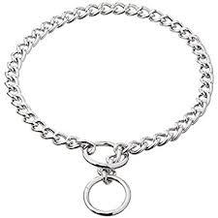

  - 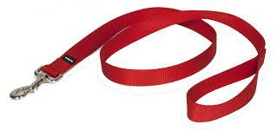
Leash (NOT retractable —Ask me why!)
  - Food & Water Dishes
  - Approved puppy food, clean water
  - Brushes:
    - Pin Brush 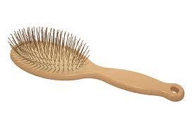
    - Slicker Brush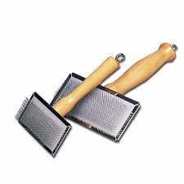
    - Comb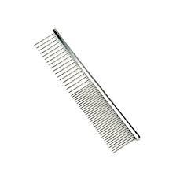
    - Rake