6 and half weeks of themed summer fun in the sun!
Some of the weeks include Moovin’ & Groovin’, Animal Week and Fitness & Fun Week.
We have games planned for children to enjoy recreational opportunities.
We have activities planned that help children with vocational tasks.
We will teach leisure skills to children that struggle to find something to do alone.
We have educational opportunities planned so that children can stay sharp in the summer.

TaG SUMMER CAMP 2019

T.A.G. Summer Camp 2019
When: June 3rd – July 19th
Where: The Rise Learning Center
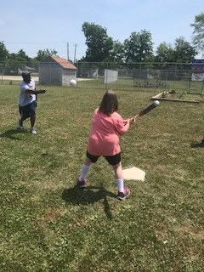
5391 Shelby St Indianapolis, In 46227
Door 4
Information: WWW.theakersgroup.com
Chris Akers 317-614-1791
