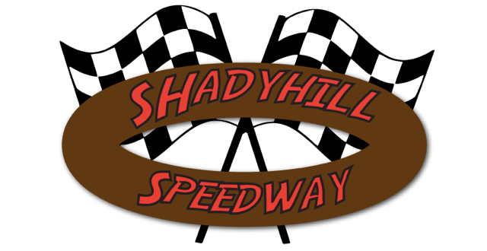
5thAnnual
MYSTERY 100
September 25th, 2021
The Mystery 100 will be the finale to the Shadyhill 2021 season! This will feature a 100 Lap UMP Modified race with a 15-minute break at 50 laps. At this time, the red flag will be thrown & cars will be stopped on the main straightaway. Crews can change tires, shocks, gears and refuel. Then, they will race all out for another 50 laps! Once the checkered flag is thrown the winner will be gifted a check in victory lane with the mystery money amount! Entry fee for the Modifieds will be $100.
(This includes Pit Pass)
Format for Modifieds: Single car qualifying with top 10 locked into the feature. Next will be heat races to transfer another 10 to the feature.

Car# & Driver Name: #_____________________________
Hometown: _______________________________________
Engine Builder: ___________________________________
Chassis: ___________________________________________
Sponsors (3 only): ________________________________

$100 (Includes Pit Pass)
Mail check & form to: 10554 West 300 North
Medaryville, In. 47957
(219) 843-8892

