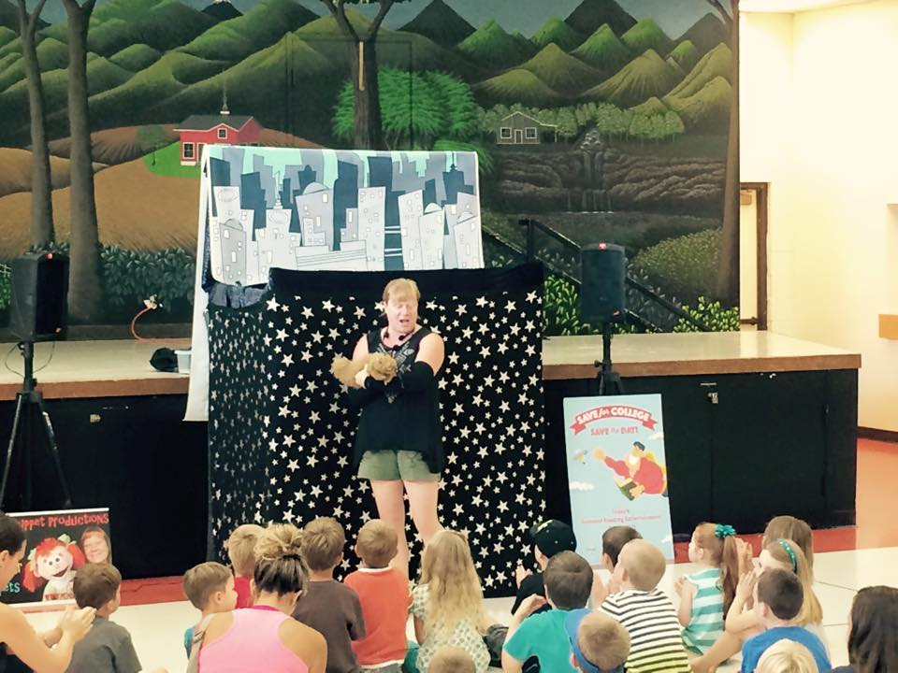
Tall stage: (I am 5foot 2 for reference)
Back drop (tallest point) 7feet 5 inches
Side panels 3feet
Front width 4 feet 8 inches
Front Height 5 feet 6 inches
If this does not work I have a much shorter stage I can use too its tallest point is 6feet 3 inches
Shorter stage:
