Our shows - All of our shows are Penny's Puppets Productions exclusives
Penny’s entire catalog
Animals Build it!: (45mins, All Ages)
Animals create their worlds. They build shelters and gather food. Like you animals live in a home. Find out what it would be like to build like a bee, a bird, a beaver and many more animal friends. Join Penny and her musical cast of animal puppets sing, laugh and build their worlds. An interactive puppet musical fun for all ages.
And they are Off -Chinese New Year (35mins, All Ages)
A Zodiac puppet show to help celebrate the Chines New Year. The Jade Emperor wants a way to tell the passing of time. How about an animal to represent each year. Let’s have a race to see what order they will go in. The animals race across the river to see who will get to the other side first. Enjoy this musical puppet show.
Basil the Bookworm's Trip around the World: (40mins, Pre-K, Kindy, Elementary, Family)
Basil is a shy, studious friendly monster show loves to read. She loves all the different places she can visit just by opening a book. Join Basil as she discovers new friends and cultures and finds strengths in herself that she never knew she had. Come sing and laugh with us in this puppet adventure.
Batunia’s Nocturnal Wonderland: (45mins, Prep-K, Kindy, Elementary, Family)
Join Batunia the Bat on a musical tour of the creatures that come alive under the night sky. See the beautiful night world in a whole new light. She meets other creatures that are awake while we sleep that she never took the time to notice before.
Dakarai and The King's Wishes: (35mins, Pre-K, Kindy, Elementary, Family)
Dakarai has lived in the same town all of his life, but in his imagination he travels the world on magical journeys every day. Then he finds out that King Cole has a 3 challenges for anyone that wants to try and he is off on his first real adventure to grant the kings wishes and meet some very valuable friends on the way. Bringing an unforgettable journey of kindness.

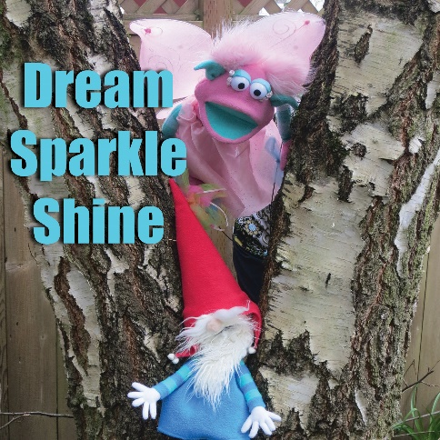
Dream, Sparkle, Shine! : (45mins, Kindy, Elementary, Family)
Faye the Fairy has a dream to earn her wings at the Wonderful Festival with all the "perfect" Fairies, but she is having a hard time getting her spells to work out right. Join her as she makes new friends in the enchanted forest who help her learn about herself and the importance of being just who you are! Meet an array of fun characters like Little Bigfoot, Puss in Boots, Baby dinosaur and many more. Enjoy this original Mini-musical by Penny's Puppet Productions. Dream Big, Sparkle More and Shine Bright!​
The Fantastical Book (Please Note this title is not available until June 2020)
Robin is at the library as she looks for a fairy tale book, when all of a sudden a book literally flies off the shelf into her hands. The fantastical book invites Robin into its pictures and stories. Soon she finds herself inside the book and all of its adventures. Where she meets characters like Mother Goose, Puss n’ Boots, a Dragon, a Unicorn and many other incredible puppets in this Mythological land where anything can happen as each new chapter turns into a whole new fantastical world. This is an original musical puppet play by Penny’s Puppet Productions.
Fay the Fairy and the Pine Tree: (40mins, Kindy, Elementary, Family)
Ever wish you were something that you are not? Newton a little Fir tree wishes his pine needles were more important and beautiful to help him stand out, so much so that he makes a wish upon a falling star. Fay the Fairy comes to grant his wish. But is it really what Newton needs? Join us in this adaptation of a classic folktale and sing, laugh and dance our way to the answer. A mini- musical original by Penny’s Puppet Productions about how being you is the best you can be.
From my head to my Toes Its's my Body, (3-8+ year olds) A non- Threatening puppet show from Penny's Puppet Productions and the Coalition for Consent Education (CFCE). They have partnered in the creation of a show on boundaries, respect and consent. The puppets ultimately find true respect for themselves and others, and by doing so, the world is safer for us all. Through stories, music and puppets the audience members learn about their body bubble, asking for consent and respecting the answer as well as appropriate, healthy affection and touch.
The CFCE is building a culture of consent, one conversation at a time. We believe where there is a culture of consent, sexual violence doesn’t exist. This show is appropriate for ages 3-8 year olds.

Golden Mitten and the three Polar Bears: Winter-(45mins, Kindy, Elementary, and Family)
Leaving their lovely ice cave the polar bear family goes out for a walk in the artic. Little Miss Golden mittens is out for a stroll too when she discovers the three polar bears ice cave. Being that she has golden mittens she feels entitled to go ahead and let herself in and starts eating, sitting and sleeping in the bear’s home. Enjoy this spin off tale full of snowy winter fun. Sing, Laugh and enjoy this fun original puppet play by Penny’s Puppet Productions.
Mother Goose on the Loose: (35-mins, Toddler, Pre K, Kindy, Family)
We are ready to have fun with songs and dancing puppets with our special guest Mother Goose, Oh No! Mother Goose hit her head and can’t remember who she is. Help the puppets sing and dance and chase Mother Goose back to her old self. Fun for all ages.
Myrna the Mermaid and The Golden Key: (45mins, All Ages)
On one of her daily dives Myrna the mermaid finds a golden key and a Treasure map. Join Myrna as she swims around the world trying to find clues to what the key unlocks. Go too far off lands, meet fun new friends and sing, laugh and dance in this nautical fun filled adventure.
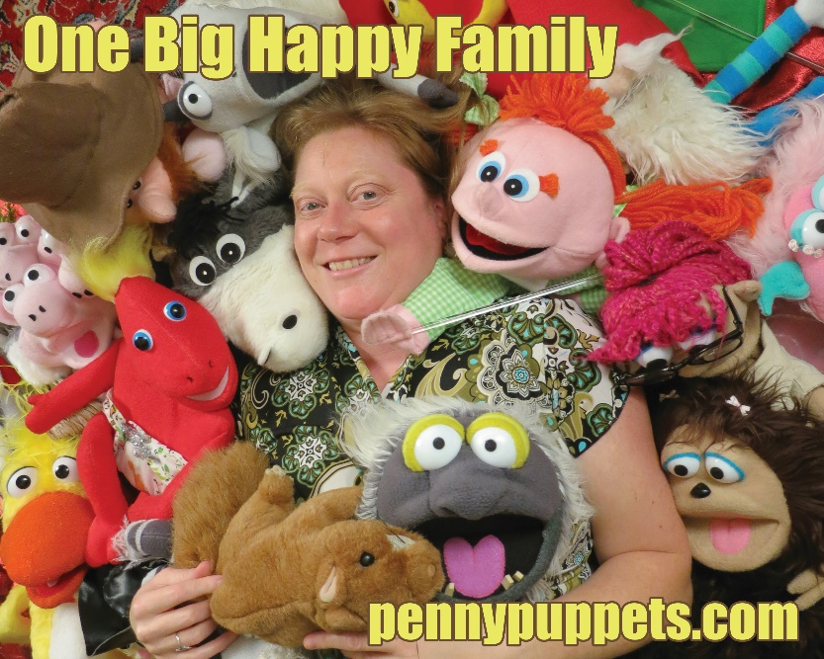

School Days: (25mins Preschool on their way to Kindergarten)
It's time for Donkey to go to school but RT can't find him anywhere, When he does, Donkey is not sure he wants to go to school. What if he doesn't make any friends? What if he doesn't like his teacher? What if it isn't fun? Help Donkey walk through the door of his new classroom and get the answers to all of his questions. (A good getting ready for Kindergarten)
Scouts's Grand Adventure: (35mins, Pre K, Kindy, Elementary, Family)
Scout is an Ant who is in charge of finding a new home for the rest of her ant hill. Join Scout as she makes unlikely new friends along the way on this Grand adventure and avoids getting eating by the snake.

Super Hero Machine: (45mins, Kindy, Elementary, Family)
Super Donkey believes that everyone has a super hero inside of them waiting to be discovered. So he builds a machine that will help his friends discover their superpowers. “Watch out Super Donkey” Vinnie the Villain wants to steal the Super Hero machine and make it his own. Come sing, laugh and discover the surprise ending to this heroic tale. An Original mini-musical puppet production by Penny’s Puppet Productions.​ *This is a good anti- bully show​​
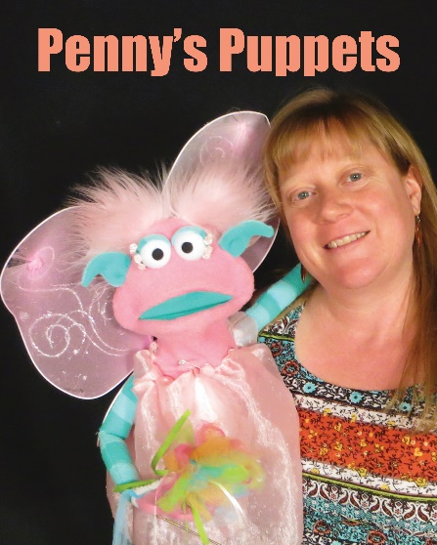
Sweet Pollinators: (30mins, All Ages)
Buzzy the Bee takes you on a pollination adventure. Learn about different Pollinators, like Bee's, Butterfly's and Beetles. Be part of a food Parade all of which is here because of the pollinators help, and much more. All while singing, laughing and clapping along with this musical puppet original productions by Penny's Puppets.
Sweet Tooth the Ghost: Fall (30mins, All Ages)
Frank the mouse and Robin are getting ready for their costume party but their treats keep disappearing. Help them solve the mystery of the missing candy and also make a new friend.
The Boogie-Woogie Puppet Show: (35mins All Ages)
Get ready to stop, sing and dance like you have ants in your pants. The puppets are putting on a rocking, sing along dance party for your pleasure and they want you to join the fun. Fun for everyone!
The Gingerbread Man: (45mins all ages)
Granny gets lonely and decides to make a Gingerbread man from a magic cookie recipe, but oops she leaves him in the oven to long and the adventure begins. Join the Gingerbread man as he tries to find a safe place for his heart.
The Little Red Hen: (35mins, Toddlers, Pre K, Elementary, Family)
The Little Red Hen wants to grow a garden but her friends are too busy to help. Watch this resourceful rocking chicken as she plants, tends, harvests and bakes the bread.
The Magic Book: (40mins, All Ages)
Robin is visiting her grandmother for summer vacation and helping her clean out her attic, when she discovers a magic talking book. The magic book invites Robin into its pictures and stories. Soon Robin finds herself inside the book and all of its adventures, meeting dragons, whales and a bee named Buzzy. After a full day of play, Robin wants to go back to Granny's attic but how? It takes some creative ideas from Buzzy the bee to get Robin back home. Join the colorful cast on this musical adventure! Big Fun.​
​
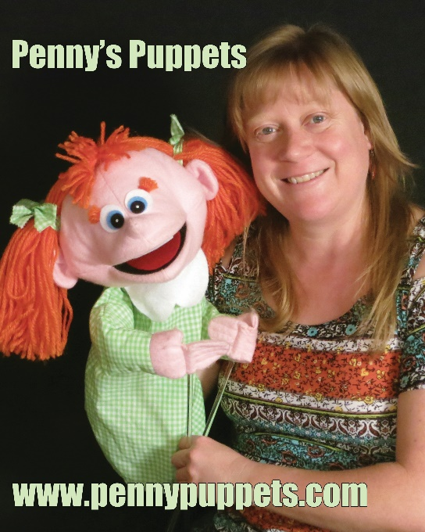

The Puppet Town Musicians: (45mins , Pre K, Kindy, Elementary, Family)
-Penny puts her twist on the traditional German folk tale of the Bremen town Musicians-
Penny’s Lovable puppets want to begin new lives. They have grown older and feel useless at the farm. Donkey wants to sing instead of carry heavy loads, D-O-G no longer wants to chase sheep but would prefer to play her rocking guitar, Puss and Boots wants to retire from hunting mice and would rather chase his dream of becoming famous and Mother Goose who's grown forgetful and forgotten wants to put a fresh spin on her lyrics. They all decide to leave the country life together and head towards “Puppet Town” to create a band. Enjoy this original musical puppet production where music and friendship shine through. You are never too old to make new friends.
The Princess and the Peanut: (35mins Pre K, Kindy, Family)
Princess Robin gets stuck in a rainstorm on her way to the library. She stops at the nearest castle for shelter. The Queen of the castle lets her stay the night but is not sure that Robin is a really princess. See what the queen does to find out.

The Sharing Carrot: Winter (35mins, All Ages)
A winter cold day and food is scarce, yet rabbit finds not one but two carrots. Rabbit decides to share his extra carrot with his good friend Lamby, who intern shares it with Donkey and Donkey with Miss Cow and etc. This is a great family winter show always a winter classic.

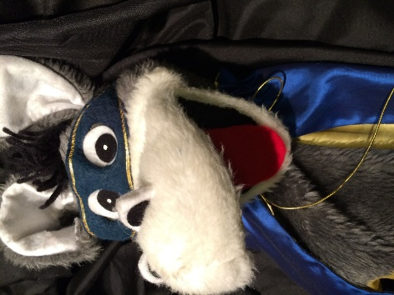
Turtle and Rabbit: (30 mins Toddlers, Pre K, Kindy, Family)
Rodney the Rabbit thinks he is the fastest animal around and is so busy exercising he never stops to eat, sleep or even make friends. Until the day Myrtle the Turtle challenges Rodney to a race. Root for and sing along with your favorite character as the race unfolds.
Where is Lilly the Catapilly? (35mins, Pre K, Kindy, Family)
Everyone loves little Lilly the caterpillar, she is friends with everyone, but one spring day when she was supposed to go to a tea party the loveable Lilly doesn't show up. Enjoy this musical mystery and find out just what has happened to Lilly.
Whiz, Bang, Boom, Professor Gabby's in the Room: (45mins, Pre K, Kindy, Elementary, Family)
Come and discover the many different sides of Science with the very excitable Professor Gabby. Science isn’t just beakers, test tubes and explosions. Everything you see and touch has a science behind it. From Animals to Dinosaurs, to what you eat and drink Professor Gabby will take you on a Science adventure you won’t soon forget. Get inspired to learn more from this musical Whiz, Bang of a Puppet Production!
Who Stole the Cookie from the Cookie Jar?: (35mins, Pre K, Kindy, Elementary, Family)
Grandma made a batch of her famous cookies for her granddaughter, but every time Granny leaves the room and comes back a cookie ends up missing. Never Fear! Super Donkey is out to solve this mystery with clues left by the cookie thief.​​

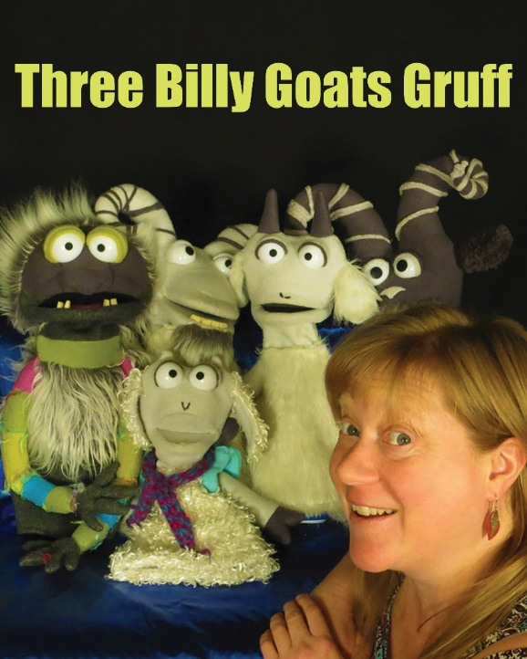

Folktales with a Twist
The Little Red Hen (35mins, Toddlers, PreK, Elementary, Family)
The Little Red Hen wants to grow a garden but her friends are too busy to help. Watch this resourceful rocking chicken as she plants, tends, harvests and bakes the bread.
The Gingerbread Man (45mins all ages)
Granny gets lonely and decides to make a Gingerbread man from a magic cookie recipe, but oops she leaves him in the oven to long and the adventure begins. Join us for this Mini- musical fun adventure and modern day twist on this endearing folktale as the Gingerbread Man looks for a safe place for his heart.
The Princess and the Peanut (35mins, Pre K, Elementary, Family)
Princess Robin gets stuck in a rainstorm on her way to the library. She stops at the nearest castle for shelter. The Queen of the castle lets her stay the night but is not sure that Robin is a really princess. See what the queen does to find out.

Turtle and Rabbit (30mins Toddlers, Pre K, Kindy's, Family)
Rodney the Rabbit thinks he is the fastest animal around and is so busy exercising he never stops to eat, sleep or even make friends. Until the day Myrtle the Turtle challenges Rodney to a race. Root for and sing along with your favorite character as the race unfolds.​
Mother Goose on the Loose: (35-mins, Toddler, Pre K, Kindy, Family)
We are ready to have fun with songs and dancing puppets with our special guest Mother Goose, Oh No! Mother Goose hit her head and can’t remember who she is. Help the puppets sing and dance and chase Mother Goose back to her old self. Fun for all ages.
3 Billy Goats Gruff (45mins Kindy, Elementary, Family)
This adaptation of the traditional tale will be a favorite for all ages. The mean and friendless Tully the troll guards a bridge that crosses to a yummy beautiful green pasture. The hungry Billy goats would like to cross it and eat what is on the other side. Help them find a solution. Sing, dance and cheer on the three clever Billy goats as they try to go across the bridge and outsmart the Bulling troll. A mini- musical original by Penny’s Puppet Productions. *This is a good anti- bully show
The 3 Little Pigs and the Huffy Puffy Wolf (40mins, Pre K, Kindy, Elementary, Family)
Join Penny's Puppets on this Musical journey for this traditional tale with a twist. Yes, the 3 little pigs all have to move out of Moms house and build houses on their own. Yes, the Big Bad Wolf huffs and puffs and tries to blow all their homes down. But in the end where does all this huffing and puffing get him. Tired and alone. Discover some coping skills when having a bad day and laugh and rejoice with the 3 little pigs and their unlikely friend the Huffy Puffy Wolf.
Golden Mitten and the three Polar Bears (45mins, Kindy, Elementary, Family)
Leaving their lovely ice cave the polar bear family goes out for a walk in the artic. The Lonely Little Miss Golden mitten is out for a stroll too when she discovers the three polar bears ice cave. Being that she has golden mittens she feels entitled to go ahead and let herself in and starts eating, sitting and sleeping in the bear’s home. Enjoy this spin off tale full of snowy winter fun. Sing, Laugh and enjoy this fun original puppet play by Penny’s Puppet Productions.
The Puppet Town Musicians (45mins , Pre K, Kindy, Elementary, Family)
-Penny puts her twist on the traditional German folk tale of the Bremen town Musicians-
Penny’s Lovable puppets want to begin new lives. They have grown older and feel useless at the farm. Donkey wants to sing instead of carry heavy loads, D-O-G no longer wants to chase sheep but would prefer to play her rocking guitar, Puss and Boots wants to retire from hunting mice and would rather chase his dream of becoming famous and Mother Goose who's grown forgetful and forgotten wants to put a fresh spin on her lyrics. They all decide to leave the country life together and head towards “Puppet Town” to create a band. Enjoy this original musical puppet production where music and friendship shine through. You are never too old to make new friends.
Red Hen and Fox: (this is a short show only about 20-25min, Pre K, Kindy, and Family)
Poor fox just can't get any sleep no matter what he tries. Chamomile tea, counting sheep even a warm glass of milk won't put him to sleep. Then he finds a book 101 ways to fall asleep by Ru Sleepy, He's tried them all, except for the 101st one, make a pillow with the feathers of a busy Red Hen, and then for certain he will fall asleep. Follow fox has he attempts to catch
​The Red Hen's Tail feathers for his pillow. Silliness, laughter, singing and dancing are unavoidable in this twist on the traditional tale.
Special Shows for middle and high school
Help Teens Create a show from their own stories or Book/theme:
Penny will come in and work with your students on character building and story form and Puppet the productions.
Custom made shows:
Don’t see a theme you need let Penny know she can custom make a show to suit your specific needs - Additional fee will be charge depending on the research and time that goes into each well thought out program.
Workshops and Classes
“Teaching with Puppets” Workshop: Tapping into her educational training and experience, Penny offers a workshop exclusively for educators that adds new teaching skills and makes learning fun, while meeting key educational standards. $500.00
Making Puppets come alive: I can come into your classroom and do a residency and help your students make their puppets come to life and perform a small skit by the end of our time together, Session times and length vary on your classrooms and school’s needs, let’s talk and see what we dream up special for your kids.
Create a Puppet Show Penny will come in and work with your students on character building and story form and Puppet Theater productions. She will help create a puppet show from your theme or original stories.

Email or Call for Pricing:
Penny Walter, M.A. Education, 503-282-9207, www.Penny@PennyPuppets

