April 2018
Highland & Fritz
Sun | Monday | Tuesday | Wednesday | Thursday | Friday | Sat
1 | 2 (Day 1) | 3 (Day 2) | 4 (Day 3) | 5 (Day 4) | 6 (Day 5) | 7
2 hour
Early Release
(conferences)
8 | 9 (Day 6) | 10 (Day 1) | 11 (Day 2) | 12 (Day 3) | 13 (Day 4) | 14
 |  | Highland’s  Family Arts Night  5-7 | PTAC/PTO Meeting—  Highland 6:30pm  Fritz Book Fair | Fritz Book Fair | Fritz Book Fair
15 | 16 | 17 | 18 | 19 | 20 | 21
 | Spring Break—No School
22 | 23 (Day 5) | 24 (Day 6) | 25 (Day 1) | 26 (Day 2) | 27 (Day 3) | 28
Student 2 hour
Early Release
29 | 30 (Day 4)
 |  |  |  |  | 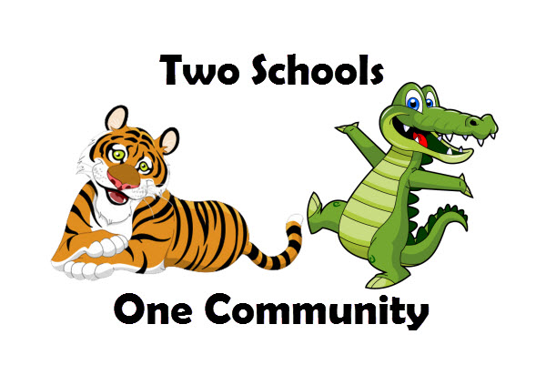
May/June | 5/2-4 W-F Highland Book Fair  5/7-11 M-F Plant Sale/Staff Appreciation Week  5/9 W PTO Meeting—Fritz 6:30pm  5/25 F Highland’s Field Day  6/1 F Fritz’s Field Day  6/6 W PTAC/PTO Meeting—Fritz 6:30pm

