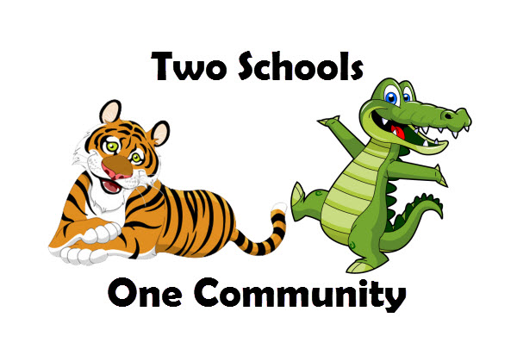

Dear Fritz Parents and Families:

Reading for pleasure unlocks the power of information and imagination and helps children discover who they are. Here’s what you can do to help children develop stronger reading skills and a love
for reading:

- Set the example. Let children see you read.
- Have a collection of books in your home. Update this collection routinely to keep up
with changing tastes and reading skills.
- Support our school’s Book Fair. Allow your children to choose their own books
to read.

Our Scholastic Book Fair is a reading event that brings the books kids want to read right into our school. It’s a wonderful selection of engaging and affordable books for every reading level. Please make plans to visit our Book Fair and be involved in shaping your child’s reading habits.
Book Fair dates: April 10th-13th
Shopping hours: 9:30-3pm

We need volunteers to make it happen! Please visit our online homepage to sign up! We need help with set up and clean up and well as help during the fair.

NEW digital payment option for students: eWallet! Now you can send your child to shop the fair cash-free! Visit our Book Fair Homepage to learn more and to create an account:
https://bookfairs.scholastic.com/bookfairs/cptoolkit/homepage.do?method=homepage&url=yalesvilleelementaryschool

If you are unable to attend the Fair in person, we invite you to visit our online Book Fair at scholastic.com/fair. Our Online Fair is available from April 1st to April 22nd.

We look forward to seeing you and your family at our Book Fair! Remember, all purchases benefit our school. Please make checks payable to HYES PTO.

Sincerely,
Shannon Sorvillo
Sorvillofamily@att.net

