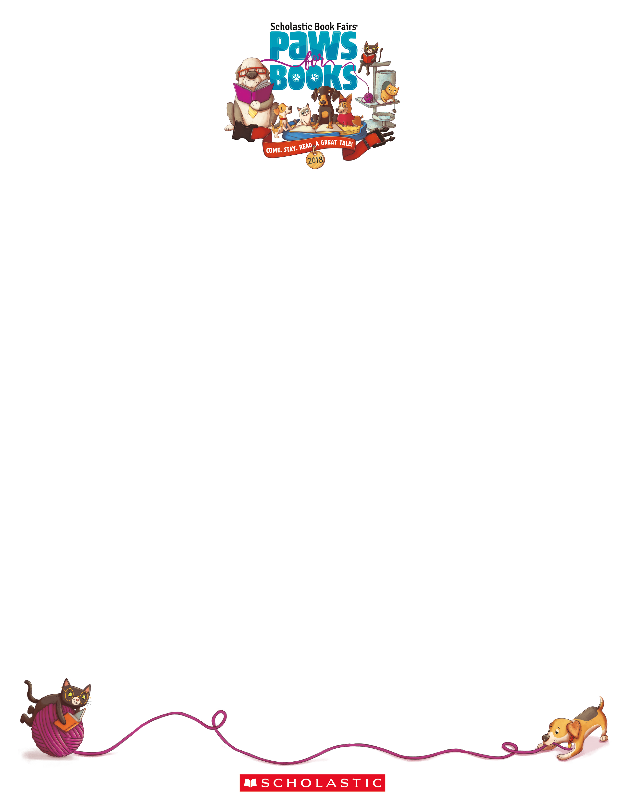

Dear Highland Parents and Families:

Reading for pleasure unlocks the power of information and imagination and helps children discover who they are. Here’s what you can do to help children develop stronger reading skills and a love

for reading:

* Set the example. Let children see you read.
* Have a collection of books in your home. Update this collection routinely to keep up

with changing tastes and reading skills.

* **Support our school’s 2018 Spring Book Fair. Allow your children to choose their own books to read**.

Our Scholastic Book Fair is a reading event that brings the books kids want to read right into our school. It’s a wonderful selection of engaging and affordable books for every reading level. Please make plans to visit our Book Fair and be involved in shaping your child’s reading habits.

Book Fair dates: **May 1st and 2nd 9-3**

**May 3rd and 4th 1:45-3**

**We accept CASH, CHECKS (made payable to HYES PTO), and the new eWallet\***

**\*INTRODUCING A NEW digital payment option for students: eWallet!** Now you can send your child to shop the fair cash-free! Available for set up April 16th.

If you are unable to attend the Fair in person, we invite you to visit our online Book Fair at **scholastic.com/fair**. Our Online Fair is available from **April 25th** to **May 8th**.

**Volunteers** are needed to help make this event a success for our students!

Please visit our Book Fair Homepage to sign up to ***volunteer*,** open an ***eWallet account*** and access the ***Online Book Fair*: www.scholastic.com/bf/highlandelementaryschool69**

We look forward to seeing you and your child at our Book Fair! Remember, all purchases benefit our school.

Sincerely,

Ané Miller

Highland Book Fair Chairperson

ane.miller@yahoo.com