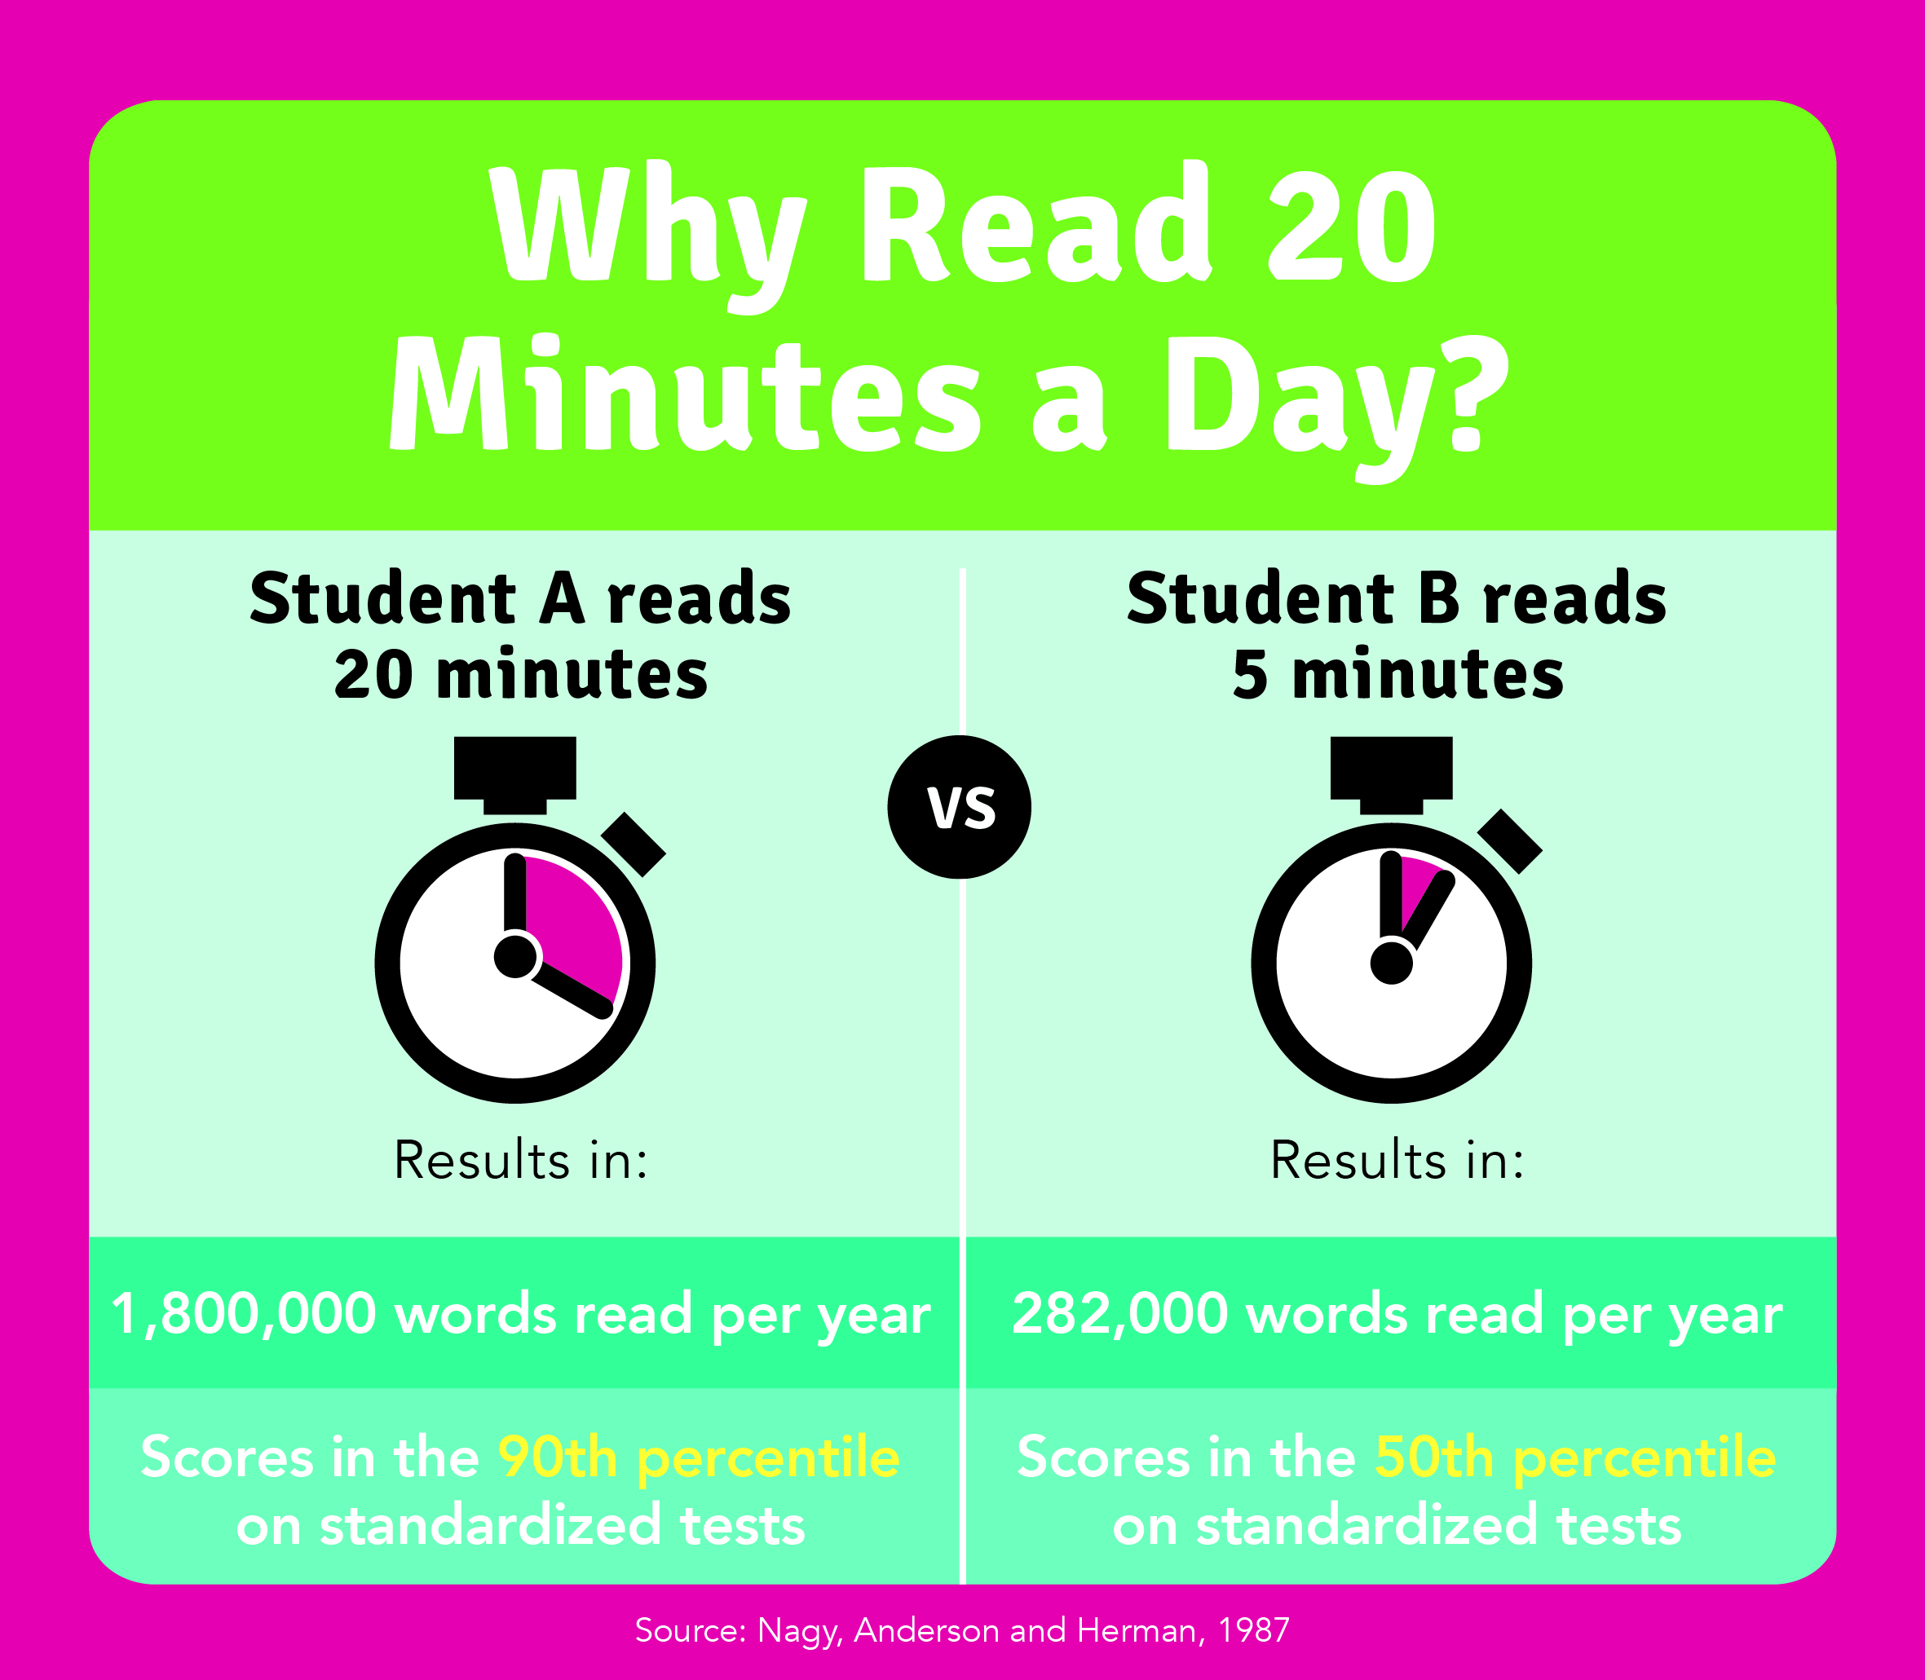**Dear Parents and Families:**

Did you know? Reading just 20

minutes a day exposes your child to about **1.8 million words** per year. Reading helps students develop a stronger vocabulary, and in addition, students who read for pleasure average higher grades in English, mathematics, science, and history!

Encourage your child to read books   
for fun by attending our upcoming **Scholastic Book Fair**. Allow your child to choose the books they want to read! It’s a wonderful selection of engaging and affordable books for every reading level.

**Mark your calendar!**

Book Fair dates: **9/17/18-9/19/18**

**NEW digital payment option: eWallet!** Now your student can shop the Fair cash-free! Visit our Book Fair homepage to learn more and to create an account:   
http://www.scholastic.com/bf/highlandelementaryschool69

If you are unable to attend the Fair in person, we invite you to visit our Online Fair at **scholastic.com/fair**. Our Online Fair is available from **9/09/18** to **9/22/18.**

We look forward to seeing you and your family at our Book Fair! Remember, all purchases benefit our school. Thank you for supporting our readers!

Sincerely,

**Cheryl Tansley, PTO representative**

**Highland Elementary School**

© 2018 Scholastic Inc. All rights reserved.   
14892 F18 400081