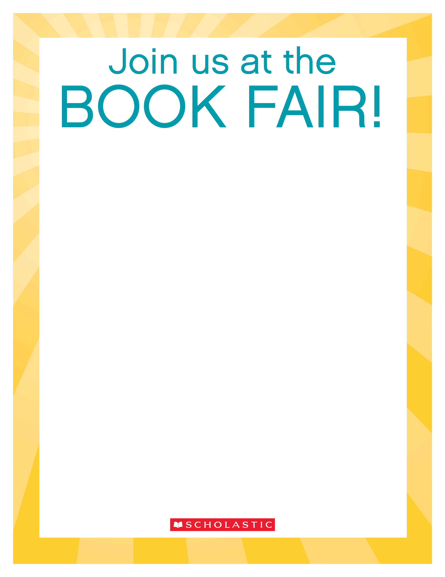

© 2017 Scholastic Inc. All rights reserved. 14045 F17 • 200107

*Permission to reproduce this item is granted by Scholastic Book Fairs®.*

Dear Parent,

The Scholastic Book Fair is coming to our school! You are invited to join your child and help him/her find the books he/she will enjoy reading. The Fair will be held on:

September 10 and11 9:30-3:00

September 12 and 13 2:30-3:30

in the FRITZ MEDIA CENTER

Here are some things to consider before you visit:

* Take a look at our booklist flyer to see a sample of the great titles that will be available. Many parents find it helpful to make a wish list ahead of time: scholastic.com/bookfairs/books
* Get a jump-start on shopping through our Online Book Fair\*! Simply find our Fair to get started: scholastic.com/fair
* Check out Classroom Wish List of books on the display at the Fair. These are titles that your child’s teacher would like to add to their class library. Refreshing classroom libraries regularly gives kids a reason to keep reading.
* Download the Book Fairs app to get the latest reading level information, book trailers, podcasts, and more. It’s the perfect shopping companion, and you can also use it to purchase books\*: scholastic.com/bookfairs/app

I hope you can make it! And if you’re interested in volunteering, visit our school’s Book Fair homepage and follow the link to volunteer: scholastic.com/fair

Looking forward to seeing you,

Ane Miller

Ane.miller@yahoo.com

*\*The Online Fair and purchase of books through the Book Fairs app is not available to “Buy One, Get One Free” Book Fairs. Online shopping is available to all other Fairs that would like to offer the expanded selection.*