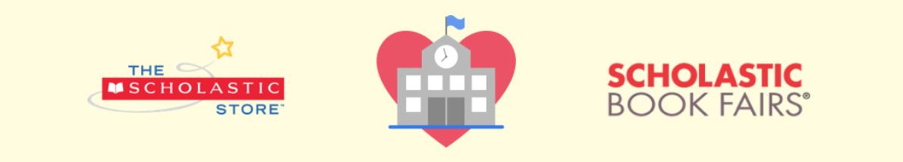
Dear families,
You’re invited to shop our Scholastic Book Fair online from April 1st-April 14th, 2021! All purchases benefit our school and connect kids with new books, favorite characters, complete series, and more.
You’ll love the NEW option to shop for Book Fair exclusives directly from the interactive booklist and enjoy these special online shopping features:
- Over 6,000 items, including new releases, best sellers, and value packs
- All orders ship direct to home
- FREE shipping on book-only orders over $25*
- All purchases support our school and earn 25% in rewards

Visit our Book Fair Homepage and click “Shop Now” to get started:
https://www.scholastic.com/bf/marygfritzelemschool2
Happy reading,
HYES PTO
*Free standard shipping is available on book-only orders of $25 or more, after all discounts are applied. Free standard shipping (books) must be selected during checkout. Orders containing products other than books are not eligible for this shipping promotion.

