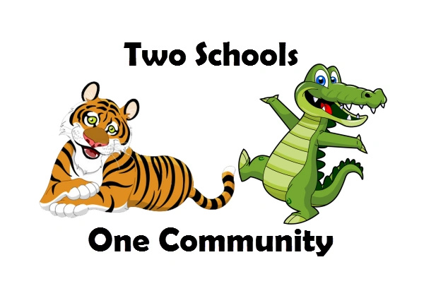  Highland and Fritz OCTOBER October | 2019
Sunday | Monday | Tuesday | Wednesday | Thursday | Friday | Saturday
 |  | 1 | 2 | 3 | 4 | 5
 |  |  |  | Highland Picture Day
6 | 7 | 8 | 9 | 10 | 11 | 12
 | Lyman Orchards Pie Orders DUE – NO exceptions | Plant sale pick up at Fritz 3:45-6:00pm | PTAC/PTO MEETING  At Fritz 6:30 |  | Mixed Bags/Boon Supply Orders DUE
13 | 14 | 15 | 16 | 17 | 18 | 19
 | NO SCHOOL  Columbus Day |  |  | 2-hour Early Release for students | Monster Mash  6-8pm at Sheehan  Store Rewards due
20 | 21 | 22 | 23 | 24 | 25 | 26
 | Box Top fall submission due date |  | Highland evening conferences 5pm  FALL FUNDRAISER  PICK-UP at FRITZ 3:45-6PM ONLY | Fritz evening conferences 5pm
27 | 28 | 29 | 30 | 31
 |  | Highland evening conferences 5pm | Fritz evening conferences 5pm
PLEASE CONSIDER JOINING THE HYES PTO IF YOU HAVEN’T ALREADY!!! https://forms.gle/bdBrXyVH2ojTPzjA9
Our website: hyespto.com Like us on Facebook: Highland Yalesville PTO

E V E N T S |  |  |  |  |  | OCTOBER PTO EVENTS & MEETINGS 10/7 pie orders due 10/8 plant sale pick up at Fritz 3:45-6:00 10/9 PTAC/PTO meeting 6:30 Fritz 10/11 Mixed Bag/Boon orders due 10/18 Monster Mash 6-8 Sheehan 10/18 Store Rewards Due 10/21 fall Box Top submission due date 10/23 fall fundraiser pick-up OCTOBER SCHOOL EVENTS 10/3 Highland picture day 10/14 NO school 10/17 2-hour early release 10/23 Highland conferences 5-8pm 10/24 Fritz conferences 5-8pm 10/29 Highland conferences 5-8pm 10/30 Fritz conferences 5-8pm UPCOMING EVENTS in NOVEMBER 11/5 Election Day NO SCHOOL 11/7 pick up pies 4-6 Fritz 11/11 Veterans’ Day NO SCHOOL 11/13 PTO meeting 6:30 Highland Upcoming EVENTS in DECEMBER 12/7 Craft Fair at Highland
Please remember to pick up your fall fundraiser On Wednesday, October 23 between 3:45 and 6pm at FRITZ. We do NOT have storage space!

