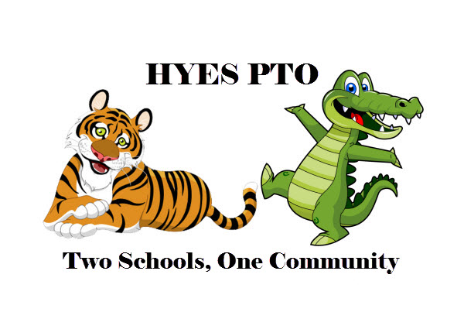**2020-2021 HYES PTO Welcome Letter**

Welcome students, parents, teachers and staff to the 2020-2021 school year. Now that the plans and guidelines with the schools are coming into focus we can share the PTO plans for the upcoming year. As we know with so much nowadays everything is subject to change, but we wanted to share our initial plans.

Generally we are approaching the year knowing most of the activities in the first half of the year will need to be cancelled, particularly any activities that would require the use of the building and/or social activities. Items we are planning to cancel this year include: Back to School Picnic, Ice Cream Social, Monster Mash, Craft Fair, and the Holiday Shoppe.

We are optimistically planning for things to go back to normal in the second half of the year and hope we can still do activities like the Sweetheart Dance, a Boys Night Out, 5th Grade Activities, and of course Field Day.

We are still planning to support items throughout the year like the Literacy Committees, Specials Class Supplies, Cultural Events/Activities, and Health and Wellness support.

We are working through the logistics on a couple of our most popular fundraisers like the Book Fair, Fall Plant Sale, Gift Card Fundraiser, and Lyman Orchard Pies. We hope to still have all these fundraisers, but need to work through the details of what we can do virtually and how we can distribute any goods since we will not have the use of the buildings.

We are also looking into some new items one of which you will see very soon called Raise Craze. This activity is all about the students performing Acts of Kindness in their schools, homes, and community. We hope everyone participates and performs some Acts of Kindness regardless of whether they want to do any fundraising.

We did not hold PTO Board Elections last year due to the shut down and plan to have elections this year. Please email us at [HYESPTO@gmail.com](mailto:HYESPTO@gmail.com) if you would like to nominate yourself or anyone else for a board position by our September meeting and we will vote at the October meeting. The meeting dates for this year are: 9/16/20, 10/14/20, 11/18/20, 12/9/20, 1/13/21, 2/10/21, 3/10/21, 4/21/21, 5/12/21, & 6/9/21. All meetings start at 6:30. Meetings on even months will start with PTAC and PTO will immediately follow. All meetings will be held virtually until further notice and links to the meetings will be shared on or just before the meeting date.

We encourage everyone to Like us on Facebook (Highland Yalesville PTO), keep checking in at our website ([www.HYESPTO.com](http://www.hyespto.com)), and have your family become a paid member of the PTO so you can stay up to date on everything going on. Become a member today by going to the homepage of our website to fill out the membership form and pay your dues.

We hope everyone is staying safe and healthy!

HYES PTO Board