Dear Parents and Families:

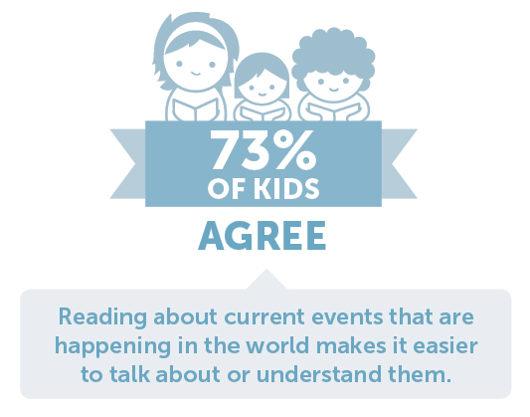
Reading increases knowledge and vocabulary, lowers stress, and supports your child’s emotional growth. But perhaps the best benefit is the lasting bond you create with your child when you read with them. Visit the Book Fair with your child to discover new books together!

Book Fair dates: March 25th – 27th, 2020 , Times at teacher discretion

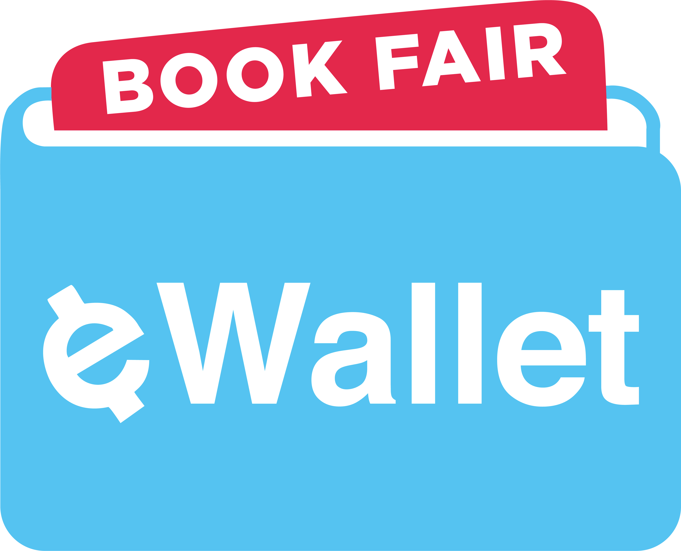
NEW In-School and Online Shopping Options! With Book Fair eWallet, a safe and convenient digital payment account, your student can shop the Fair cash-free! And if you’re not able to attend the Fair, try our new online shopping option. We’ve partnered with The Scholastic Store™ to offer over 6,000 products that ship direct to your home (with free shipping on orders of $25 or more)! Visit our homepage to access eWallet or shop online.
Kids & Family Reading ReportTM: 7th Edition

https://bookfairs.scholastic.com/bf/highlandelementaryschool85

We look forward to seeing you and your family at our Book Fair!

Cheryl Tansley, PTO Representative
cheryltansley@gmail.com

