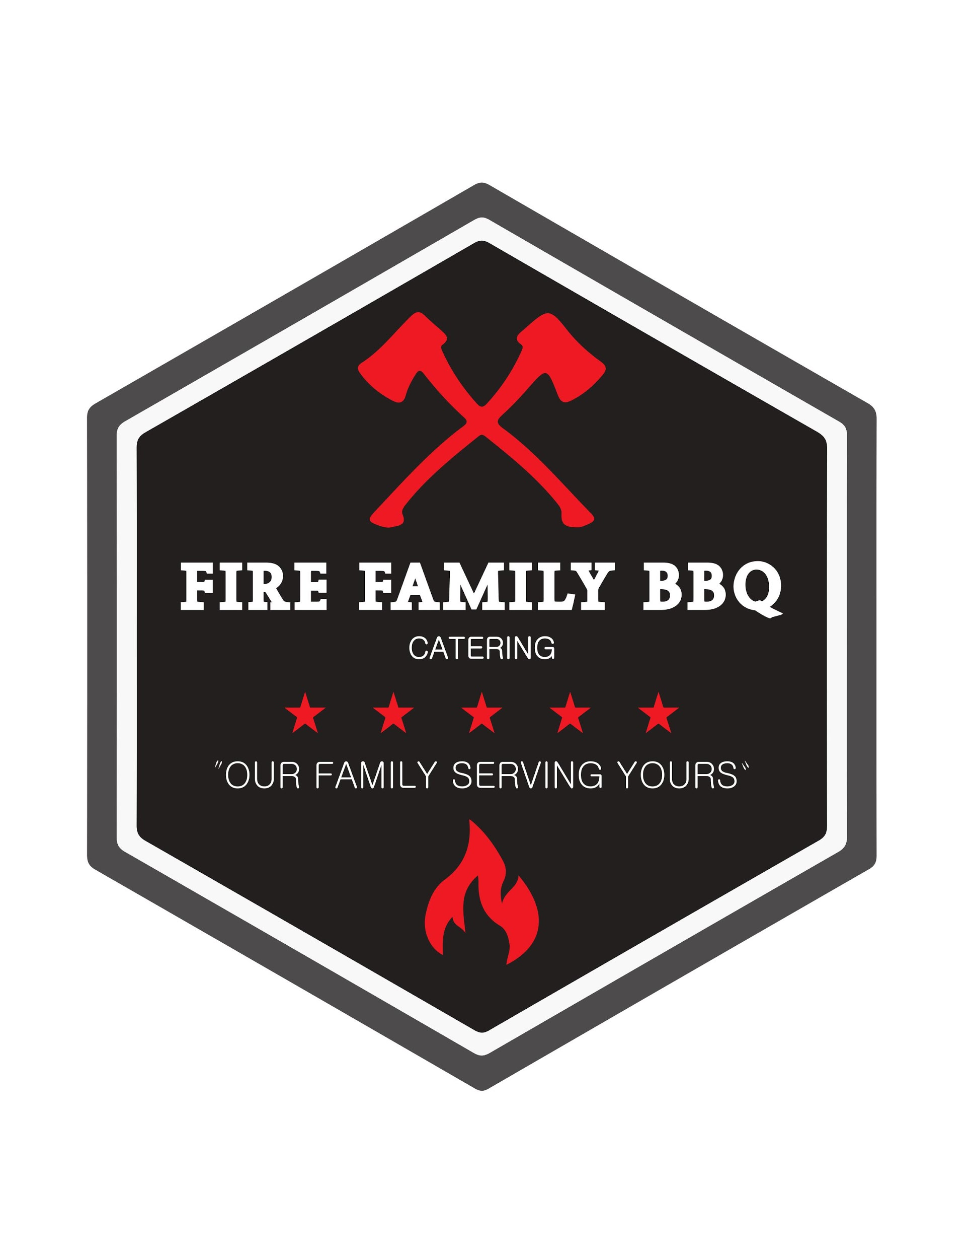

**Fire Family Barbecue Catering Options**

*$125 minimum for Catering*

Firefamilybbq.com

(417) 838-5567

**Smoked Meats**

***Pork(pulled, chopped, or sliced)***

***Chicken(pulled, chopped, or sliced)***

***Sliced Brisket(premium)***

***Ribs(premium)***

**Sides**

**Coleslaw**

**Baked Beans**

**Potato Salad**

**Cheesy Potatoes**

**Mac-N-Cheese(premium)**

**Meal Options**

*Meal Options- Includes Bun, pickle, onion, signature BBQ sauce, and delivery!*

1 meat 2 sides= $10pp

1 meat 3 sides= $10.50pp

2 meats 2 sides= $12pp

2 meats 3 sides= $12.50pp

3 meats 2 sides= $14pp

3 meats 3 sides= $14.50pp pp=per person

**Premium meat= upcharge price will be quoted at time of bid based on current market price**

**Premium side= upcharge price will be quoted at time of bid**

**Additional add on**

Cutlery(napkin, fork, spoon,knife, salt, pepper)= $10(qty 50)

Plates(premium plastic heavyweight)= $15 add on(qty 50)

* **Specific quotes** will be provided once we know catering needs. Please contact us for a quote or any questions you have! We would love to cater for you!