MINUTES

Village of Waldeck, Saskatchewan
Aug 12, 2025 Time: 6:30 p.m.

Present: Mayor: Bill Martens Deputy Mayor: Allan Kaufmann

Councillors: Jason Loeppky Staff: Sherry Kinney
Brenda Martens Alex Moon
Colleen Mielke

2025-73 Mielke THAT these minutes of the regular council meeting held on July 9th, 2025
Minutes be approved as corrected and circulated
Carried

2025-74 Loeppky THAT the listed correspondence has been read, be filed/referred
Correspondence 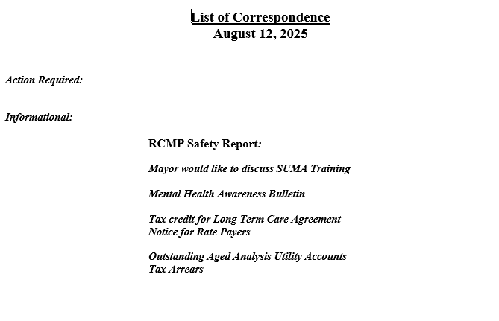
Carried

2025-75 Kaufmann THAT Council agrees to the purchasing of large shredder cost up to $550.
Larger Shredder Carried

2025-76 Loeppky THAT the accounts totaling $31, 144.90, for this August 12, 2025
Accts of Approval meeting be approved for payment
Carried

2025-77 Martens THAT this meeting be adjourned 8:10 p.m.
Adjourned Carried

