Community Partner Registration
Business/Organization

Contact Person

Phone

Email

Website / Social Media

We would like to participate as:
☐ Community Vendor
☐ Sponsor
☐ Community Partner
☐ Educational Organization
☐ Nonprofit Organization
☐ Volunteer
☐ Product Donor
☐ Service Donor
☐ Monetary Sponsor

If donating, please describe your contribution:

Vendor Information
Products or services you'll provide:

Need electricity?
☐ Yes ☐ No
Bringing your own table?
☐ Yes ☐ No
Bringing your own canopy?
☐ Yes ☐ No
Special accommodations:

Agreement
I understand this is a family-friendly Detroit Month of Design event hosted by Foster Villa Foundation and agree to follow event guidelines.
Name

Signature

Date

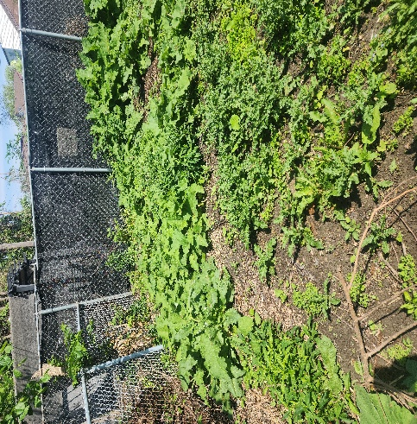

BEFORE

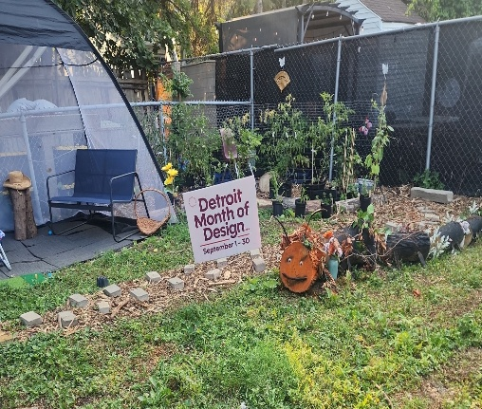 AFTER

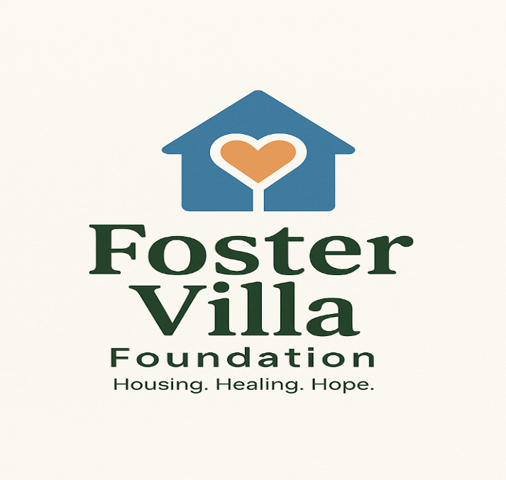
Thank you for considering a partnership with Foster Villa.
Together, we are demonstrating how design, education, gardening, and community collaboration can transform neighborhoods—one backyard, one family, and one connection at a time.
We look forward to welcoming you to From Caterpillar to Community.

