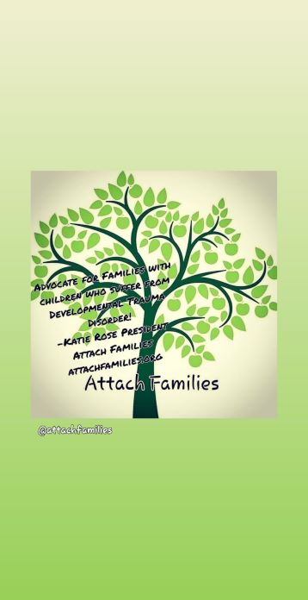
Date _________________ Date __________________________ Zip Code________
Event _________________________
ATTACH FAMILES GROUP FEEDBACK FORM
Directions: Please respond to the following items. We want your input so we can improve programs to better meet your needs!
- What did you expect to learn and/or gain when attending this group event?

- How well did 1 2 3 4
today’s event meet Did not meet Somewhat met Met Exceeded
those expectations? expectations expectations expectations expectations
- What topic(s)/activity(ies) would you like to see in future events?

- How well does 1 2 3 4
this group meet Does not meet Meets a few of Meets most Meets all of
your needs? any of my needs my needs of my needs my needs
- What can we do to better meet your needs and/or improve your experience in this group?
- What was the most beneficial/meaningful thing you took away from today’s event?
- What factors would stop you from attending future events? (Ex: scheduling conflicts, inconvenient location or limited transportation, topics don’t seem relevant to my needs, felt unwelcome, etc.)

- What emotions were you experiencing at the start of today’s event? What emotions are you experiencing now? (example: I felt anxious to come to an event where I did not know many people. Now I am feeling excited and grateful for the support I received tonight)

