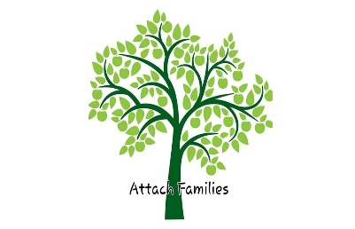
Reactive Attachment Disorder, Developmental Trauma Possible Signs and Symptoms in Children (These disorders 1 DTD which is NOT in the DSM yet, are on the Spectrum. Not all children with these diagnoses will have all symptoms) Children who have experienced trauma, abuse, neglect, from in utero though 3 years old are susceptible to these disorders. Trauma, Abuse and Neglect cause a child’s brain to not develop properly. Talk therapy alone will not help fix the connections in the brain. Neurofeedback/Biofeedback can, along with a trusted adult and eventually Attachment therapy, there is hope. We offer this checklist for Families to use for their child’s team, their school, their “Go Folder”.
___ Superficially charming/engaging, with strangers or those who they feel they can manipulate
___ Indiscriminately affectionate, often to strangers; sometimes to parent’s but not on parent’s terms
___ Problems making eye contact, except when angry or lying
___ Severe need to control everything and everyone; worsens as the child ages
___ Hypervigilant
___ Anxious, ambivalent
___ Hyperactive, yet lazy in performing tasks
___ Argumentative, often over silly or insignificant things
___ Oppositional Defiance (especially towards primary caregiver) (AKA Nurturing Enemy)
___ Frequent tantrums, or “raging”, often over trivial issues
___ Demanding or clingy, often at inappropriate times
___ Trouble understanding cause and effect
___ Poor impulse control, risk taker
___ Lacks morals, values
___ Little or no empathy; often without a developed conscience
___ Cruel to animals
___ Lying for no apparent reason
___ False allegations of abuse/neglect (physical, sexual, starving, excessive punishments)
___ Destructive to property or self
___ Poor Hygiene (refusal to wash, shower, bathe, brush teeth)
___Refusal to use toilet, will defecate or urinate on themselves or in inappropriate places in the home
___ Constant chatter and/or nonsensical questions
___ Abnormal speech patterns; uninterested in improving communication skills
___ Developmental, learning, and/or emotional delays
___ Fascination with fire, blood and gore, weapons, evil; will typically make the “bad” choice
___ Food issues; hoarding or refusal to eat. Binge and purge/anorexic for control
___ Concerned with details, but ignoring main issues
___ Few or no long-term friends; tends to be a loner
___ Attitude of entitlement or self-importance (Narcissistic)
___ Sneaks or steals, even if he could have had them by asking
___ Triangulate adults (pitting one against the other)
___ Darkness behind the eyes / pupil enlargement when raging
___ Gaslighting (manipulation causing other people to doubt themselves)
___ Deceiving / lying persona; for the sport, the win or victory
___ Trauma (toxic) bonding with others
___ Lacks altruism, concern for others, and ability to understand its meaning
___ Blames everyone else or their choices
___ Threatens Suicide to get their way
___ Suicidal or Homicidal Ideation
___ Oversexualized Behaviors
___ May be physically or sexually abusive to siblings
*Children with untreated Reactive Attachment Disorder, Developmental Trauma Disorder may become adults diagnosed with sociopathic, narcissistic, antisocial, or borderline disorders, at risk of abusing their own children.
Attach Families Inc. 501 (C) (3)
2463 Pleasant Road Suite A PMB10407 Fort Mill SC 29708
attachfamilies.org
We can be found on all Social Media and offer Support Groups, Education, and Advocacy

