THANKS for visiting our web site!
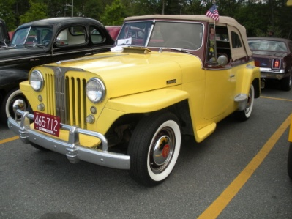
We hope we can welcome you to the WILLYS OVERLAND JEEPSTER CLUB!
Our club was founded over 40 years ago by a group of die-hard Jeepster people in the Ohio area, and has become an international group with over 500 members around the world. We have most of our members in the US & Canada, but do have a decent showing in the UK, Europe, Australia, New Zealand and Central America. We have heard of 'Jeepster Sightings' in Turkey, The Philippines, China, and Japan. Did you know that under license Brooks Stevens Designed Jeepsters were built in Argentina?
One of our founders, Jay Sherwin said it best when he coined our motto… “Love at first sight… It lasts a Lifetime!” Unlike some other clubs there is no requirement for car ownership, only an interest in this wonderful ’48-’51 Model ‘Willys’. Many members own other various Willys or Jeep vehicles, vintage or modern. We hold ‘Jeepster Meets’ at least twice a year in various parts of the US or Canada where members agree to host them.
Our Fall ‘09 meet was held at Dennisport on Cape Cod, Massachusetts that my wife and I hosted on 10-13 Sept., 2009. We had 30 cars from 11 states, and a local record for the MOST RAIN IN FOUR DAYS!
Our most recent ‘National Meet’ was in Shipshewana, Indiana….beautiful Amish Country where the group toured farms, enjoyed an Amish Cinnamon Roll Baking demonstration, and got in some shopping and touring on their own…. Plus enjoyed the hospitality room, and a great club dinner with friends. Our Fall ’14 tour will be the “LINCOLN TOUR” in Springfield, Illinois where we’ll visit Lincoln’s Tomb and drive the legendary Rt. 66 ! Don’t Miss This!
Often members conduct ‘Mini-Meets’ by bringing a few cars together at someone’s driveway or at a restaurant parking lot convenient to several members in a particular area. The club does not have ‘Chapters’ or organized local meetings other than our Spring and Fall “National Meets” each year.
As you become more familiar with club members, in various regions of the world, you may wish to host a National Meet. Of course members are under no obligation to host such meets… they’re completely voluntary!
Stories and reports about these events, and folks photos and stories of how they enjoy their cars is covered well in our AWARD WINNING monthly publication, “JeepsterNews”. The newsletter also contains a classified section in which many professional parts suppliers are listed, and members can place free advs as well. For the last several years, Jim Sommer our Newsletter Editor has earned the GOLDEN QUILL AWARD from “OLD CARS WEEKLY”…. Jim does a great job! We also have a newly formed “WILLYS OVERLAND JEEPSTER CLUB” GROUP on Facebook.com.
In the last few years, with the invention of on-line auctions and such, many people have come to call all vintage Jeeps… “Jeepsters”… and many clubs have formed where Jeep enthusiasts call themselves ‘Jeepsters’…. The focus of WOJC is the ’48-’51 Willys Overland Jeepster model. As noted above, many members own other Jeep Models… we of course welcome all to join and participate in club activities. Many simply enjoy the monthly newsletter and use it as a source of parts and services.
SO... with all of that said, we want you to join the club! Please complete the attached membership form and mail it with your dues to the club secretary. We don't have the ability to do this on-line right now, but maybe someday.
Also, please when you do your membership form, please put my name, "Pete Mozzone / Web Site" on the "REFERRED BY" line.... This will let club officers track web site progress in new member recruiting efforts...

