HOW TO SEND HIGH DEFINITION PHOTOS WITH YOUR iPhone: 20 Oct 2019
BY: Pete Mozzone, WOJC VP
Thank you, Willys Overland Jeepster Club Member, for your interest in sharing photos of yourself, your family and your car with fellow members for possible use in one of our annual “Jim Sommer Memorial Jeepster Calendar” Projects!
As you know, many folks use a real “CAMERA” anymore but use their iPhones. I am not familiar with other types of mobile phones. So, this is for folks using an iPhone.

#1: Take a photo of your Jeepster. (I am using a photo of my computer screen only for demonstration purposes.
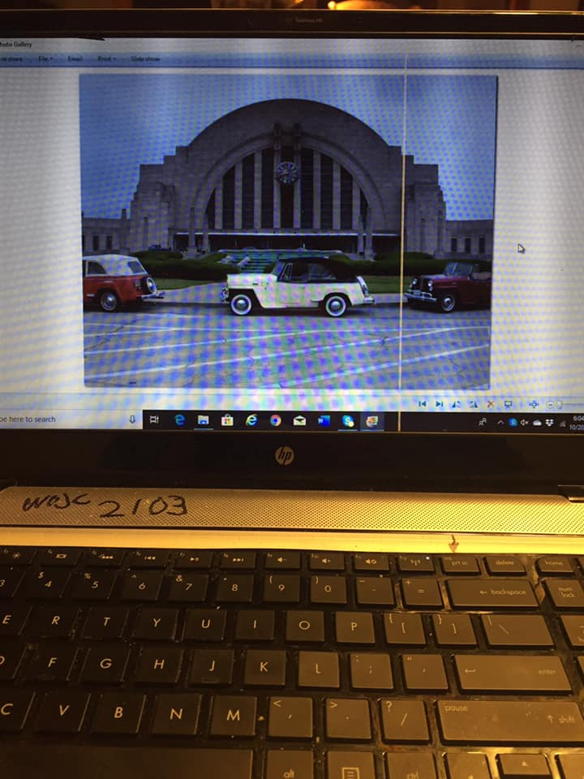
#2: Touch your ‘Photo File’ to bring it up on your screen.
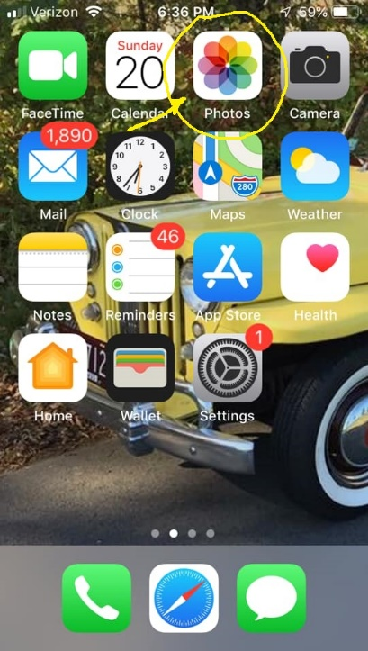
#3: After selecting the image you want from your photos; you will see this on your screen. Touch the box with upward arrow in the lower left corner of your screen. This means you want to “SEND” it to someone.
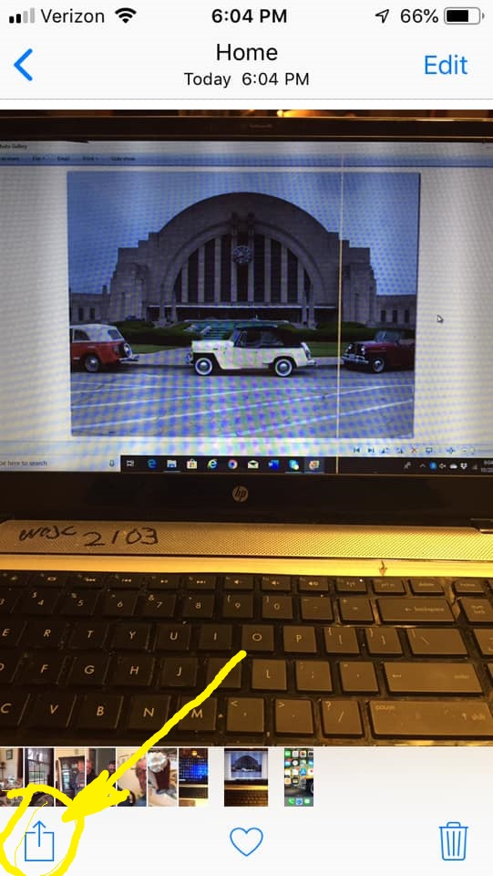
#4: You will see top center your photo is selected. You then touch the “MAIL” icon.
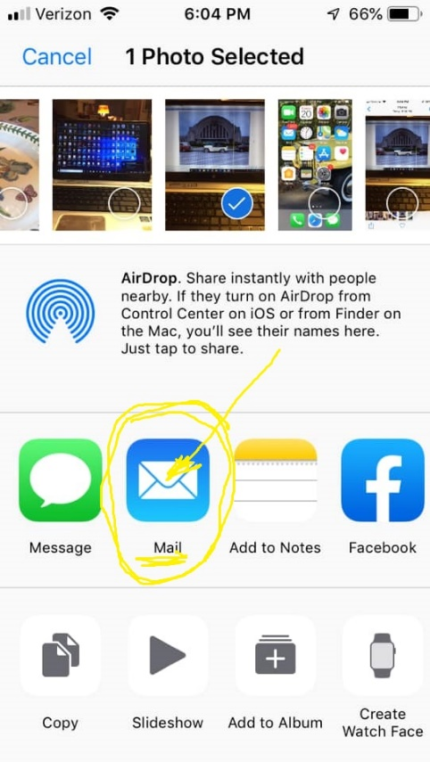
#5: Address your photo to Jeepsterme@aol.com
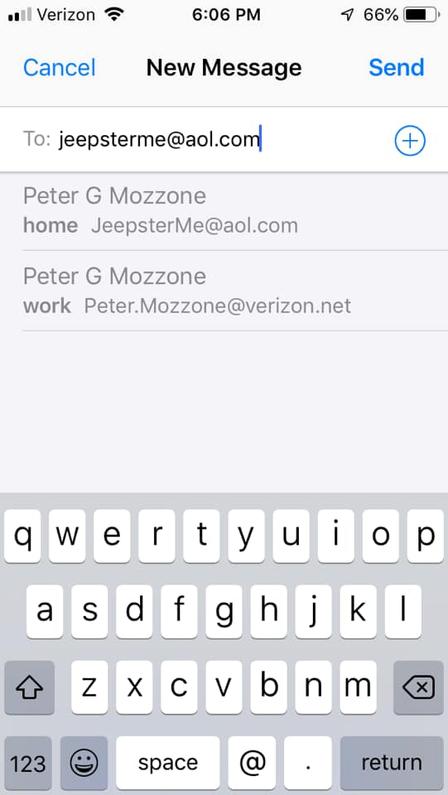
#6: Put something in the ‘Subject Line’ like your name or Jeepster Photo.
Also, please send a message in this or another email to tell me who you are, and a story about your car and the photo. Be sure to push the “SEND” BUTTON, Upper Right.
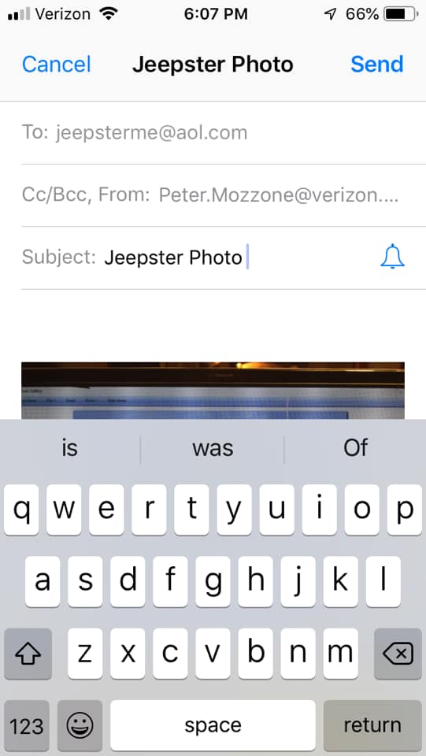

#7: THIS IS THE IMPORTANT PART
After you’ve pushed the “SEND” Button, you will see this screen…
Select and touch “ACTUAL SIZE”… This will send the best quality image your phone has taken which will have the highest file size… Notice in this example it’s 2.3 MB or Megabytes….This will be a suitable file size for use by our newsletter printer and calendar printer!
Thank You!
Pete Mozzone, WOJC
Questions can be directed to: Jeepsterme@aol.com or TEL: 508.320.5337
