ORDER FORM:
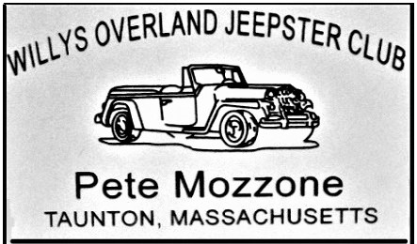
WILLYS OVERLAND JEEPSTER CLUB
Official 2”x3” Name Badge w/Pin Clasp
Indicate what is to be engraved on name tag.
___________________________ ________________________ ______
Name City State
___________________________ ________________________ ______
Name City State
Badges are $6.97 Including Tax. Each. Shipping is $3.50 for one or two badges.
Please enclose entire order form with your check or money order as indicated below.
* 1 badge $10.47 Incl. Shipping. ___________
* 2 badges $17.44 Incl Shipping. ___________
Please provide your shipping address:

_______________________________
Name
_______________________________
City
_______________________________
State Zip

Mail Form To:
UNIQUE AWARDS AND SIGNS
1865 Selina Road
St. Mary’s, Ohio 45885

