CUSTOMER NAME:
STREET
CITY, STATE, ZIP
EMAIL
PHONE
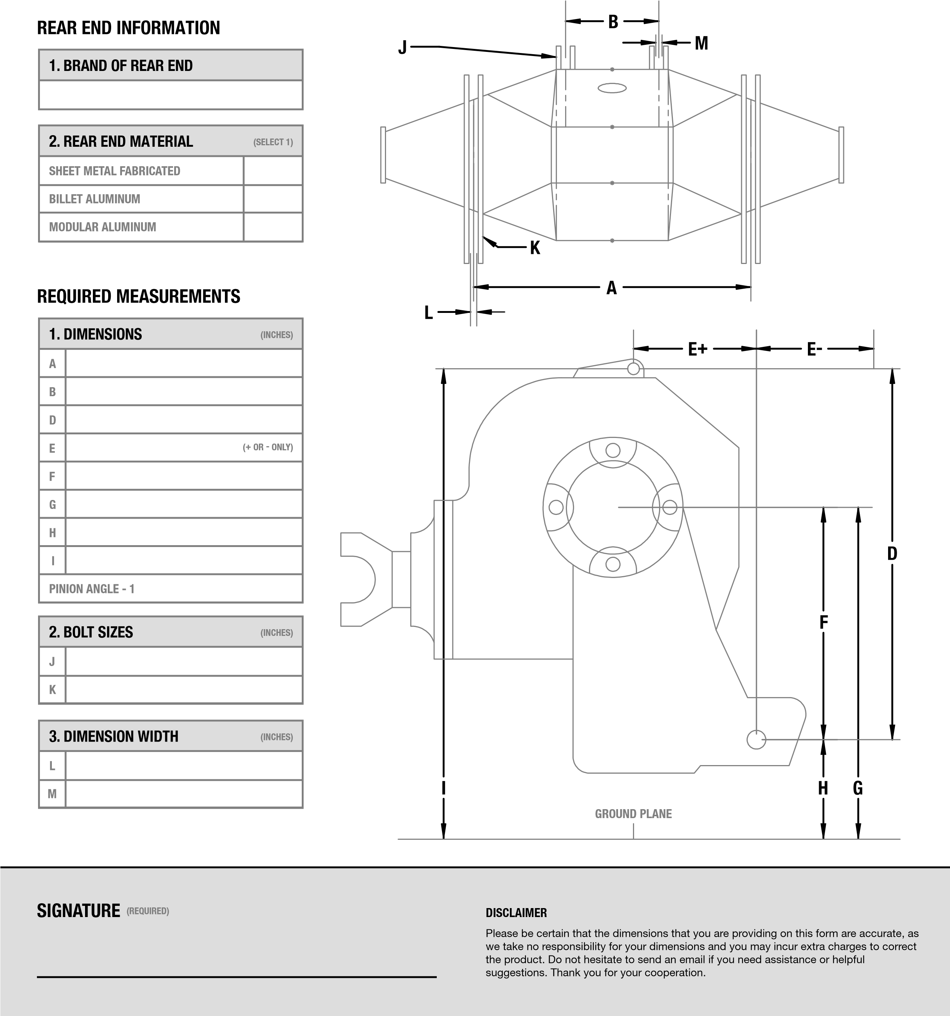
MVMBARS@GMAIL.COM
PO BOX 962
CLINTON, NC 28329
MOBILE: 910-305-2207
SHOP: 248-474-4544

