Subject- Field Trial

Cover Page Bhat Biotech Farm , Kankapura Rd, Bangalore, Knk

Title : Comparison of use of AzaSol with other need based EC product ( AzaMax)

Location : Bangalore Rural Area

Duration - Sept 2022- Feb 2023

Crops : Tomato, Brinjal , Cabbage, Cauliflower,

Cropping Patter- Mono Crop

Area tested: 1 acre each Crop in RBD (Random Plot Design)

Products used :
AzaSol- Systemic water soluble Neem Botanical
AzaMax- EC based contact insecticide
Control (no plant protecting agent- water only)

Product info
AZASOL
AzaSol AzaSol does not contain neem oil, neem bitters, and does NOT affect taste, aroma, or color. It doesn’t leave a residue, significant odor, or sticky mess on plants. It works great on bugs such as mites, aphids, root aphids, thrips, fungus gnats, caterpillars, beatles, etc. After ingesting AzaSol an insect can’t feed because they feel full all the time. The insects cannot shed their skin to molt, and they cant form a pupae. Ultimately the insects end up becoming paralyzed and dying. After feeding on a plant that has been treated with AzaSol, a female insect can’t lay any eggs. Because of the way AzaSol works, insects don’t gain resistance. AzaSol is a growth inhibitor, a reproductive inhibitor and it works to interrupts an insect’s brain and neurotransmitters. If insects do make it to adulthood, they are going to be super messed up and not able to do much harm. AzaSol is the only water soluble form of Azadirachtin extracted directly from seeds of the Neem Tree of India. It has a 2 years shelf life.
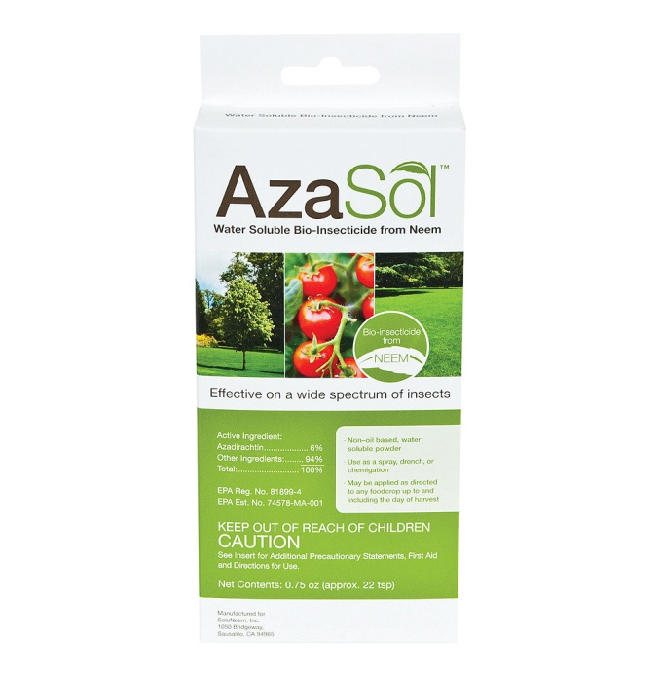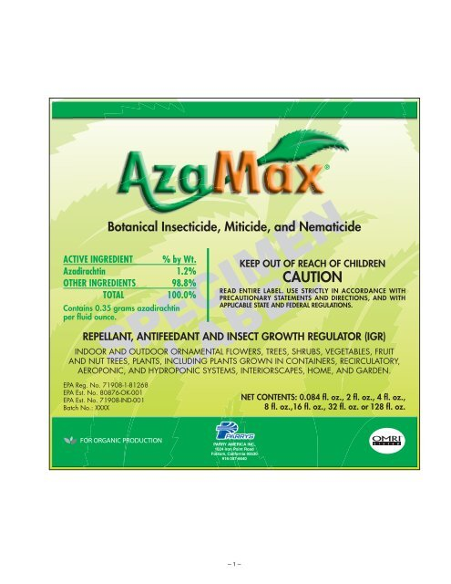

AZAMAX
AzaMax is a natural product with a broad spectrum of pest control and broad plant applications. AzaMax is made from special Azadirachtin Technical extracted using patented extraction technology from Neem, a tree known for it’s innumerable benefits. AzaMax contains Azadirachtin A&B as active ingredients and more than 100 limonoids from it’s special technology. The special feature of AzaMax is that it does not use hard chemical solvents and uses food grade formulation ingredients. AzaMax is licensed in all 50 states

Crops Tested :
Brinjal-Eggplant- Solanum melongena L
Cabbage- Brassica oleracea var
Cauliflower- Brasicca oleracea vs botrytis
Tomato- Lucopersicum esculentum

KNOWN PESTS ON THE CROPS
Cabbage and Cauliflower Insect pests
- Diamondback moth.
- Cabbage head borer.
- Cabbage leaf Webber.
- Cabbage aphids.
- Tobacco caterpillar.
- Cabbage butterfly.

Major pests of tomato are:-
- Fruit Borer.
- Serpentine leaf miner.
- Leaf eating caterpillar.
- Whitefly.
- Thrips.
- Striped mealybug.
- Red spider mite.

Major Pests Eggplant
- Aphids,
- whirefly
- Caterpillar,
- Borer, Mites

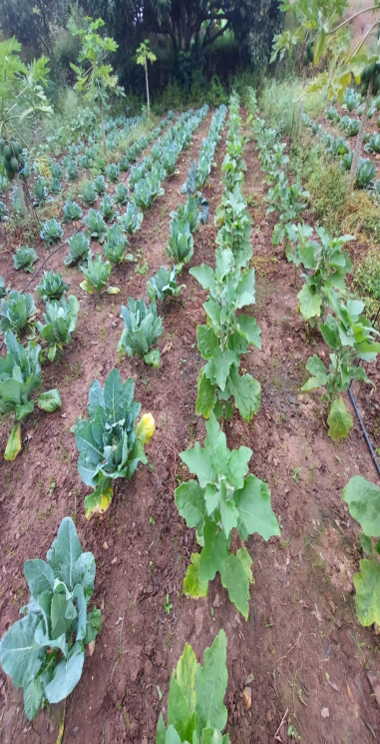
Cauliflower and Brinjal Field

Major Pests Found in the Field
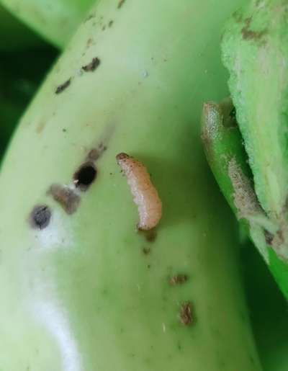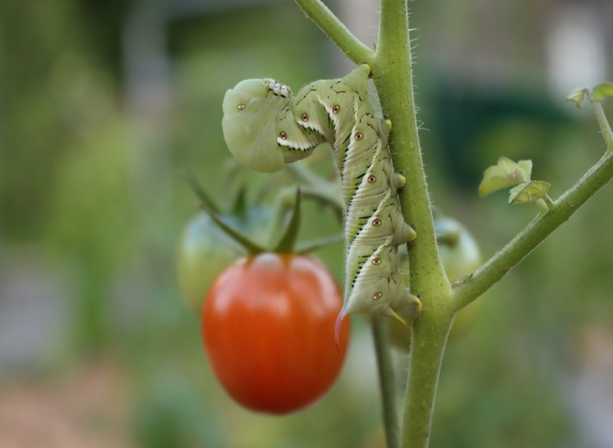
Brinjal and Tomato Fruit Borer

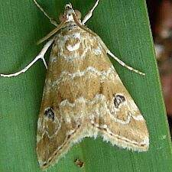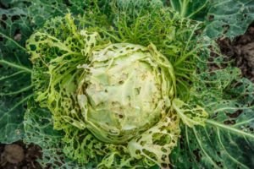
Cabbage Head Borer- and its effect

Pest Control agents Usage :
AzaSol, as per the technical bulletin - was treated after 10-15 days

AzaMax EC as per the technical bulletin- was treated as per EPA recommendation every 5-7 days

Control : Water alone

Summary :
Important Highlights:
Both Tomato and Brinjal had serious problem of Fruit borers.
EC was not so effective because of its contact nature.
Cabbage has serious attack of Diamond moth
AzaSol being systemic water soluble was very effective in total control in all the pests of these crops.
The yiled in all the crops was inacresed by about 50% using AzaSol and about 20% using AzaMax.
Major effect was also seen in marketability- as most customers won’t buy the whole fruit even if there was one bore/hole/infection.

This lead to effective financial impact on farmer as such- as marketable vegetable increased by about 70% when treated with AzaSol and 30% when using Azamax.
The fruit size in plants sprayed with AzaSol was 20-20% bigger than that of EC treated.
It may be prudent to stake some more trials in different locations and in different seasons.

