CULTIVATION OF SHIITAKE MUSHROOMS (Lentinus edodes)
INTRODUCTION
Shiitake mushroom (Lentinus edodes) is a type of edible fungus. It's native to Japan and contains a chemical called lentinan. They are the second most commonly eaten mushrooms in the world. They are the most important culinary medicinal mushroom which ranks at number two in terms of total mushroom production in the world only next to button mushroom. Lentinan and other chemicals present in these mushrooms stimulate the immune system. Lentinan (a cell-wall constituent extracted from the fruiting bodies of shiitake) is an immunomodulation agent which may be useful both as a general rejuvenate for older persons, as well as prophylactically to protect healthy, physically active young people from overwork and exhaustion.Their raw fruit bodies include 88–92% water, protein, lipids, carbohydrates as well as vitamins and minerals. On a dry weight basis, they have a relatively high nutritional value when compared to commonly consumed vegetables. Dried shiitake mushrooms are rich in carbohydrates and protein. They contain 58–60% carbohydrates, 20–23% protein (digestibility of 80–87%), 9–10% fiber, 3–4% lipids, and 4–5% ash.It is rich in B vitamins, including B1 (thiamine), B2 (riboflavin), B12 (niacin), and pantothenic acid.They also contain eritadenine, a compound known to reduce cholesterol levels in the blood, beta-glucans that reduce inflammation and help prevent the intestines from absorbing cholesterol, and support immune health. They are rich in polysaccharides like lentinans and other beta-glucans and have excellent nutritional value.Shiitake is a prized mushroom with a delicious taste and texture. It is used medicinally for diseases involving depressed immune function including cancer, AIDS, environmental allergies, Candida infections and frequent flu and colds. They are beneficial for soothing bronchial inflammation and regulating urine incontinence as well as for reducing chronic high cholesterol.
The commercial cultivation can be carried out on sawdust of broad leave trees mainly tuna, mango, safeda, oak, maple and poplar using saw dust (80 kg), wheat bran (19 kg) and calcium carbonate (1 kg). Water should be adjusted to 60-65% and pH to be adjusted to 5.5-6.0 using gypsum. Saw dust is soaked for 16-18 hours and wheat bran for three hours. All the ingredients are thoroughly mixed. Filling and sterilization of bags: Fill the bags (1.5 to 2 kg) immediately after mixing all the ingredients. Otherwise fermentation and contamination may start. Polypropylene (heat resistant) bags are used for filling. The bags are first loosely filled and later pressed to get cylindrical shape. After filling the bag PVC or iron ring is inserted at the mouth of the bag and plugged with non-absorbent cotton. Sterilization is carried out in an autoclave at 15 psi for 1½-2 hours

SUBSTRATE PREPARATION
1:1 ratio of saw dust and wood chips were dried in sunlight (overall 2kg); 120g of calcium carbonate is added and mixed well. 3.2 liters of water is added to maintain the moisture level at 60-65%. The mixture is boiled for 30 minutes. 1kg of wet substrate is weighed and filled in PP bags (Different weights for further experiments), autoclaved at 121°C for 15 minutes and further maintained at 25-30 ºC.Grain spawn is introduced @ 3% (dry wt. basis) under aseptic conditions5% of spawn with respect to weight of substrate is added to bags. After inoculation bags are placed in cropping rooms where these are incubated in a 4 h/ 20 h light/ dark cycles at 22-26°C. Spawn run takes 60-80 days or more depending upon the strain and environmental conditions. During the period it goes through mycelial growth, mycelial coat, mycelial bump, pigmentation/browning and coat hardening phase
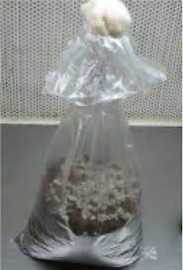
Figure: Spawn running
MYCELIAL COAT FORMATION
A thick mycelial sheet coat will develop on the surface of the substrate. This will be formed after 6- 8 weeks of inoculation/spawning
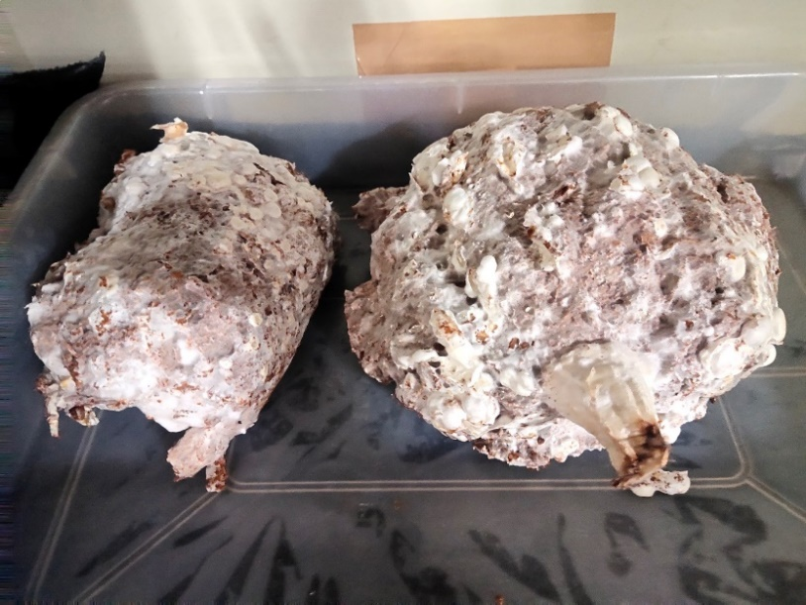
Figure: Growth of blister head formation for Shitake Mushrooms after (85-90days)

MYCELIAL BUMP FORMATION
Bumps are clumps of mycelium, commonly formed on the surface of most strains after 9-10 weeks. These bumps can turn into mushroom primordia at a later stage but most of them abort. Fluctuating temperatures and high CO2 promotes bump formation.

PIGMENTATION
Some aeration should be provided when the bumps have formed. After longer spawn run the surface of the colonized substrate may begin to turn brown, some exudates may also be there during spawn running.
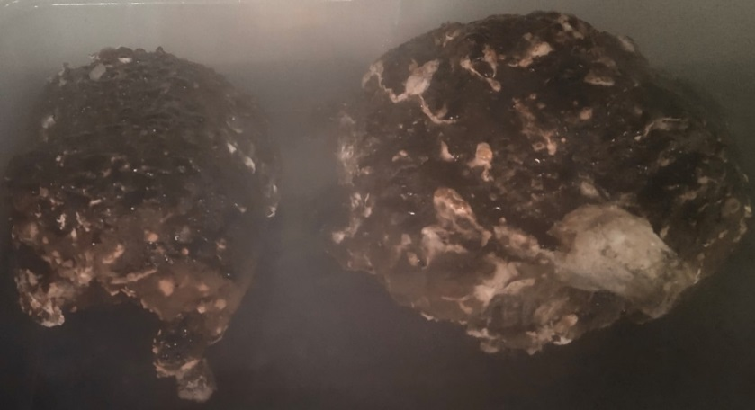

Figure: Browning of mycelial coat on Shitake Mushrooms after (90-105 days)

COAT HARDENING PHASE

Remove the polypropylene bag when synthetic log has partially (half or one third) turned brown. The coat will gradually become hard and outside of the substrate should also be hard while the inside should be softer and moist. The core of the substrate has moisture of about 80%.

FRUITING
For induction of fruiting suitable temperature, high RH, good ventilation and cold water/ shock treatment are required. After 5-8 days of cold-water (4-6°C) treatment for 10-20 minutes, initiation of primordia begins. The fruit bodies further develop and became ready to harvest in next 5-7 days.Take the stalks of the mushrooms and break them from the substrate. Don’t tear them from the surface. Harvest the mushrooms at an early stage. Normal yields are 35-45% of the wet weight of the substrate.
Table: Various fruiting parameter
Stages/ Activity | Days | Temperature(°C) | Lightintensity  (Lux) | Humidity  (%)
Incubation | 60-80 | 22-26 | 500-1000 | 65-70
Induction | 2-4 | 10-20 | 500-1000 | 85-95
Fruiting | 7-14 | 12-25 | 800-1000 | 60-80
Rest | 7-21 | 22-26 | None | 65-70
Induction | 2-4 | 10-20 | 500-1000 | 85-95
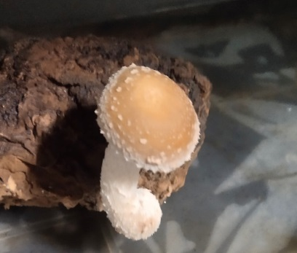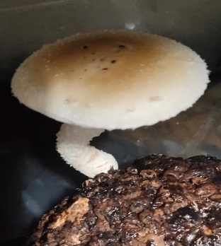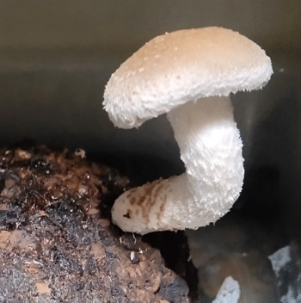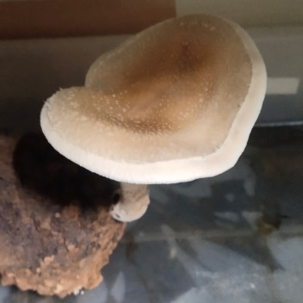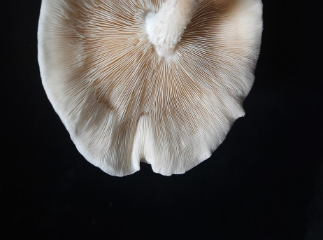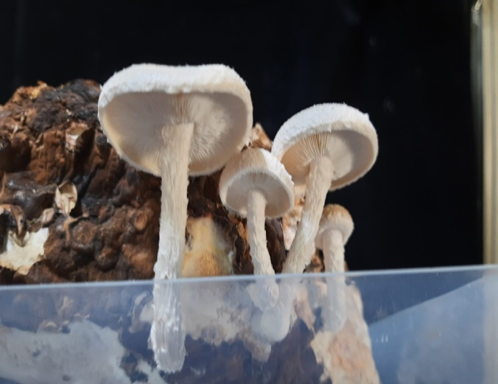

Figure: The fruiting bodies of shiitake mushrooms

OBSERVATION
- The colonization of mycelia took 7-9 months
- The substrate turned completely white, and the process of browning was initiated
- The substrate was given cold shock by placing the hard solid substrate in 4ºC, for 4 hours which was repeated for 3 days
- The substrate was further placed in the growth chamber where the pin heads appeared after 2 weeks

