Voted the Best burger in cedar park
Now you can order online!
MooniesBurgerHouse.com/CedarPark
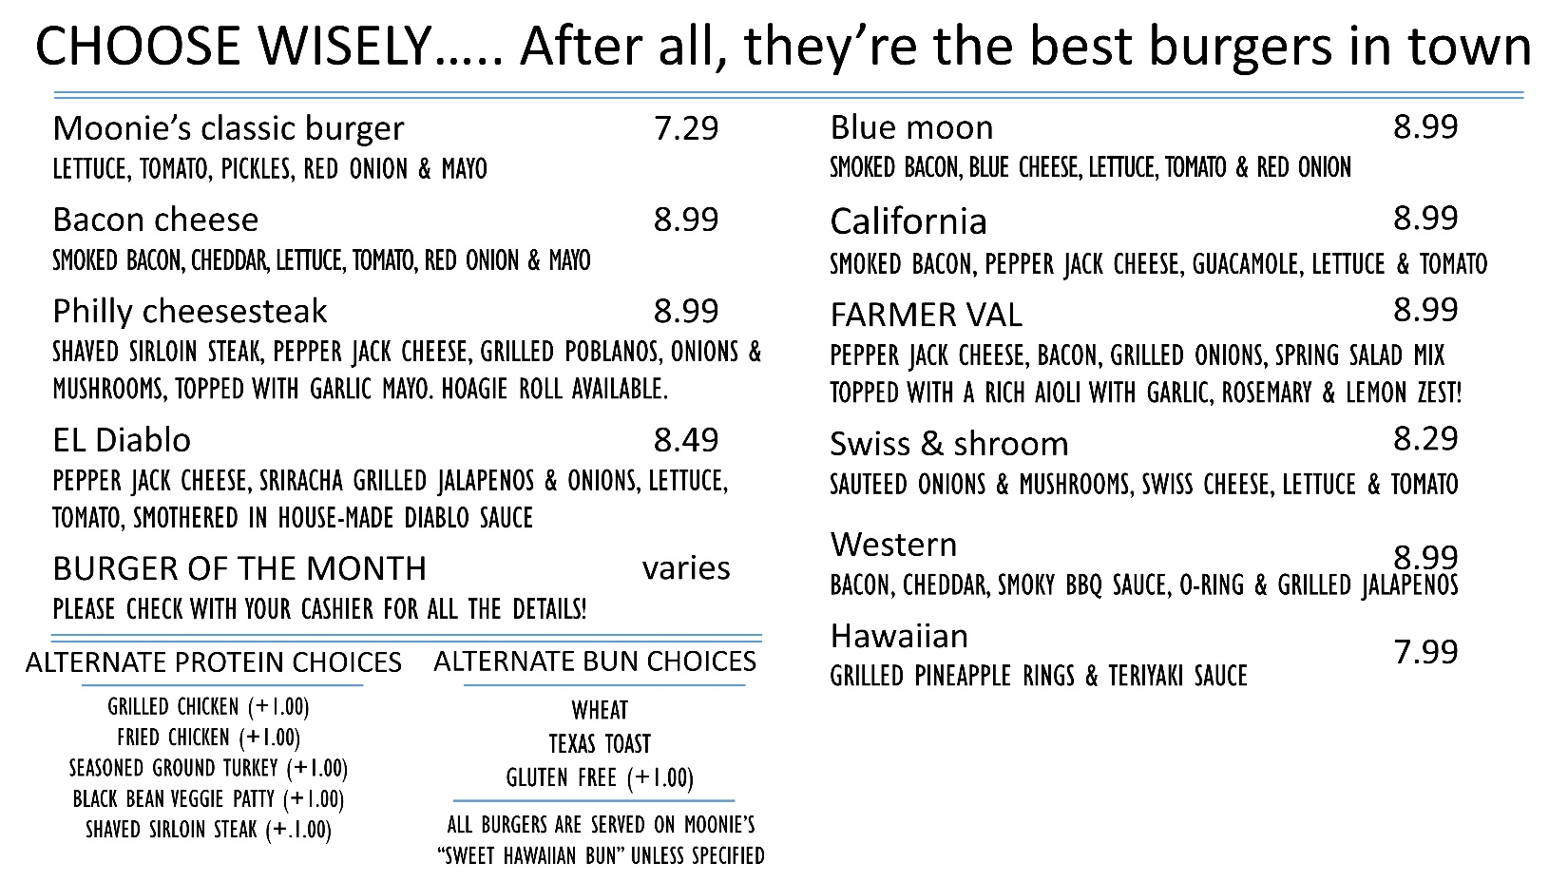
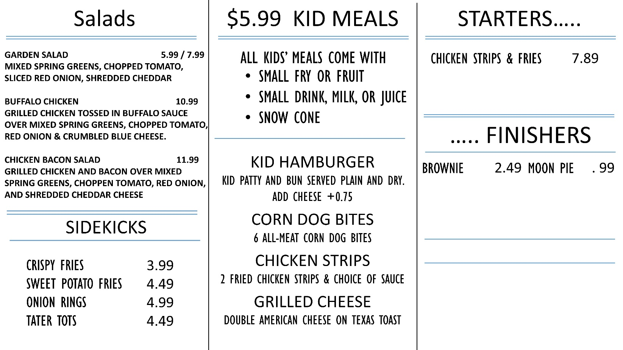
4.99
200 S. Bell Blvd, Cedar Park, TX 78613 (512) 249-5214 MooniesBurgerHouse.com/CedarPark

