31735 Riverside Drive Suite I Lake Elsinore, CA 92595

(951) 291-8849 email: [info@serenitywellnesscenter.net](mailto:info@serenitywellnesscenter.net)

[www.serenitywellnesscenter.net](http://www.serenitywellnesscenter.net)

Cryoskin 3.0

Name: _____________________________________________________ Date: _____________

Address: ______________________________________________________________________

City/State/Zip __________________________________Cell phone: ______________________

Email Address: ______________________________ ___DOB:_________________ Age: ______

Gender: Male ( ) Female ( ) Height: ________________ Weight: ____________________

Children: Yes ( ) No ( ) Activity Level Low ( ) Moderate ( ) High ( )

Treatment of Interest: Skin Tightening ( ) Cellulite ( ) Slimming ( ) Facial tightening ( )

Brazilian Butt Lift ( ) French Butt (less curvature) ( ) **Referred by: _______________________**

Please mark all areas of the body you are concerned with:

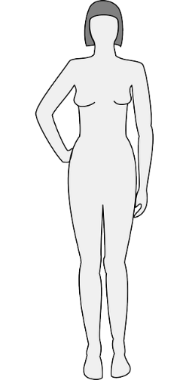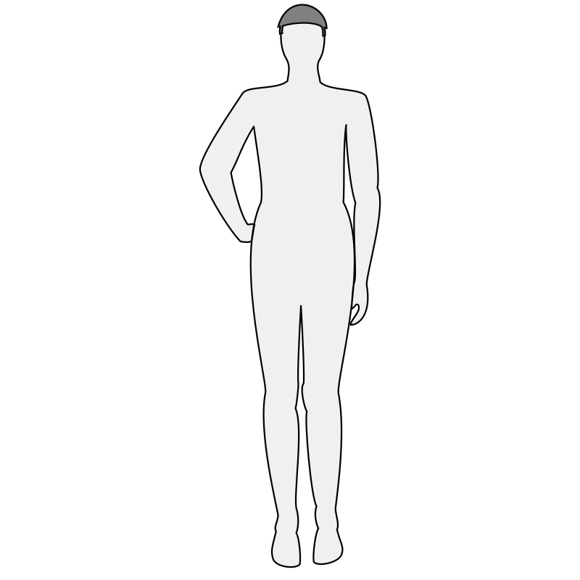

Background

1. Have you had any other aesthetic procedure (s) before: Yes ( ) No ( )
2. If “yes” what? __________________________________________________________________________________________________________________________________________________________________________________________________________________________________________
3. How did you hear about Cryoskin 3.0? TV ( ) Friend ( ) Internet ( ) Other ( ) __________________
4. Do you have any of the following: Please check ALL that apply:

**Procedure** **Date**

* Botox/Fillers ( Last 3 months)
* Surgery ( last 3 months)
* Breast Implants
* Pregnant
* Breast feeding
* Cancer
* Cold sensitivity (Reynaud’s)
* In Vitro Fertilization (IVF)
* Open or infected wounds
* Scar tissue (in the area to be treated)
* Eczema, rashes, or dermatitis
* Circulation or heart disorders
* Liver or kidney disease
* Diabetes (type 1 insulin dependent)
* Foreign ointments or lotions on the skin
* Tattoo’s
* Other __________________________________________

Current medications: _____________________________________________________________

_______________________________________________________________________________

1. What is your goal with Cryoskin 3.0?
2. Did someone refer you?

Consent, Release and Indemnity Agreement

The Cryoskin safely and effectively uses thermal shock to naturally destroy fat cells without any damage to the skin. The Cryoskin breaks down fat cells, which your body naturally flushes out through the bloodstream and then the lymphatic system in the days to weeks following the session. Cryoskin also helps to reduce the appearance of cellulite, fine lines and wrinkles by stimulating collagen and elastin production while tightening muscles. Cryoskin is also beneficial for facial toning and lifting. Protocols will be discussed and or adjusted during consultation based on recommendations and guest needs. ________Initial

I understand that results may vary depending on individual factors including but not limited to medical history, prior treatments of area being treated, skin type, medication, hormones, patient compliance with pre/post session instructions and individual response to treatment. I understand that I must maintain good dietary habits, have sufficient water intake and participate in light physical activity as well as comply with other items outlined during consultation.

________Initial

Photos will be obtained for records. If pictures are used for education and marketing purposes,, all identifying marks will be cropped or removed, unless the Cryoskin 3.0 treatment is done on the face. We only use the facial photo with your permission. _______Initial

The completed form is for informational purposes only. Serenity Wellness Center and its staff are not medical professionals, and do not claim to be. We are Cryoskin 3.0 experts and hold the highest standards of safety, customer service and education. The Cryoskin 3.0 products and equipment have not been tested or proved by the FDA or any other government agency for the treatment of any illness or disease. Use at your own risk. ________Initial

Cryoskin should not be used on or applied to clients who have certain medical conditions and/or contraindications as listed below:

**Contraindication Date**

* Cryoskin should not be applied over infected or swollen areas of the skin
* Cryoskin should not be applied over or near cancerous areas
* Do you have cancer or a history of cancer? YES/NO
* Are you undergoing active chemotherapy? YES/NO
* Do you suffer from serious kidney disease? YES/NO
* Are you on dialysis? YES/NO
* Do you have any lymphatic drainage disorders? YES/NO
* Have you had Botox or filler within 45 days? YES/NO
* Do you suffer from Type 1 Diabetes? YES/NO
* Do you have loss of sensation in your extremities? YES/NO
* Are you pregnant, lactating or undergoing IVF? YES/NO
* Do you suffer from Cold sensitivity or Reynauds? YES/NO
* Recent surgery? (last 3 months) YES/NO
* Do you have Eczema, Rashes, or dermatitis? YES/NO
* Have you had breast augmentation or any other elective surgery? YES/NO
* Do you currently have any open or infected wounds? YES/NO
* Do you have any mesh inserts? YES/NO
* Are you currently taking hormone therapy of any kind? YES/NO

The statements above are factual to my knowledge. I understand that any procedure involves risk. Risks may include redness, swelling, irritation, skin reaction, or increased heart rate. Some may experience delays onset muscle soreness from treatments on the stomach due to unintentionally engaging the abdominals, which disappear later the same day. I understand that each person has a different reaction to Cryoskin. The risks, benefits, and possible results have been explained to me. I have been provided the opportunity to ask questions and receive satisfactory responses. ______Initial

I agree to have my photograph taken to document my results. I give permission for any photographs and other audio-visual and/or graphic materials to be used for marketing, education, and/or promotional purposes without any payment to me. I understand that although the photographs or accompanying material will not contain my name or any other identifying information, I am aware that I might be identified by the photos. _______Initial

**CANCELLATION POLICY**

 Your appointments are very important to the Serenity Wellness Center team.  They are reserved especially for you.  We understand that sometimes schedule adjustments are necessary.  Therefore, we respectfully request at least 24-hour notice for cancellations or rescheduling of appointments.

Please understand that when you forget, cancel, or change your appointment without giving enough notice, we miss the opportunity to fill that appointment time, and clients on our wait list miss the opportunity to receive services. Therefore, we have a strictly enforced 24-hour cancellation and rescheduling policy.

Any appointment missed, late cancelled, or changed without 24-hour notice will result in a $50 charge. The appointment may be taken off a contract/package or charged individually.

As a courtesy, your appointments are confirmed the day before your scheduled appointment by a courtesy phone call, email and/or text messaging because we know how easy it is to forget an appointment you booked months ago.  From this confirmation call and or email/text, you have the option of the following without a charge:

* confirm your appointment in the email;
* reschedule/change/modify your appointment;
* cancel your appointment;
* respond back by email with any changes or issues;
* call our office number which is provided in the email for customer service;

Please understand that it is your responsibility to remember your appointment dates and times in order to prevent any missed appointments which result in a cancellation fee.  Not receiving an electronic notification of your appointments from us the day before is not sufficient reason to miss an appointment if the original confirmation notification was received timely.

Any late arrival will shorten your appointment time and will not be made up by running into the next client’s scheduled appointment.  More than 15 minutes late will result in needing to reschedule as well as result in a $35 missed appointment fee.

All appointments must be held with a valid credit card at the time of booking.  A credit card hold transaction may be made on your credit card to reserve the appointment time.  Your credit card information is stored will full encryption.

Emergency absences will be considered on an individual basis by Serenity Wellness Center.  You may request not to be charged for the late cancelled session in writing within 7 days if you feel such action is warranted.  Serenity Wellness Center will make the decision to honor your request on a case-by-case basis and will respond back to you in writing within 7 days.

It is mutually understood that if a cancellation is due to circumstances beyond any of our control, such as power outage, unfortunate incidence, or weather that requires you or us to have to cancel or be closed during regular business hours, we will reschedule your existing appointment and no discount or charges will apply.

Serenity Wellness Center stands by our policies.  We feel that it is only fair that we honor the same policies to our clients.  If we have to cancel a client with less than 24 hours’ notice of the appointment scheduled, we will honor the same policy and your next appointment will be free of charge.  Serenity Wellness Center reserves the right to modify a scheduled appointment to a different Staff Member during the same time allotment if circumstances arise without prior approval of the client.

The 24-hour cancellation policy gives us time to inform our wait list clients of any availability, as well as keeping our staff schedules filled, thus better serving everyone.  Serenity Wellness Center policies are presented and provided in the best quality and tradition of excellent service for our established and future clientele. Thank you for viewing and supporting our 24-hour cancellation and rescheduling policy criteria!

______________Initial

By signing below, I _____________________________________, acknowledge and certify that I have read and understand the “Consent, Release and Indemnity” agreement for this treatment, and that I am signing it voluntarily. Should any pain or discomfort occur, I will immediately notify the technician. I understand that I must be at least 18 years old to participate in this treatment. I understand that all sales are final, and refunds are not permitted.

Printed Name: ____________________________________

Signature: ________________________________________

Date: ____________________________________________

Technician: _______________________________________