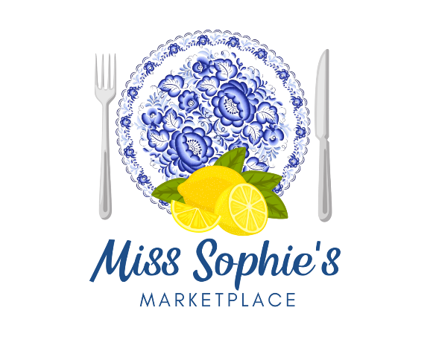
175 Bourne Avenue, Pooler, GA 31322
(912)330-0778
www.sophiesmarketplace.com

CORPORATE LUNCH BOXES
$12.50

SANDWICHES
(Served on your choice of Country White, Hearty Wheat, Croissant, or
Wheat or Spinach Wrap)

MISS SOPHIE’S FAMOUS SOUTHERN CHICKEN SALAD
Chunks of Chicken, Sweet Grapes, Diced Celery, and Chopped Pecans
SPECIALTY SANDWICHES $1.50 UPCHARGE PER SANDWICH

PUB CLUB
WEST COAST PUB CLUB

TURKEY CRANBERRY GRILL

GRILLED CHICKEN WRAP

SOPHISTICATED GRILLED CHEESE

BACON, BRIE AND APRICOT

SHRIMP SALAD
Wild caught domestic shrimp, celery, and diced eggs

TUNA SALAD
Tuna, eggs, sweet relish and a tiny bit of onion

PIMENTO CHEESE
Made from scratch with freshly grated sharp cheddar cheese

OLD FASHIONED EGG SALAD
Diced boiled eggs and spring onions

HAM, TURKEY OR ROAST BEEF
With your choice of Swiss, Provolone or Cheddar Cheese

HUMMUS VEGGIE WRAP
House made hummus, tomatoes, carrots, cucumbers, spinach,
& roasted red peppers Nn your choice of wrap

PESTO BLT
A BLT with our house made pesto sauce

*Served with lettuce and tomato unless otherwise requested

SIDES
(Choose 1 per group)
●Italian Pasta Salad ●Oven Baked Potato Chips ●Mixed Green Salad
●Caesar Salad
DESSERT
(Choose 1-per group)
●Banana Pudding ●Peach Cobbler ●Assorted Cookie Tray● Assorted Sophie Snacks
BEVERAGES
(Choose 2-per group)
●Sweet & Un-sweet Tea ●Lemonade ●Water
⧫ Available in Boxes or Platters
⧫ Disposable Utensils, Condiments, Cups, and Plates (for platters) included in Price
⧫ Delivery Fee May Apply
⧫ MINIMUM ORDER OF 10 FOR DELIVERY

