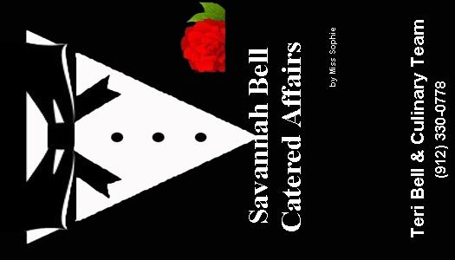

**Formal Buffet Menu**



Two Appetizers:

●Meatballs in Your Choice of Sauce

●Ham Tea Biscuits

● Warm Spinach and Artichoke Dip and Tortillas

●Warm Crab Dip with Crackers

●Warm Vidalia Onion Dip

●Warm Bacon & Gruyere Dip

●Salmon Cakes with Remoulade*

● Shrimp Cocktail ***

● Mini Crab Cakes ***

●Smoked Salmon Cucumber Bites ***

●Sweet Bacon Chicken Wraps *

●Mini Spring Rolls with Sweet Chili Sauce

●Crudités Display Fresh Cut Vegetables & Dip

●Fruit & Domestic Cheese Display

● Deviled Eggs and Tomato Sandwich Display

● Caprese Bruschetta Served With Garlic Crostini

●Peach Crostini with Goat Cheese and Honey

●Assorted Pinwheels

●Red Pepper Hummus in Cucumber Cups

● Mini Chicken Salads on Croissants

●Chicken Fingers with Honey Mustard

● Pigs in A Blanket

●Pimento Cheese in Phyllo Shells

●Chicken Parmesan Envelopes

One Salad:

●Garden Salad with Your Choice of 2 Dressings ●Caesar Salad with Caesar Dressing

●Strawberry Spinach Salad● Mixed Greens with Cranberries, Walnuts, Blue Cheese and Poppy Seed Dressing

Two Entrées:

●Herb Roasted Chicken

●Fried Chicken

●Chicken Picatta

●Champagne Chicken

●Barbecue Chicken

●Oven Roasted Turkey Breast

●Baked Ham with Mustard Sauce

● Herb Roasted Pork Tenderloin

●Barbecue Pork Shredded with buns

● Boston Butt & Gravy

●Roast Beef & Gravy

●Beef Brisket

●Beef Burgundy

●Shrimp & Grits **

●Poached Salmon w/Cucumber Dill Sauce ***

●Savannah Seafood Parmesan ***

●Crab Cakes ***

●Shrimp Newburg in Puff Pastry Cup ***

●Shrimp Alfredo ***

●Roast Beef Carving Station ***

●Prime Rib Carving Station ****

●Sliced Prime Rib ****

●Country Fried Steak

● Baked Ziti (vegetarian available)

●Pasta Primavera

●Baked Fish

Three Sides:

●

●Butterbeans

●Roasted Tomato & Squash Medley

●Roasted Vegetables with Balsamic Glaze

●Okra & Tomatoes

●Succotash

●Asparagus Spears with Bleu Cheese Sauce **

●Honey Roasted Butternut Squash**

●Southern Style Green Beans

● Roasted Haricot Vert

●Seasonal Vegetable Medley

●Squash Casserole

●Collard Greens

●Corn Casserole

●Honey Glazed Carrots

●Garlic Mashed Potatoes

●Herb Roasted Potatoes

●Cream Potatoes

●Macaroni & Cheese

●Rice Pilaf

●Savannah Red Rice

●Potatoes Au gratin

●●

Savannah Bell Catered Affairs

by Miss Sophie’s

www.savannahbellcatering.com

912-330-0778

1014 Highway 80 East #700

Pooler, Georgia 31322

912-330-0778

*Each asterisk represents a $1 up charge