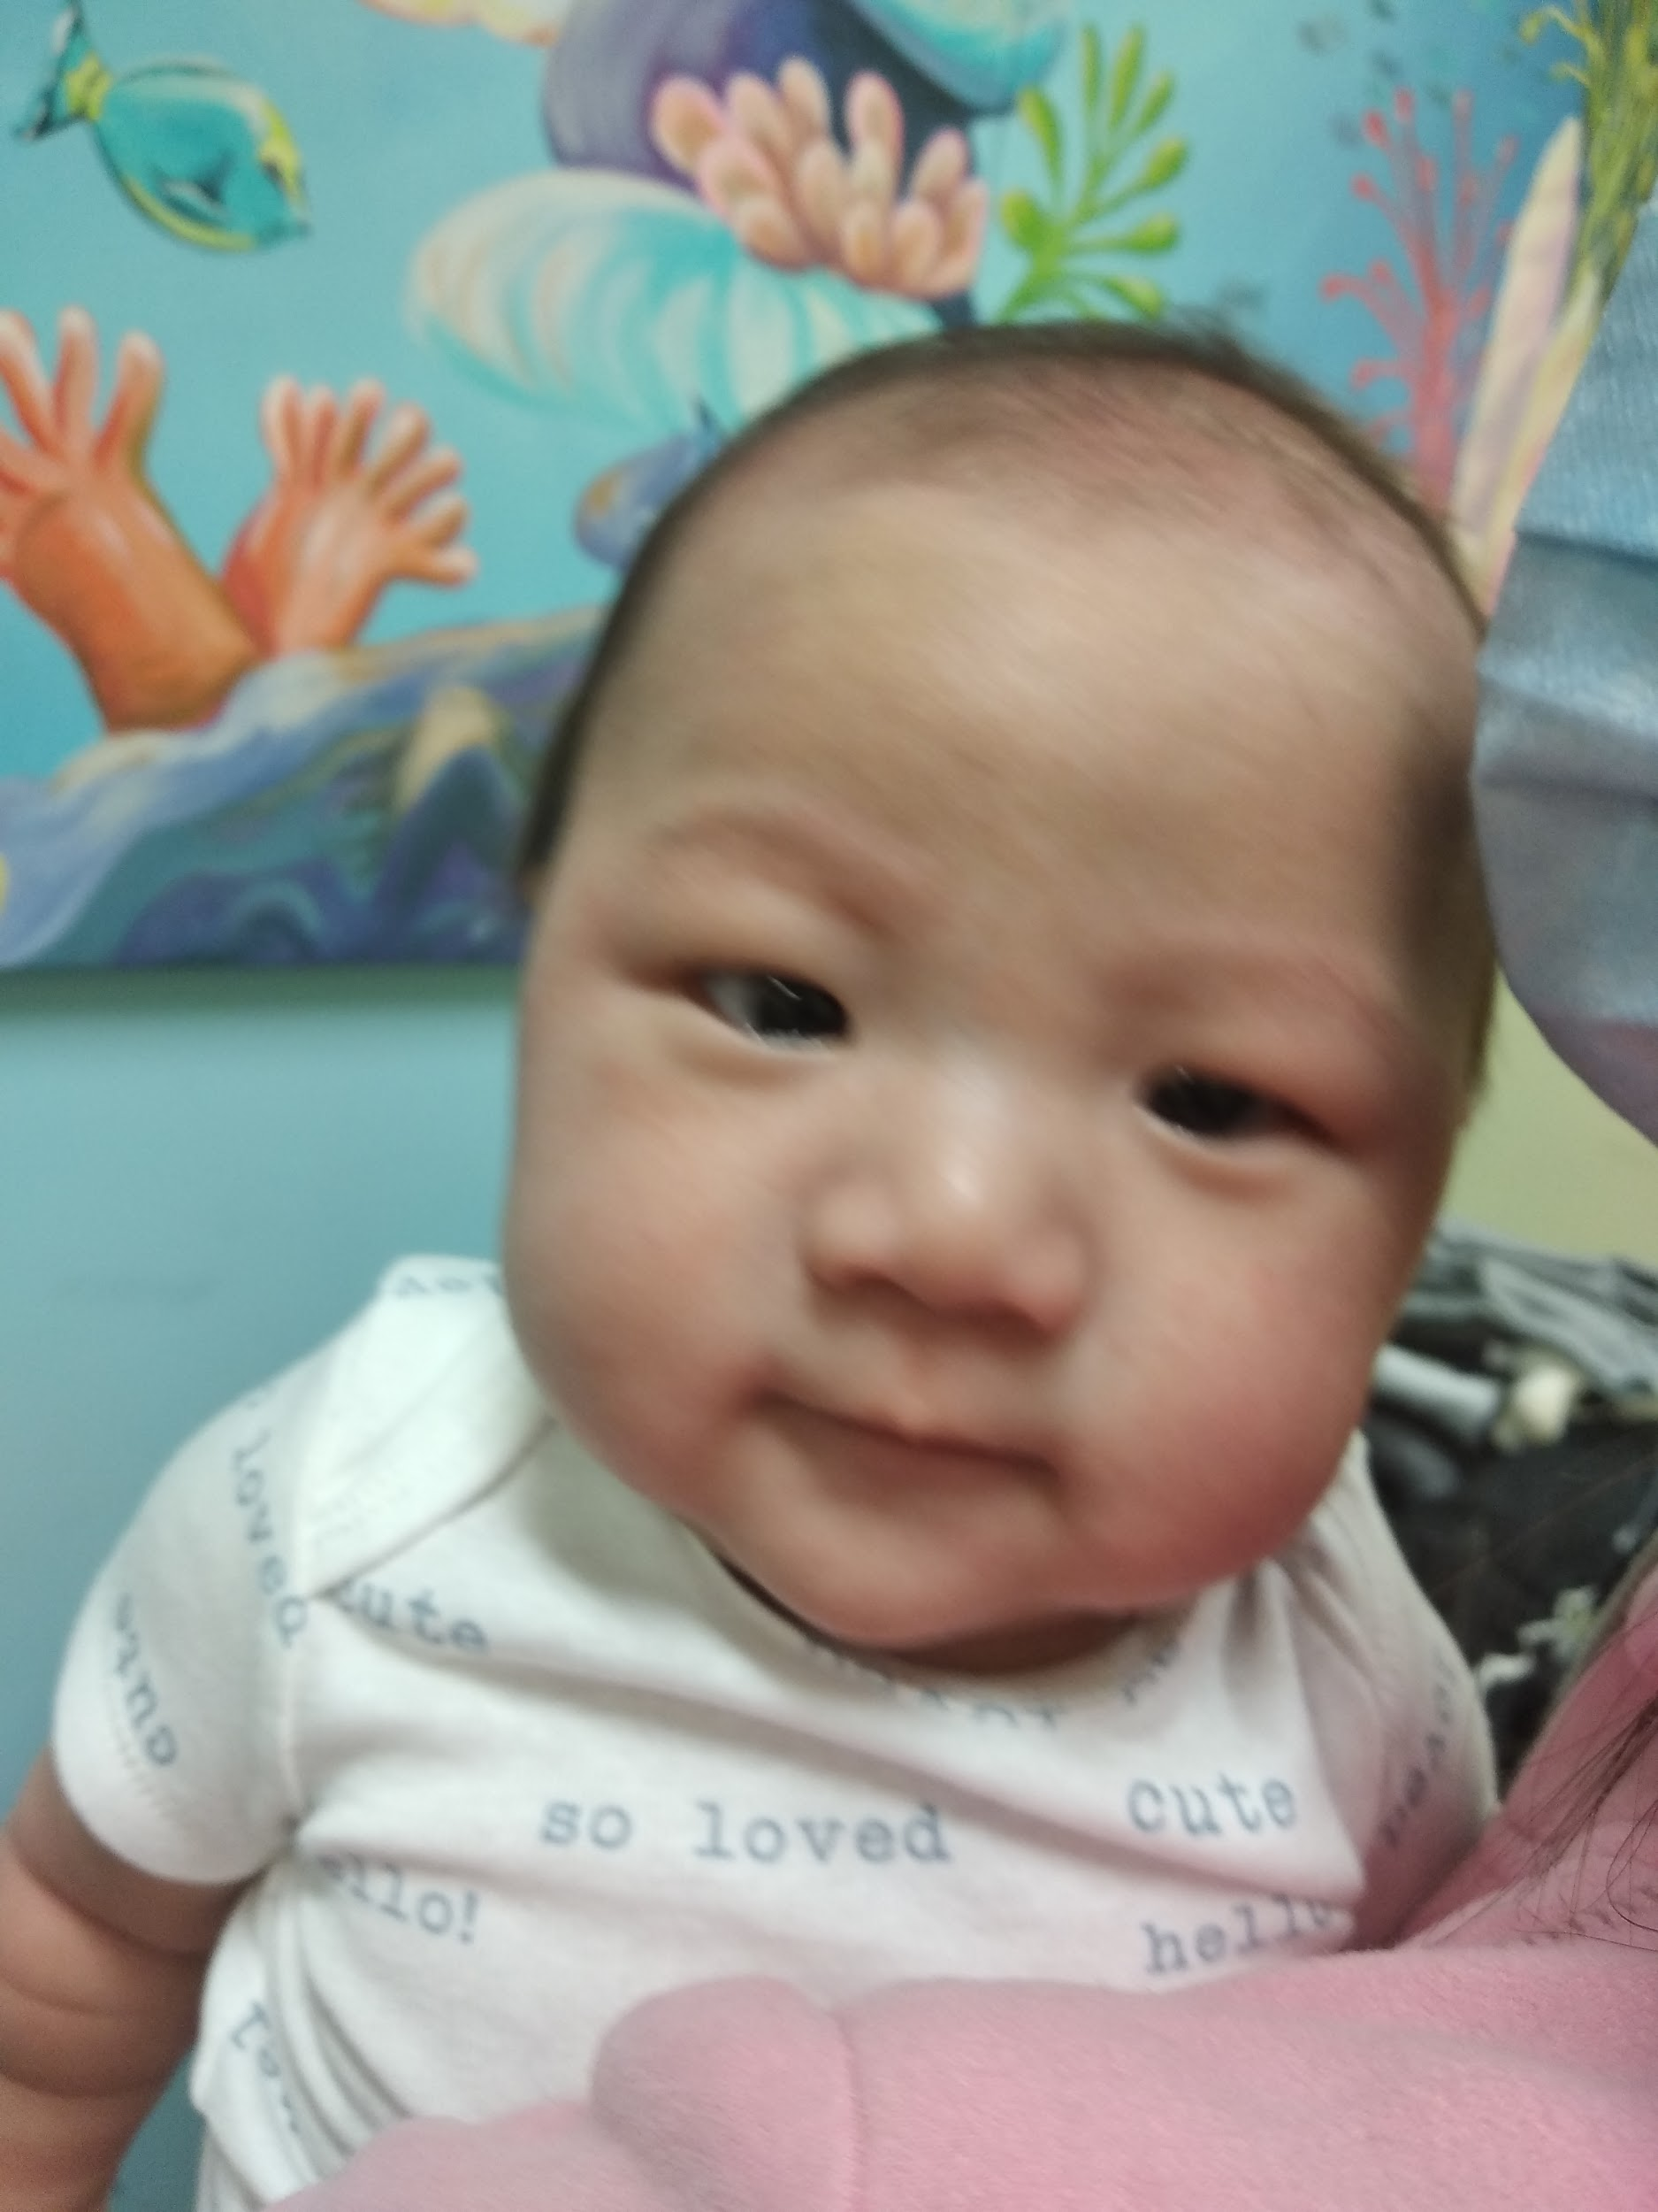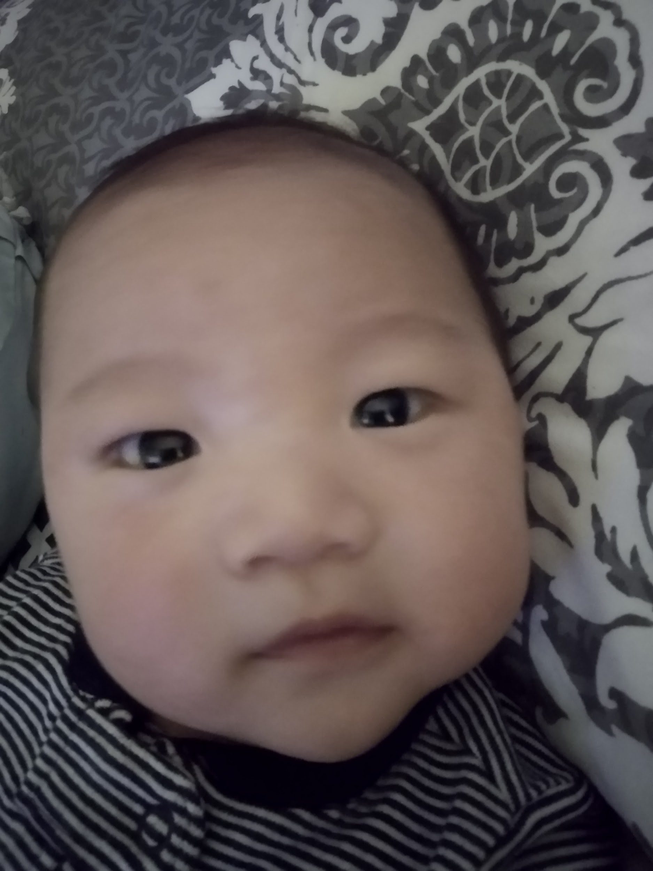

February 09, 2021

Dear Hon.Christine Elliott,

This letter is concerning Baby’s with a devastating diagnosis: Marcellinus Muljarahardja (Brantford, ON) who have Spinal Muscular Atrophy (SMA) type 2. Marcellinus Muljarahardja and other babies with SMA in Ontario are in desperate need of a lifesaving gene therapy called Zolgensma that comes at a staggering cost financially unattainable by most. Health Canada approved Zolgensma on December 16th, 2020 but securing federal and provincial funding through negotiations with Novartis will take time. In order to be effective and minimize irreversible damage, Zolgensma should be administered before the age of two and/or prior to the child exceeding a designated weight limit.

SMA is caused by a loss of specialized nerve cells called motor neurons that control muscle movement. It is a devastating disease that robs babies of their ability to move, talk, swallow and eventually breathe through the death of motor neurons (the communication link between the brain, spinal cord and the body’s muscles). SMA is the number one genetic killer of children under the age of 2.

What motor function they have has been preserved by a drug called Spinraza that must be administered via a lumbar puncture every 4 months at a cost of approximately $700,000 for the first year. Each following year injections cost approximately $360,000 and this continues for the rest of the child’s life. Over just a short period of time, the cost of Spinraza drastically exceeds the cost of Zolgensma. Spinraza only slows the progression of SMA, it is NOT a cure. Furthermore, these children’s access to Spinraza through provincial funding is always contingent on their symptoms improving or at minimum not getting worse – a constant source of strain and anxiety for the families and these procedures are traumatic for the children. Zolgensma works by replacing the missing survival motor neuron protein that is critical to muscle function. It is the superior treatment in terms of efficacy and its one time administration is much more cost-effective over the lifetime of the child (Dr. Wong-Reiger President and CEO of the Canadian Organization for Rare Disorders).

Now that Zolgensma is approved in Canada it will still take several months for funding negotiations to take place between the pan-Canadian Pharmaceutical Alliance and Novartis (Zolgensma’s manufacturer). Some provinces may end up not funding Zolgensma at all. These children do not have several months. With every day that goes by irreversible motor neuron damage occurs. Therefore, I am asking you to please advocate for and help Marcellinus Muljarahardja and other babies in Ontario to receive a compassionate dose of Zolgensma prior to it being funded in Ontario.

Every child in Canada with SMA deserves a chance at the highest quality of life and for the children you see pictured above that chance is dependent on the action you take today!

I look forward to your response and timely action on this matter.

Regards,
Daniel Muljarahardja

