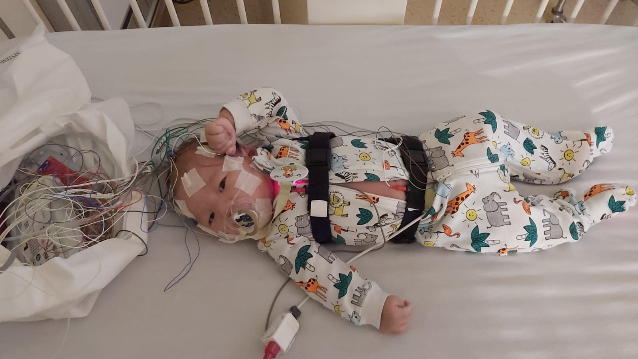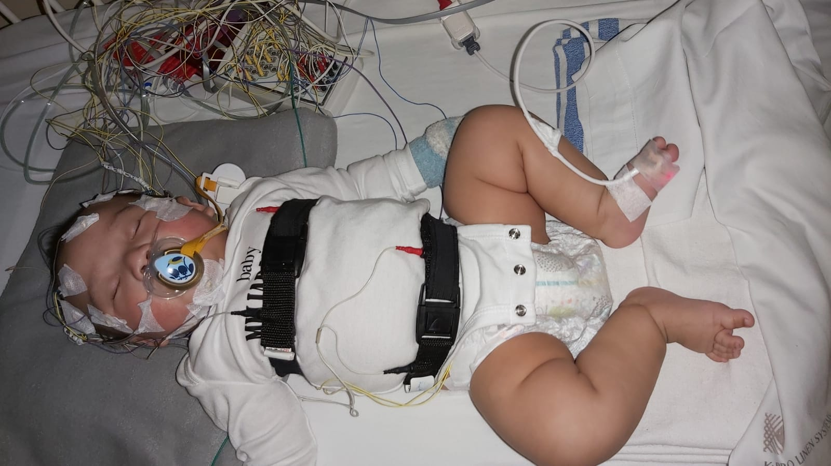

Dear MP Will Bouma,
I am writing to you today regarding the situation of one of your constituents – three month old baby Marcellinus Kornelius Muljarahardja, who was diagnosed shortly after birth with Spinal Muscular Atrophy (SMA) type 1 and has an urgent need to receive the newly approved life altering gene therapy, Zolgensma.
SMA is caused by a loss of specialized nerve cells called motor neurons that control muscle movement. It is a devastating progressive disease that robs babies of their ability to move, talk, swallow and eventually breathe through the death of motor neurons (the communication link between the brain, spinal cord and the body’s muscles). SMA is the number one genetic killer of children under the age of 2. While there is an existing treatment available (Spinraza), it only slows the progression of the disease, it does not stop it. Zolgensma would stop it.
Health Canada approved Zolgensma on December 16th, 2020 but the standard funding process through CADTH and the pan-Canadian Pharmaceutical Alliance (pCPA) is ongoing and will take many months to complete. Baby Marcell does not have time to wait to receive treatment. With every day that passes, more irreversible damage is done to his body. He is young enough that if provided with Zolgensma now he may live with very few of the complications of SMA. He needs to be treated as quickly as possible to halt the destruction this disease causes.
I understand that while no public announcement has been made, the government of Ontario has communicated to some physicians and families that they may be able to access Zolgensma on a case-by-case basis under the Exceptional Access Program. I am writing to ask that you support and advocate for baby Marcell to be provided with this access immediately. It is a medical review, yes, but it is also a bureaucratic one and therefore your voice in support of this funding - both the exceptional access and the fast overall funding - is important.
I would like to further draw your attention to is the number of Ontarians who consider prompt access to Zolgensma an important issue. Pre-Health Canada approval, a federal e-petition was posted online for one month in Fall 2020 (petition e-2868) asking the Federal government to work with provinces to support early access to Zolgensma for these children who are being left behind by the standard pharmaceutical approval and funding process. 1,412 Ontario residents signed this petition. 3,710 Canadians signed this petition. Access to Zolgensma for these children who so desperately need it is something that Canadians want to see happen now.
None of these children should be left behind. There are many arguments in favour of Zolgensma, especially for an infant as young as baby Marcell: it is substantially more cost effective than Spinraza, better health outcomes & less use of the healthcare system, reduced infant & parental stress, and the list goes on. Please help baby Marcell access Zolgensma as quickly as possible. The quality and quantity of his life depend on it.
Thank you for your time. I look forward to hearing from you regarding your actions on this.
Sincerely,
Daniel Muljarahardja
resident of Ontario

