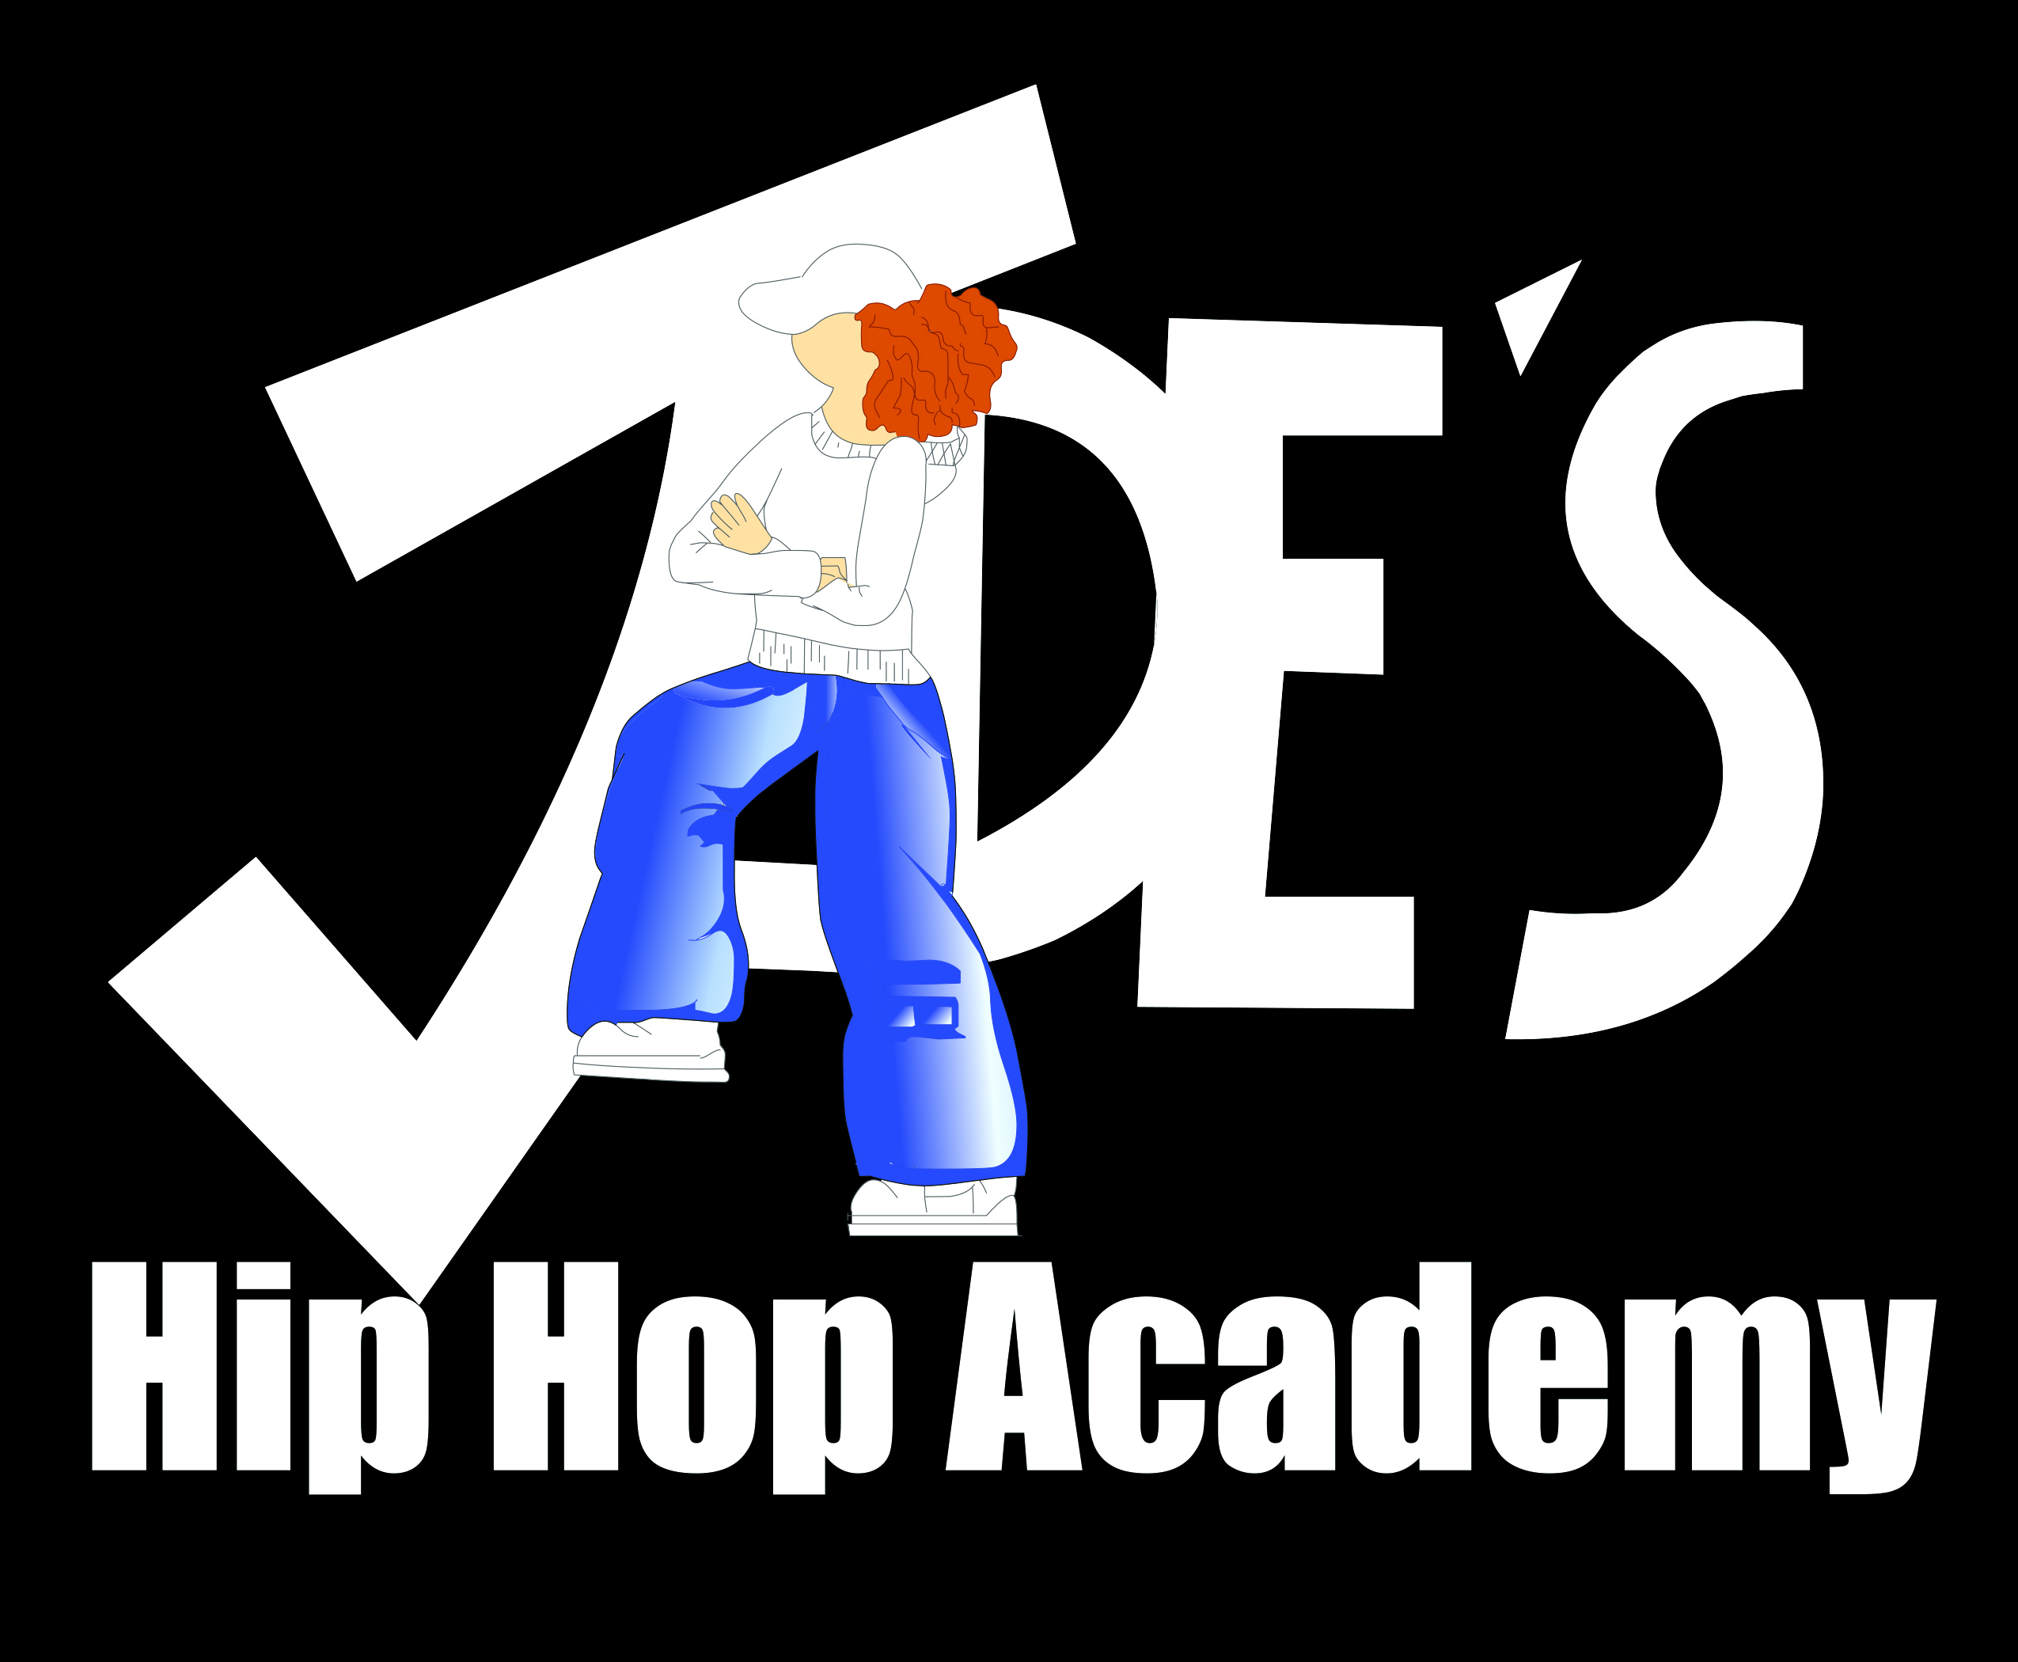
Summer Camp 2022

Registration Form

First Name: ______________________ Last Name: _______________________ Gender M F

Age: ____Date of birth: _______________ Any Medical Conditions/Allergies: ___________________

Name Parent: ______________________________ Cell #:________________________

Address: __________________________________City: ___________________________________

Postal code: _______________Email: __________________________________________________

Emergency Contact Name: ____________________ _____Cell #:____________________________

How many years of dance experience: ______ Recreational_______ Competitive: _______________
July 4th – 8th Beginner/Intermediate ages 8-18 □ Intermediate/Advanced ages 8-18 □ AGES 4-7 □
August 8th – 12th Beginner/Intermediate ages 8-18 □ Intermediate/Advanced ages 8-18 □ AGES 4-7 □
Ages 13-17 □

DRESS CODE – Dancers must wear comfortable clothing that they can move in easily. Under no circumstances should the
clothes be revealing in any way. No jeans, tight pants or crop tops. Dancers who do not come to class appropriately dressed will be
asked to change.
INDOOR SHOES – Clean Indoor shoes must be worn for all classes; these are a second pair of shoes that are not worn outside
but are specifically for the dance class. Indoor shoes must be CLEAN, carried into and changed into once inside the studio. Please do
not wear the indoor shoes from the car to the studio. We also advise dancers to wear flip flops/slides to make changing into and out
of their running shoes/sneakers easier.
JEWELRY – For dancers safety it is recommended that no jewelry be worn during class. Big jewelry, such as hoop earrings may get
caught in their hair, rings and watches can scratch and get caught or hooked in clothes and bracelets could fall off while dancing.
HAIR – Unless dancers have a short hair style, hair should be worn back and away from the face, either in a ponytail or half up.
DRINK – Dancers should bring at least 2 water bottles per day. Juice is not permitted in the studio. Only at lunch time.
NO GUM – Dancers are not allowed to chew gum during class or at the studio. Dancers must dispose of gum before class.
FOOD – Due to allergies, any food or snack brought to the studio must be NUT/Peanut FREE. Please provide your dancer with
enough food, snacks and sufficient drinks.
MASKS – It is your choice if you want your child to wear a mask. Masks will be mandatory when government demand it.

PAYMENTS – Cost of full day Camp $300 + HST = $339 Cost of half day camp $150+HST= $169.50
A spot in our camp will be officially confirmed when this registration form + release and waiver of Liability have been filled out, signed and e-mailed to us along with an e-transfer of the full payment. Forms can be filled out electronically or printed out. You can send us a photo of the paper work as well. The E-transfer can be sent to info@jadeshiphopacademy.com No Refunds.
FULL REFUND will only be issued if the government shuts down summer camps due to Covid-19.

The undersigned has read Jade’s Hip Hop Academy Rules and Regulations and agrees.

Name Participant: _________________________________

Parents/Guardian name (if younger than 18): ______________________________________________

Signature Parent/Guardian: ___________________________ Date: __________________________

Release and Waiver of Liability

Name: (the “Student)
Address:
City: | Province: |  |  | Postal Code:
Phone: |  | Email:
Name Parent/Guardian: |  |  | Relationship to Student:
Information of Medical Significance or Injuries:

In consideration of being permitted to participate in any way in the Jade Jager Clark o/a “Jade’s Hip Hop Academy” (JHHA) with a business address of 1310 #6 Steeles Ave. E., Brampton, Ontario (the “Academy”) programs, competitions and/or instruction and being permitted to enter for any purpose any area where in admittance to the general public is prohibited (a “restricted area”) and/or training at home, the Student (or parent(s) and/or legal guardian(s) of the Student, as applicable):

- Understands that it is his or her responsibility to advise every instructor of any physical conditions which may limit his or her participation in the dance instruction program offered.
- Understands and agrees that bumps, bruises, scrapes, scratches and soreness are commonplace and there is a high probability of incurring such injury. There also exists the possibility of more serious injury, including but not necessarily limited to, sprains, twist, strains, fractures, torn ligaments, and other injuries which could result in bodily injury partial and/or total disability, paralysis and death. The Student understands and agrees with the rights and responsibilities associated with such risks.
- Accepts and assumes such risks and responsibility for the losses and/or damages following such injury, disability, paralysis or death, however caused and whether caused in whole or in part by the negligence of the persons named below.
- Consents to physical contact as a result of dance training, and understands that the Student has the right to immediately withdraw from any exercise or drill in which the conduct of any party seems beyond the scope of training or comfort. Student further agrees to abide by Academy etiquette in all matters pertaining to training and instruction, including to not, in any way, conduct his or her self inappropriately or take inappropriate advantage of any physical contact which dance training might allow.
- JHHA will abide by the rules of the government set during covid-19.
- HEREBY IRREVOCABLY RELEASES AND WAIVES ANY CLAIM AGAINST Academy, its shareholders, directors, officers, agents, owners, instructors, sponsors and other participants in relation to any loss, damage, illness or injury resulting to Student, its parents, agents, and permitted assigns as a result, whether directly or indirectly, of its participation in the dance instruction program to which this Waiver of Liability relates.

Student further hereby acknowledges and agrees that the choreography of dance routines and the music compilations made for dance routines provided to Student at Academy (the “Choreography”) are the sole and exclusive property of Academy (including any and all copyright and other intellectual property in and to the Choreography. Any use, in whole or in part, of the Choreography without the express written consent of the Academy is strictly prohibited (including any personal use, public performance, and publication on websites or social media).

Any digital storage media received by Student from the Academy containing Choreography, in whole or in part, is the sole and exclusive property of Academy (inclusive of any and all copyright in and to said digital storage media and the contents thereof) and may only be used as a reference by Student for the sole purposes of personal private training at home by the Student. Any use, in whole or in part, of said digital media and the contents thereof without the express written consent of the Academy is strictly prohibited (including any personal use, public performance, and publication on websites or social media).

Any and all third party requests made to Student in connection with the performance or use of the Choreography provided by Academy to Student in connection herewith shall be directed to the Academy. No Student is permitted to perform publicly any routine incorporating the Choreography without the express written consent of the Academy.

I HAVE READ THIS RELEASE AND WAIVER OF LIABILITY AND FULLY UNDERSTAND ITS TERMS, UNDERSTAND THAT I HAVE GIVEN UP SUBSTANTIAL RIGHTS BY SIGNING IT, AND HAVE SIGNED IT FREELY AND VOLUNTARILY WTHOUT ANY INDUCEMENT, ASSURANCE, OR GUARANTEE BEING MADE TO ME AND INTEND MY SIGNATURE TO BE COMPLETE AND UNCONDITIONAL RELEASE OF ALL LIABILITY TO THE GREATEST EXTENT ALLOWED BY LAW.

Student
Name: ________________________________ | Date: __________________________________
Parent/Guardian Parent/Guardian

Name: ________________________________ | Signature: ______________________________

