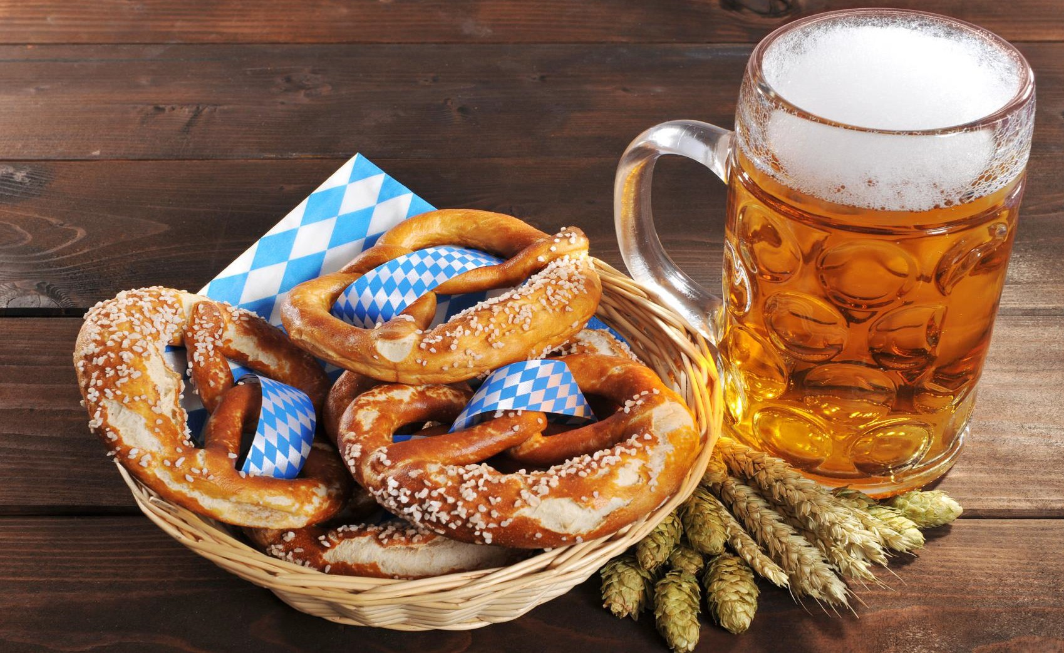

Oktoberfest Apex

**2nd SATURDAY of OCTOBER at NOON APEX TOWN HALL CAMPUS**

**FOOD MUSIC BEER**

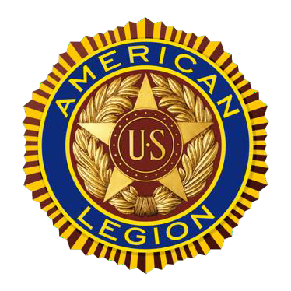**GAMES KIDS’ ZONE**



**POST 124**

Veterans helping Veterans and supporting our community,

**This event is not organized by the Town of Apex**

while serving our Nation