30 Days Of Devotion

Mount Wade Baptist Church

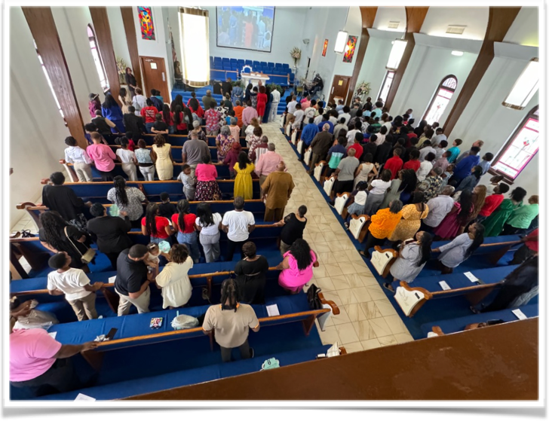

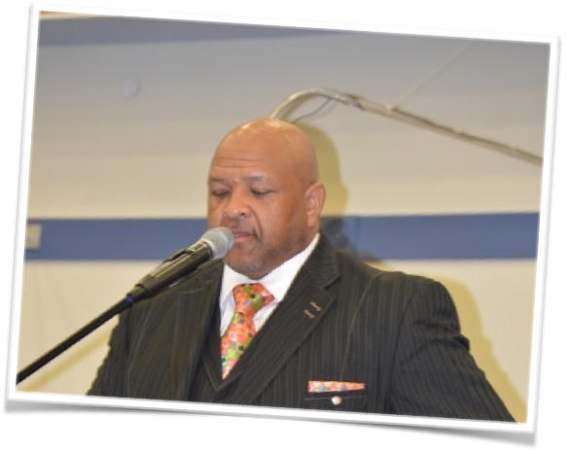

December 4, 2024

**“Let The World Know”**

**Dr. P. Randolph Hamilton, Sr., Pastor**

Psalms 40:8-10

I delight to do thy will, O my God: yea, thy law is within my heart. I have preached righteousness in the great congregation: lo, I have not refrained my lips, O LORD, thou knowest. I have not hid thy righteousness within my heart; I have declared thy faithfulness and thy salvation: I have not concealed thy lovingkindness and thy truth from the great congregation.

How often do you talk about God outside of the church or when you are away from the Christian comfort zone? The world needs to know how great God is and we as believers serve as the public address announcers to sound the word.

Throughout the Psalms, David spoke about God’s specific attributes and actions. This collection of songs and poems can be read as a biography of God, one that relies on the language of praise and adoration to tell His story.

Learning about the other person’s character is the basis for genuine love. And since our ability to worship God grows out of our love for Him, that means the true root of praise is knowledge. This is why God instilled in every believer a longing to know more of Him. We satisfy that desire by spending time with the Lord and observing how He works to meet our needs and provide blessings. Discovering each new facet of His character deepens our understanding of Him and our awareness of why He’s so worthy of our praise.

As believers, we all have a “biography” of the Lord to share. It’s a story of accumulated praise, not only for the ways He has intervened in chaos, comforted in tragedy, and blessed abundantly but also for the lessons we’ve learned in the process. We should share our adoration of Him with the world so others might come to know, love, and praise the Savior.