Knowing & Doing The Will Of Good
Psalm 143: 10

“Teach me to do thy will; for thou art my God: thy spirit is good; lead me into the land of uprightness.”

The Lesson

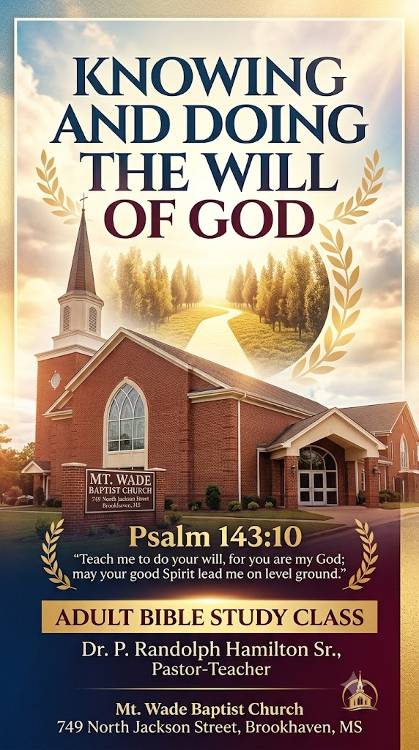
In this study we shall consider the heart-cry of the psalmist for grace to know and to do God’s will. “Teach me to do your will…’ (verse 10). There is only one thing that really matters in the life of the Christian; it is to know and to do the will of God. To know and to do God’s will was a priority in the life of Christ and as believers, we should be as focused. (Ref. Psalm 40:7-8; John 4:34; 17:4; Matthew 26:39)

What does this six-word prayer of David teach us?

- It Expresses The Believers Heart-Cry

Question #1: On a scale of 1-10 (with 10 being the highest), how concerned are you about knowing the will of God?

Question #2: On a scale of 1-10 (with 10 being the highest), how committed are you in doing the will of God?

- In most cases, before we become Christians we are not really interested in know God’s will and we certainly are not committed to doing it. We are only interested in our own will and in going our own way. The proof is in Isaiah 53:6 which says, “All we like sheep have gone astray; we have turned every one to his own way; and the LORD hath laid on him the iniquity of us all.” But what happens when God in His mercy steps into our life? God assigning us a place in His will is actually a mercy move to rescue us from ourselves. How terrible would be if God would not intervene in our lives and order our step according to His divine directions?

- The more we learn about God and His faithfulness to humanity, we become more concerned about know His will for our lives. The day comes when we find ourselves praying the prayer of David, “Teach me to do your will.” It’s now that we have final reached that place in our Christian maturity that we desire to know the will of God and how to live it out daily. For an illustration of this read Acts 9:1-6, and especially notice verse 6. One of the marks of a truly born again soul is the desire to know and to do God’s will. Let’s read it together (Acts 9:1-6). V. 6 says, “And he trembling and astonished said, Lord, what wilt thou have me to do? And the Lord said unto him, Arise, and go into the city, and it shall be told thee what thou must do.” Paul is convicted and convince enough that he is willing to change his life to mirror that of Christ. If you are truly saved, your desire should be to do the Lord’s will with fear and trembling.

- It Exclaims God Will And Plan For His Children
- Is it possible to fully please God without knowing His will for your life? Without speaking out loud, answer the question inwardly and be honest about it. Based your answer, how pleasing has your life been up to this point? Again, be honest with yourself. This is not about exposing your position to others in the class or cyber classroom. This is about being honest with self so that you can be intentional about your next step.

- When you read the Bible, the theology of God’s will is continuously expressed. Take the Book of Psalms for instance. How often the Psalmist prays to know God’s will in order that he might please God! Over and over again. But let’s look up some New Testament reference s to compare. Let’s read Colossians 1:9; 4:12. Christian biography also confirms the glorious truth that the Lord has a plan for the life of each one of His children. This means that the Lord has a plan for your life.

- Knowing that God has a plan for our lives gives us a sense of peace. We know that we are not hopelessly wondering for the next 40 years for our lives looking for the promise land. This also means that whatever we go through in live, negative or positive, God has a plan. Whatever we face from day to day, God has a plan. And as long as we seek to know and do, things will work out in our favor.

- It Emphasizes God’s readiness to expose His will to His children.
- People often ask the question, “How can we know God’s will?” What if I tell you that God’s wants you to know. God is not truing to keep it a secret from you. But he will not reveal it to the insincere heart and mind. If you are not serious about knowing and doing the will of God, you may never know God’s will for your life because of a spiritual bridge that you can’t cross over leads to understanding God on a higher level. It’s not a question “if” God desires for us to know His will, it a matter of how much of His will does he desire for us to know. I personal believe that as we mature, God reveals more and more to us to the point were we become totally submerged in knowing and doing His will.

- God is always far more willing to guide us than we are willing to be guided. He wants the very best for us and will never settle for second-best. The least blessing that God gives us (Lk. 16:10-11), is a blessing that we need to survive in this society. We need to distinguish between the directive (perfect) will and the permissive will of God. By His directive (perfect) will we mean that which is His highest guarded purpose and plan pertaining to grace. His permissive will is that which He may allow, yet not necessarily approve. Often He permits that which He does not desire or commend. Israel wanted a king after God told them they did not need one. God eventually gave them a king and Israel came to regret not obeying God’s plan. Has God given you something that you realize now that you didn’t need it.
- God may allow me to make my own plans and insist on my own choice, and He may allow me to follow it; and even grant me some measure of success. But time will prove it to be a serious mistake. In Psalm 106:15 (BBE) it says, “And he gave them their request, but sent a wasting disease (Heb. razon - deterioration) into their souls.”
- This leads us to the question: What are the conditions of knowing and doing God’s perfect will, and how may we know His perfect plan for our life? Does David’s prayer give us any clues? There is no need to talk about God’s will if there is no pathing to knowing.

- It indicates the conditions for knowing God’s will.

- There must be a teachable attitude. Where is the validation of a teachable attitude in the text? It’s indicated by David’s request, “Teach me…” The right attitude is a necessity in the learning process. You cannot assume that you already know. You be willing to admit a lack of knowledge. And you must surrender with a childlike spirit. David acknowledged his need to be taught the things that’s necessary for him to please God. The Basic Bible English in Jeremiah 10:23 says, “O Lord, I am conscious that a man's way is not in himself: man has no power of guiding his steps.” In Matthew 18:3 is says, “If you do not have a change of heart and become like little children, you will not go into the kingdom of heaven.” It is absolutely necessary to become teachable to gain understanding of God’s will. Are you teachable?

- There must be an intense desire to know God’s will. This also is indicated by David’s prayer. It was because he longed to know and to do God’s will that he cried out, “Teach me to do your will.” The word “teach” is an imperative stated and “me” is a pronominal suffix (personal pronoun) attached to the end of a word to express one’s immediate desire. It’s also stated in the active voice which makes it a continuous process. David is saying it’s vital that you teaching me continually. The word “teach” would be better expressed with “ing” on it (teaching). David is committed to receiving teaching. Psalm 37:5 says, “Commit thy way unto the LORD; trust also in him; and he shall bring it to pass.” It impossible to know God’s complete will after one spiritual revelation. This is why consistent an continual learning is beneficial.

- There must be a willingness to do His will, whatever it involves. Notice that David prayed, “Teach me to do your will,” not simply, ‘Teach me to know your will.’ He was prepared to do the will of God, whether it was easy or hard, pleasing or painful, and whether it was harmonious with what he wanted or otherwise - look up John 7:17.

- How does the Lord teach us to do His will?

He does it in three ways.

- By the teaching of His Word. In the Bible we have God’s will revealed in general terms and in clearly stated principles that bring clarity to the will of God. For example, (1) will it glorify God? Anything that does not glorify God is definitely not His will. (2) Will it honor the Holy Spirit? If we are not yielding to the Spirit, it’s outside of God’s will. (3) Does it conflict with any clear command? God’s will never contradicts itself in scripture. These clear principles give us definite guidance concerning a number of matters. There are matters, however, about which the Bible does not have any specific word for us. Suppose we are in doubt as to whether we should go on a certain journey or buy a certain house. How can we be sure of our guidance about matters like this to remain in the will of God? We can be sure because God guides us not only by the teaching of His Word, but also…
- By the promptings of His Spirit. Read Romans 8:14. It says, “For as many as are led by the Spirit of God, they are the sons of God.” Now compare it to Psalm 143:8, 10, 11, “Cause me to hear thy lovingkindness in the morning; for in thee do I trust: cause me to know the way wherein I should walk; for I lift up my soul unto thee.” “Teach me to do thy will; for thou art my God: thy spirit is good; lead me into the land of uprightness.” “Quicken me, O LORD, for thy name’s sake: for thy righteousness’ sake bring my soul out of trouble.” Particularly notice the words, “Show me the way I should go…may your good Spirit lead me on level ground…For your name’s sake, O Lord, preserve my life…” When there is no specific principle by which we may discover guidance, God graciously intervenes and guides us by the prompting of the Holy Spirit who dwells within the heart of every believer according to 1 Corinthians 6:19 (What? know ye not that your body is the temple of the Holy Ghost which is in you, which ye have of God, and ye are not your own?) We have an internal spiritual navigational system that guests our life moment by moment. The Lord also guides us…
- By the overruling of His providence. He guides us through what we call the circumstances of life. He opens and closes doors to path of righteousness. “I know thy works: behold, I have set before thee an open door, and no man can shut it: for thou hast a little strength, and hast kept my word, and hast not denied my name.” Revelation 3:8. He hedges up our way so that we cannot do the thing that we planned to do. In Acts 16:6–7 it says, ”Paul and his companions traveled throughout the region of Phrygia and Galatia, having been kept by the Holy Spirit from preaching the word in the province of Asia... they tried to enter Bithynia, but the Spirit of Jesus would not allow them." (NIV)

These are the three ways in which the Lord enables His children to ascertain His will. You will know for certain.
It is important to note however, that to be sure of knowing the will of God these three must agree in harmony as God speaks. “And thine ears shall hear a word behind thee, saying, This is the way, walk ye in it, when ye turn to the right hand, and when ye turn to the left.” Isaiah 30:21.

