30 Days Of Devotion

Mount Wade Baptist Church

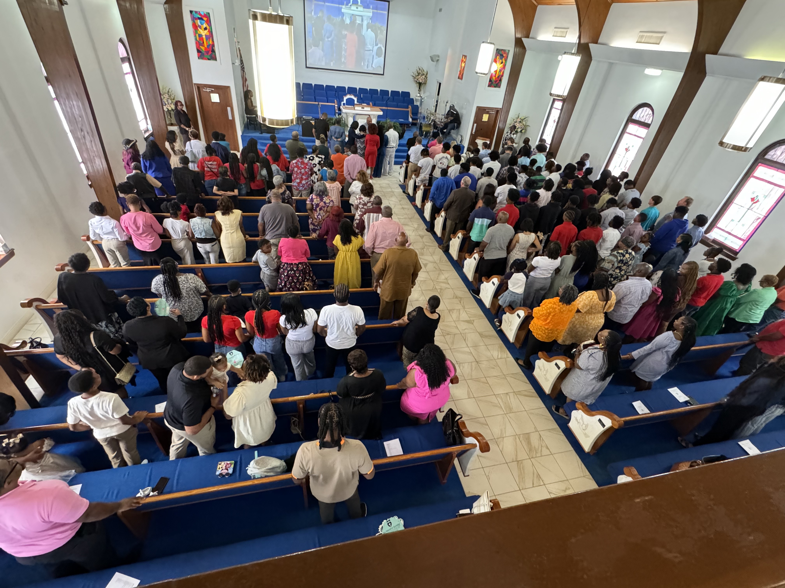

December 3, 2024

“The Power Of Daily Prayer”

**By Dr. P. Randolph Hamilton, Sr.**

Scripture: "Pray without ceasing.” 1 Thessalonians 5:17 (ESV)

Introduction

In the busyness of life, it's easy to think of prayer as a momentary, ritualistic act which is simply a part of our day we check off the list. But in reality, prayer is not just an isolated event; it is a continuous thread that can run through every moment of our day. The Apostle Paul encourages us to "pray without ceasing," which suggests that prayer is not limited to a specific time or place, but rather a constant, ongoing conversation with God.

At its core, prayer is about communion with God. It’s an intimate exchange, where we open our hearts and minds to the One who knows us fully and loves us unconditionally. While we often think of prayer as asking for things or expressing our needs, it is also a space where we can simply rest in God’s presence. We can always find peace in the presence of God.

When we set aside time for prayer each day, we are intentionally choosing to engage in that communion. But, as Paul reminds us, prayer is not confined to those set moments. We are invited to make our entire lives a prayer, drawing near to God not only in times of need but in every joy, every challenge, and even in the ordinary moments in between. Man should always pray.

Transforming Thought:

Incorporating prayer into our daily lives is powerful for several reasons:

1. Strengthening Our Relationship with God: Like any relationship, the more time we spend with someone, the deeper the bond becomes. When we engage with God in prayer daily, we grow in intimacy with Him. This strengthens our trust and dependence on Him. We come to love Him more. We learn to lean on Him, look to Him and listen to Him.
2. Aligning Our Hearts with God’s Will: Prayer helps us refocus on what truly matters. There is nothing more important than God’s will for our lives. Through regular prayer, we seek His understanding and guidance of how to live out His will for our lives. In doing so, we find His peace and learn to align our desires with His purposes.
3. Finding Peace in Life’s Storms: Life can be chaotic and unpredictable. Unexpected situation and unpredictable events can happen at any moment. Prayer offers us a way to steady ourselves amid the storm, reminding us that we are not alone. God is present and He's listening to our hearts cry.
4. Transforming Our Perspective: Daily prayer reshapes the way we see the world. It helps us look beyond our circumstances and see things through God’s eyes. We begin to see His fingerprints in everything and trust that He is at work even when we cannot immediately understand what He is doing. We come to know that all things are working together for our benefit.

Closing Thought

God is never farther than a prayer away. When we approach God in prayer, God immediately comes into our immediate presence of spirit, conscious and intimacy. God is a Spirit and we can only connect with Him on a spiritual level. In prayer, our thoughts (mind) should be solely on God and His will for our life. We block out the world and enter our closet of sacred and solitary focus. That is where we find the most intimate relationship with God and we feel His absolute presence.