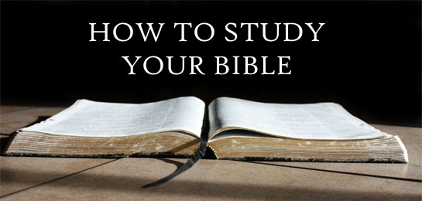

**Mount Wade Missionary Baptist Church**

**749 North Jackson Street**

**Brookhaven, MS 39666**

[www.mountwade.com](http://www.mountwade.com)

**January 26, 2020 - Lesson 1**

**Written by Dr. P. Randolph Hamilton Sr.**

**Prayer & Preparation**

**What is the most power tool that we have in understanding the Word of God? The answer is simple. It’s the Holy Spirit**.

John 16:13 says, “Howbeit when he, the Spirit of truth, is come, he will guide you into all truth: for he shall not speak of himself; but whatsoever he shall hear, that shall he speak: and he will show you things to come.” **[CWSB]**. “When the Spirit of truth comes, he will guide you into all the truth, for he will not speak on his own authority, but whatever he hears he will speak, and he will declare to you the things that are to come.”  **[ESV]**

**How do we access the Spirit of truth so that He may reveal to us the truths in God’s word? The answer again is simple. Pray! Never underestimate the importance and power of prayer on the path to understanding the word of God. If you want to know what someone said, ask the person who said it.**

**Step One: All Preparation Begins with Prayer**

**What are we to pay about before we begin to read and study the Bible?**

* **Pray for discipline, direction, & dialog**
* Discipline – Controlled behavior. One must learn to control their behavior in order to commit to study, maintain focus, and allocate an appropriate amount of time that is personally beneficial for spiritual growth. Self discipline is vital because sinful attack that will come in various forms attempting to disrupt, distract, and destroy your study and learning time with the Holy Spirit.
* Direction - Ask God to direct your study time towards that which is intellectually and spiritually digestive according to your level of maturity. 2 Peter 2:2 says, “As newborn babes, desire the sincere milk of the word, that ye may grow thereby:” [CWSB] As a newborn baby matures, the go from milk to eventually meat. Spiritually, God feeds us in like manner. He starts out with simple truths and as we mature, he leads us to deeper more difficult passages to read and understand.
* Dialog – Pray for the ability to recognize the voice of God so that you will know the difference. The devil will attempt to create chaos and confusion while we seek to communicate with God. A group of mothers gather at a home for lunch. Their children were all in the play room together when suddenly one of them begin to cry. The mother of the child immediately when to see what was wrong. The child did not call her name. She did not look on a monitor to see if it was her child. She knew her Childs voice and responded immediately. God knows our voice and it should be our desire to know the voice of God so that we may respond to His word immediately.
* **Pray for inspiration, revelation, & transformation**
* Inspiration – 2 Timothy 3:16 says, “All Scripture is given by inspiration of God, and is profitable for doctrine, for reproof, for correction, for instruction in righteousness:” [CWSB] The word “inspiration” means God breathed (All scripture is breathed from God). Pray that God will breath directly into you so that what you receive comes from a direct link (from God to you) and that it gives you spiritual insight leading to spiritual growth.
* Revelation – Christian theology defines the word “revelation” as to uncover truths. Pray that as you study hidden truths will be uncovered.
* Transformation – Romans 12:2a, “And be not conformed to this world: but be ye transformed by the renewing of your mind…” [CWSB] Transformation begins in the mind. I you desire to be stronger spiritually, you must become stronger intellectually. The mind must be transformed to think godly rather than ungodly. The natural mind automatically thinks ungodly. The mind must be transformed from the natural sinful thought to the spiritual empower mind likeness of Christ. Philippians 2:5 says, “Let (Have) this mind be in you, which was also in Christ Jesus:” [CWSB]

**Inductive Bible Study**

**The Bible was written so that anyone who desires to know God and how to please Him discover it this sacred dialog.. The Bible is God’s method of revealing Himself to humanity intellectually, providing understanding of how to recognize Him Spiritually. Th Bible is God personal autobiography. It is defined as God’s revealing work of redemption through His Son, Jesus Christ in a written format for human learning.**

For the past thirty three years, I have committed myself to learning various forms of biblical studies. One of the most effect method of Scripture interpretations that I have found is **INDUCTIVE BIBLE STUDY.** The main requirement for learning to study the Bible inductively is the willingness to slow down and really look at what the Scripture is saying.

The primary source of information for inductive Bible Study is the Bible itself. Remember this. “Scripture validates scripture.” Everything in the Bible is true, but every thing in the Bible is not right. For example. Judas betrayed Jesus for 30 pieces of silver. That is the truth. Was that right? No! But it does not change the truth. Just because something is true does not mean we are to do like wise. There are some truths in scripture that are not commands (principles that we are to live by). Some truths are designed to teach us what not to do. Again, Judas betrayed Jesus for 30 pieces o silver. That truth teaches us never to betray Jesus for any amount of money because in the end we want be able to live with ourself. Judas ended up returning the money and committed suicide because of actions.

**There are three component parts in Inductive Bible Study. They are as follows.**

1. **Observation** - **What does the Bible say?**  A good Bible student learns to ask the right questions. Assume the position of a police detective interview a suspect. You job is to ask questions that will lead to uncovering the truth. Along the way you will discover evidence that will help you “connect the dots” until the picture becomes clear and the truth is revealed. In Bible Study, you are a biblical investigator seeking to uncover (by revelation) the truths of God, collect bits and pieces of evidence that leads to accurate interpretation of the text. One of the tools that help us to ask questions the aid in truths being revealed is called the “5 W’s and the H.” You will learn more about them later.
2. **Interpretation** - **What is the meaning of the text/scripture?** Gather as much information about the text as possible. Who wrote it, when was written, to whom was it written, why was it written, what was written, how was it written, and more. After gathering the facts, now figure out the meaning. Observation is the key to unlocking the text. The more you see the better the chances of accurate interpretation. For example…

**A piece of Biblical evidence  does not reveal Jesus clearly. But the more piece of evidence you collect and observe, to truth becomes visible.** 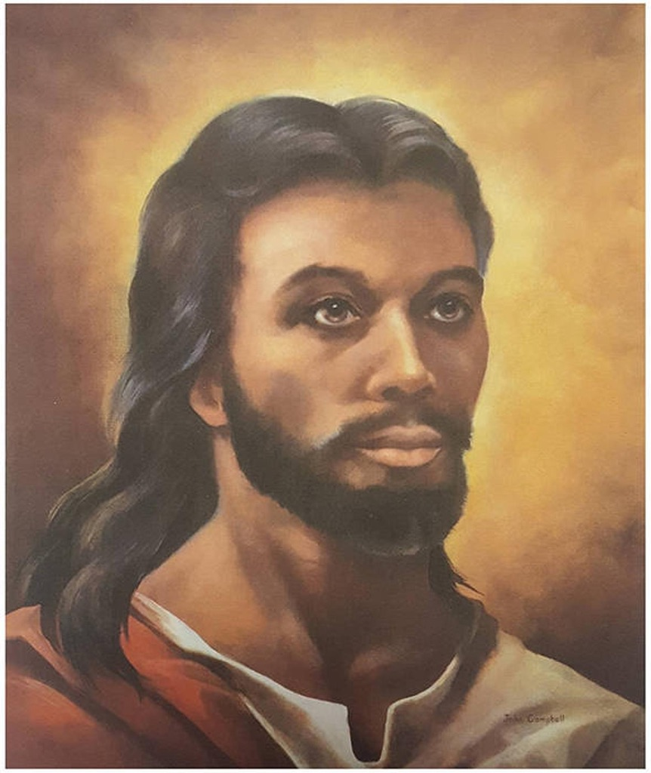

Observation comes before interpretation. Sorting through the facts helps to develop an interpretive conclusion. Learn to observe every fact, every word, every detail. The truth is right before your eyes. You just have to see it to understand it. Observe!

1. **Application** - How does the meaning of these truth, these facts, theses commands, and these instructions apply to humanity? What is the principle learned and what is to be put into practice. Once the truth is reveal and you discover the accurate interpretation of the text, now you are responsible for changing your life to comply with God’s word.

Inductive Bible Study reveal two methods of deriving at a textual conclusion. **Exegesis and Eisegesis.**

* Exegesis – interpretation based on what is drawn from the text.
* Eisegesis – interpretation based on what is put into the text.

**Correct or Accurate interpretation is always based on what is drawn from the text.** Allow the text to speak for itself. Never draw a conclusion without scriptural evidence. This means that some information that learned traditionally may not be accurate. For example; there is a traditional truth that is not a biblical truth therefore it is an untruth. “You cannot be forgive for suicide.” This is an untruth because there is no biblical truth to support what has been traditional claimed as a truth by some so called “Bible Scholars.” If it cannot be proven by scripture, it is simple not true. There is no truth outside of the word of God.

**Before we get to the study of a particular passage, we must establish the ground rules. There are some steps that must be learned and apply to every passage of scripture. There are some rules that must never be violated for any reason. The rule of context must never be violated.**

**THE RULES OF CONTEXT**

**How do we approach the text/scripture contextually? First, we must understand the meaning of the word context.**

**Thought 1:** The word context means, “that which is woven together; that which goes together or with the text”

* The Bible is one book about God saving activities through His Son, Jesus the Christ. The Bible is like a puzzle the when each piece is put in its proper place, we see the self revelation of God.
* The **Self Revelation of God** means that God took the initiative to reveal Himself to humanity through scripture. The only way that we know God is because God wants us to know Him. God gave us His word so that we can know Him. There is nothing written in God’s word that He does not want us to know. If He did not want us to know it, He would have simple not given it to us.

**Thought 2:** Context is the environment in which something dwells, or the setting in which something exist.

* Example 1: There is a fish in the pond. Is the context the fish or the pond? The context is the pond in which the fish dwells or exist.
* Example 2: Brookhaven is located in Lincoln County, Lincoln County is located in Mississippi, Mississippi is located in the United States. The context is the United States; every thing else dwells within the United States.
* Ray Stedman on the subject of contexts ays, “The Bible is **not** a collection of "one-liners." All verses must be interpreted in the context of the verses that come before and after them, the whole passage, the chapter, the book and even the whole Bible. It is the nature of language that it takes many sentences or even paragraphs to convey a complex concept. A single Bible verse or passage often tells us only one aspect of a topic. We must look at **all** the Bible passages on a particular topic to get the true picture. If we look at just one or a few verses, we can get an incomplete view or even a totally wrong view of the Bible's teachings.”

**Context can be used to discover the meaning of words. For example…**

* If someone said to you, “Look at that trunk,” what are they telling you to look at? In order to determine what type of trunk it is, you must determine the context (Where does the trunk exist?). Is it an elephant trunk, car trunk, or a piece of luggage called a trunk? The meaning of the word depends upon what it is connected to or where it exist.
* What is the meaning the phrase “Kick the bucket?” He kicked the bucket? Who kicked the bucket? (1) A cow while being milked, (2) a person kicked a bucket, or (3) did someone die? Again it depends upon what the word is connected to or where the word exist. “Tommy was milking the cow when he kicked the bucket by mistake and spilled all of the milk.” Now that we know the full story, it is easy for us to understand the meaning of “kicked the bucket."
* We use phrase “What’s up?” Or you referring to direction, asking what’s going on, or just speaking to another person? Again it depends upon the context in which it is used.
* That’s tight! What’s tight? Do you mean that something is tight meaning to be confined, something looks good, or something sounds good? Knowing the context will easily clear up any question that we may have about this statement.

Practice Lesson

Mark 10:46. “And they came to Jericho: and as he went out of Jericho with his disciples and a great number of people, blind Bartimaeus, the son of Timaeus, sat by the highway side begging.”

Question: Where is Bartimaeus located? Follow the rules of context.

1. He sitting on side of the highway.
2. He is in Jericho
3. He is on a road outside of Jericho
4. He is on a road between old Jericho and new Jericho

**I will give you the answer next week.**

Read the following text.

2 Timothy 2:15

Study to show thyself approved unto God, a workman that needeth not to be ashamed, rightly dividing the word of truth.

Q: What does this text mean?

Step 1: Who is talking and who is he talking to? Answer: Paul writes this letter to Timothy, his young disciple. Timothy is preparing to take a leadership role in the church. Paul is teaching him that he must prepare properly to do what God has assigned him to do in the church. Paul tells him to “study….”

Step 2: What is the meaning the key words or phrases in the text? Since we have not reached the lesson on “Key Words or Phrases,” I will give you all of the key words. (The words in red or key words or phrases.)

Study to show thyself approved unto God, a workman that needeth not to be ashamestd, rightly dividing the word of truth.

Exegetical Study (/Word Study) of 2 Timothy 2:15

Study (spoudázõ) means to make every effort to do one’s best, to be diligent, to be eager.

Show (paristánõ) means to stand before and present.

Approved (dókimos) mens to be accept; to be accepted, approved, received by God.

Workman (ergátēs) means a spiritual workman or laborer.

Needeth not be ashamed (anepaíschunto) means not to be ashamed, irreproachable (beyond criticism, fautless).

Rightly dividing (orthotoméō) to cut it straight, to cut or divide. To handle correctly, skillfully; to correctly teach the word of truth .

Word (lógos) meaning the divine declarations, precepts, oracles, relating to the instructions of men in religion, the Word of God, i.e., the divine doctrines and precepts of the gospel, the gospel itself.

Truth (alétheia) means the true doctrine.

Step 3: What have we learned from the exegetical study of each word or phrase? (This is observation)

Make every effort and be be diligent in presenting one’s self to God as a spiritual worker who will see us as faultless without shame in teaching the word of truth correctly .

Step 4: How does this scripture apply to us today? (Please answer and text or email to me. [Text: 601-248-5555 or Email: [pastorhamilton9380@gmail.com](mailto:pastorhamilton9380@gmail.com)]