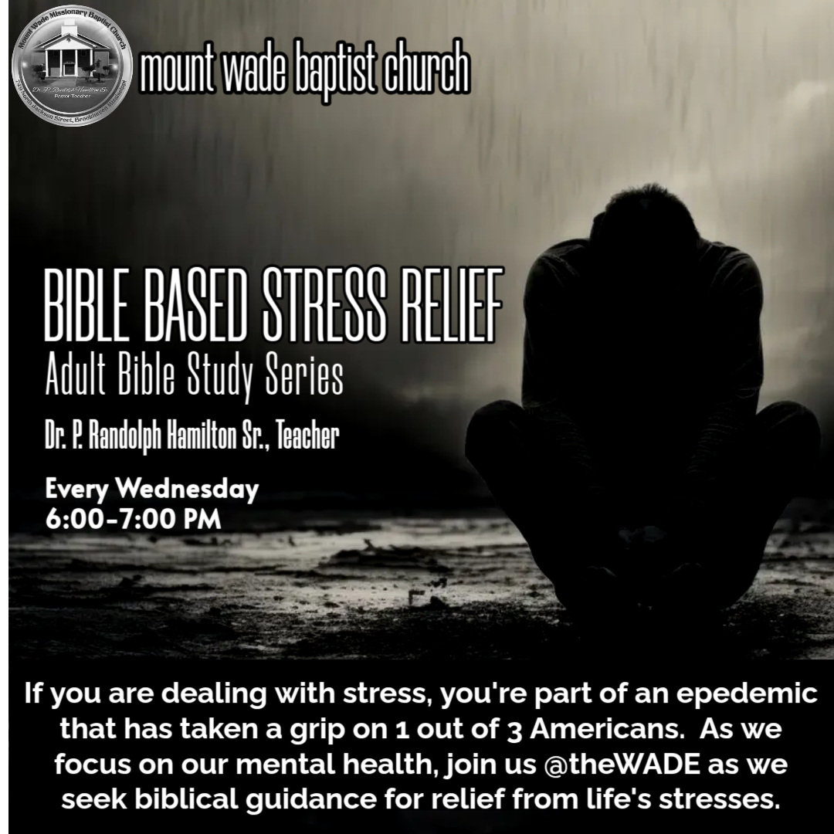
Part 1: Bible Based Stress Relief
One in three people in America say they feel “extreme stress.” And nearly half of all people have trouble sleeping because of stress. Clearly, stress is an epidemic!
This lesson is personal to me (Pastor Hamilton), because over the past four years, I have experienced personal stress that have pushed me against wall and at times in a dark room. However, I realize that I am not alone on this journey. Many of you have face personal stress relating to family, finances, grief, careers, marriage, children, school, insecurities, etc.
While the Bible doesn't provide a specific outline on how not to be stressed, it does offer numerous verses and principles that can help you find peace and calm in difficult situations.
In the following lesson, I’ll give you several keys that can help you relieve stress God’s way. These are principles that have proven to be true in my own life as a pastor, husband, father, grandfather, brother, son, uncle, and as a child of God. God’s word never fails if you obey the principles and apply them to your life.

- Trust in God
I know that you have heard that before, but truth is unchangeable. The first stop in dealing with any situation in life, including stress, is simply to trust in God.
Proverbs 3:5-6: "Trust in the Lord with all your heart and lean not on your own understanding; in all your ways submit to him, and he will make your paths straight.”
- Trusting in the Lord with all your heart requires emotional control, intellectual clarity, and determine will (which is drives commitment).
- Stress can cause one’s emotions to become unstable and out of control if not harnessed properly. Emotional swings can take you from an over exertion of energy of unnecessary business, to low points where you don’t have the energy to get out of bed. There can be times when you can’t stop crying and other times when you’re starring out into space with a blank countenance. You have to find a way to control your emotions that will allow you to seek intellectual clarity.
- Intellectual clarity focus on seeking understand of God perfect will for our life even when the events of life don’t seem fare. Why would God permit tragic events to happen in our life? Why would God allow the wicked to prosper while those worship Him suffer? Only God can provide the answer to these questions, but without a clear mind to be receptive to God’s voice, we will not hear His truths. Intellectual clarity means to clear your mind of thoughts that would silence the voice of God and prevent you from receiving clarity from the Holy Spirit. We must remember that God does not speak to us in an audible voice, but rather through the conscious conviction of the Holy Spirit who speaks to your heart (emotions) and mind (intellect) to guide us into all truths (John 14). I learned this through the process of learning to deal with my stress. “If you can’t think clearly, you can’t hear the Holy Spirit with clarity.” God will make your path straight, but it begins with emotional control and intellectual clarity. If you can do this you can commit to a determine will.
- A determined will means to do it God’s way and God’s way only. In all thy ways means in all thy ways. Put every thing you have into doing it God’s way. Let this mind be in you that is also in Christ Jesus. Commit thy way unto the Lord. Submit your body as a living sacrifice. In all thy ways means to direct the totality of your life to surrender to the will of God. (Note: Last week I saw my wife in a condition that shook me to say the least. I was in a place where my stress level cause my reaction and response to act out of character based on past experiences; but I had never experienced this current condition that I was witnessing. The only thing I could do was say to God, “Lord I know you’ve got this, now I need you to remove my hands off of what I don’t have control of. Let your will be done as I do my part and ask, seek and knock.”)
Philippians 4:6-7: "Do not be anxious about anything, but in every situation, by prayer and petition, with thanksgiving, present your requests to God. And the peace of God, which transcends all understanding, will guard your hearts and your minds in Christ Jesus."
- My part in the equation was to ask, seek and knock. Ask and it shall be given. Seek and you will find. Knock and doors will be opened. At this point, God directed me to Philippians 4:6-7.
- Again, I know that trusting in God is a central theme in the Bible and a fundamental aspect of the Christian faith. It involves placing our confidence and hope in God's wisdom, power, and goodness, even in the face of uncertainty or adversity. When you trust in God, you acknowledge that He is in control and that His plans and purposes are greater than your own. I had to come to a point to trust God in the present. Past trust provides a foundation for future trust, but present trust is what will get you through the moment. When you are in a present state of stress, depression and anxiety, you’re not think about a better tomorrow, you need a better right now! Only present trust (faith) will get you through the present stresses.
Here are some suggestions I would like offer to develop and deepen your trust in God.
- Recognize God's sovereignty: Understand that God is in control of all things and that He has a plan for your life. Jeremiah 29:11 says, “For I know the thoughts that I think toward you, saith the LORD, thoughts of peace, and not of evil, to give you an expected end.” What’s happening in your life might have caught you off guard, but it did not sneak up on God. God planned ever step of your life (…the steps of a good man…) that’s why He is sovereign; He’s in absolute control. Trusting in God's sovereignty means believing that He is working for your good, even when circumstances may not seem favorable (Romans 8:28).
Dr. Young said, “Never forget that when you’re the main character in a stressful scene, remember that God is working behind scene as the writer, executive producer and director of your life story.” You’re only a character, God is the creator.
- Cultivate humility: Trusting in God requires humility, as it involves recognizing the limits of your own understanding and abilities. How far is the distance between genius and stupidity? The person representing geniuses and the person representing stupidity had the same answer. “I don’t know.” No matter how much you know, situations will come up when you will have to admit the limitations of your understanding.
We must acknowledge that God's wisdom far exceeds our own. Therefore we must submit to His guidance and direction to navigate out of that dark room and your back from against the wall (Proverbs 3:5-6).
- Pray regularly: There are individuals who specialize in counseling who have receive extensive training in how the mind works. My expertise are limited to Christian counseling and encouragement. This is my purpose in utilizing Philippians 4 to stress the importance of prayer as it relates to stress. Prayer and faith are partners. Prayer is a powerful way to build trust (faith) in God. Share your concerns, fears, and needs with God, and ask for His guidance and wisdom. By doing so, you demonstrate your reliance on Him. Prayer is how we say to God, Lord you know best, so my your way. Prayer also welcomes the peace He offers into your heart and mind (Philippians 4:6-7). A peace that transcends all understanding. A peace that keeps us calm in chaos, patient under pressure and strong through struggles. So when you’re stressed and struggling, PRAY!
- Reflect on God's faithfulness: Remember how God has been faithful in the past, both in your life and in the lives of others throughout history (even ancient history). I encourage you to do as I done, remind yourself that if God did it before, He can do it again. Answered prayer is answered prayer. If God answered your prayer before, He will answer it again, and again, and again… When we reflect on the faithfulness of God, it helps to strengthen our faith in His continued care and provision for us in the times of trouble. Psalm 77:11-12 says, “I will remember the works of the LORD: surely I will remember thy wonders of old. I will meditate also of all thy work, and talk of thy doings.” (Note: Anyone here ever talk with yourself? I was always told that it’s ok to talk to yourself, the problem starts when you start answering back. In Acts 26, Paul was talking with himself when he stood before Agrippa. He was reflecting on the goodness of God when he said, “I think myself happy.”) Remembering past blessings restores hope for better days. As the song says, “Better days are coming.”
- Read and meditate on Scripture: The Bible is filled with stories of God's faithfulness and promises. For many of our ancestors who endured slavery, the stories of Israel’s deliverance provided stress relief and renewed faith in their belief that God would deliver them out of slavery. God’s word will provide encouragement through examples of His grace in hard times. Spending time reading and meditating on scripture provides strength to trust in God. Remember according to Romans 10, “Faith comes by hearing the word of God.” Psalm 119:105 tells us that it’s God’s word that makes our way clearly visible. “Thy word is a lamp unto my feet, and a light unto my path.”
- Surround yourself with believers: When you’re stressed, you don’t need to be around people who create more stress are engage in negative communication. This is a rime when you need to engage with individuals (preferably real Christians) whose trust in God can provide encouragement and support. It's not alway easy to talk about what we are going through, but you need someone in your circle who you feel comfortable sharing your thoughts and experiences. This is an opportunity for you to learn from each other and grow in faith. Hebrews 10:24 says, “And let us consider one another to provoke unto love and to good works:” When stressed, you need encouragement more than you realize.
- Practice patience: We live in a microwave society. We want quick fixes to everything. Some problems are not microwaveable, they require a crock pot. It takes time, commitment and PATIENCE. Trusting in God often involves waiting on His timing. According to James According to James 2:2-4, trials in life are temporary, tabulated and therapeutic. First, troubles don’t last always. Second, God knows what to add and subtract in the situation. Third, it’s designed to make you better not bitter.
Be patient and steadfast in your faith, even when you don't see immediate answers to your prayers. Remember God’s delay is not denial; it’s development deliverance. God is developing you as He delivers you. Deliverance without development could cause a backwards decent. Be patient and wait on God to elevate you. Psalm 27:14 says, “Wait on the LORD: be of good courage, and he shall strengthen thine heart: wait, I say, on the LORD.”

SUMMARY
I discovered that by focusing on these practices, I developed a deeper faith in God and His plan for my life. It’s helping me to navigate through life's challenges with greater peace and confidence. As Paul said, “I have not apprehended,” but I am pressing towards the mark. Trusting in God does not mean that you won't experience stress or difficulties, but it does mean that you can face them with the assurance that God is with you and working for your good.

Mental Health Crisis Hotline (844) 755-5325
Depression Hotline (866) 903-3787

