“Begin To Be”
Ephesians 5:1-2

Be ye therefore followers of God, as dear children; And walk in love, as Christ also hath loved us, and hath given himself for us an offering and a sacrifice to God for a sweet. smelling savour.

Introduction: In 1878, William Gladstone presented himself before Parliament to announce the death of Queen Victoria’s daughter, Princess Alice of Britain, the Grand Duchess of Hesse. In making the announcement, Gladstone told a touching story.

The Duchess had seven children, six of them came down with diphtheria during an epidemic in England. Her youngest child, Marie had a painful death in spite of her mother’s tender care. The Duchess concealed the sad news from the other children to protect them from shock and more pain. Later, she had to reveal it to her son Ernest who was very devoted to his little sister. Ernest was overcome with grief and broke down in tears. In an affectionate attempt to console and comfort her grieving son, she embraced him in her arms and kissed him, ignoring the doctor’s warning about the disease spreading through physical contact.

Alice was already weakened by her heavy work load and the loss of sleep, that she easily caught the infection. Within a week after the kiss of love, the Duchess fell severely ill and she breathed her last on the morning of December 14, 1878. What that mother did was a picture of true love. She loved her child, and she willingly sacrificed herself to comfort her child.

That mother’s love is an illustration of the unconditional, unending, unrestricted love of God for us. It is also a picture of the kind of love we are to have for others.

As we begin tonights study, we are immediately confronted by a demand to do the impossible. We are called to be like God. We are called to love like He loves. It sounds like an impossible task. How can we sinful, frail, failing people ever be like Him or love like Him? This text has much to say about this calling on our life, to be like the Lord which in turn places us directly in the will of God.

I want to draw your attention to verse 1, where Paul writes, “Be ye therefore followers of God, as dear children…” Please notice with me the challenges we face in this text.

The word “therefore” requires that we look backwards to the previous verse. The previous verse is the last verse of the previous chapter. Verse 32 of chapter 4 says, “And be ye kind one to another, tenderhearted, forgiving one another, even as God for Christ’s sake hath forgiven you.” We are reminded that the saints of God have been saved by the grace of God and because saints have been saved they are to be different in the way they walk (live), the way they talk (communicate), and the way they think (soberly). They are to be different in every area of life. The “old man” of sin, with all his evil desires and appetites, is to be “put off,” Eph. 4:22. The “new man,” created in righteousness, with an appetite for righteousness and the glory of God, is to be “put on,” Eph. 4:24. Since we have been made a new creature in Jesus, we are to live as new creatures in our daily lives, 1 John 2:6.

Having been challenged to bring our lives under the control of God Spirit, be forgiving, kind, and compassionate towards one another, I believe that Ephesians 5:1 presents one of the greatest challenges of all. Let’s examine the text.

Eph. 4:32 “And be ye kind one to another, tenderhearted, forgiving one another, even as God for Christ’s sake hath forgiven you.” Eph. 5:1 “Be ye therefore followers of God as dear children:”

Be (gínomai) - The word “be” is a Greek imperative (English ‘command’). It primarily means to begin to be.

Since God has forgiven us for Christ sake (4:32) we are to begin to be (5:10, “even as God…”

- The Command is “Be ye followers of God.” The word “followers” (mimētḗs, where we get the word mimic) means to “mimic” to be an “imitator.” The command here is for the people of God to imitate God. We are to learn all we can about God, and we are to mimic His characteristics. We can never imitate God in every way.
- God is perfect; we are imperfect.
- God is omnipotent; we are weaklings.
- God is omniscient; we are ignorant (lack of knowledge)
- God is omnipresent; we are restricted to single location
- God is Spirit; we are flesh.

We are to learn all we can about the Lord from His Word; then we are to put into practice everything we know about Him and His desire for man. We are to do the things we see Him doing, and we are to avoid the things He avoids. We are to be like God in every respect. In essence, God is commanding us to do something that is impossible to do within our selves. We could never be imitators of God without God providing for us what we need to be like Him in His word.

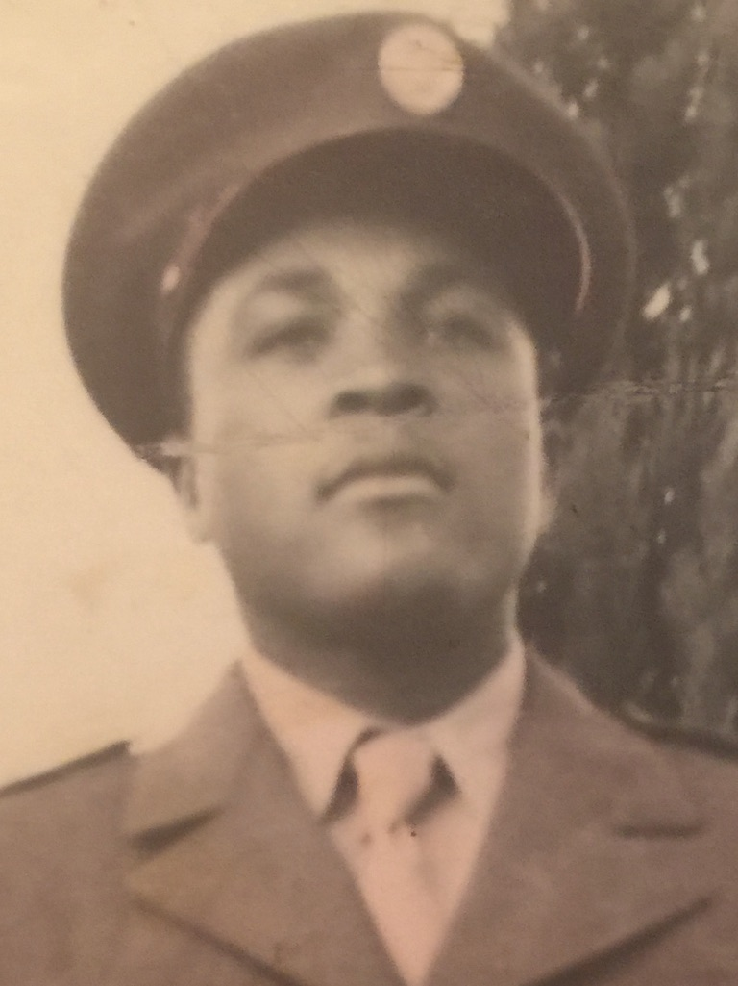


- The Condition is for imitating God, requires that we do it as “dear children.” It’s natural for children to imitate their parents. Children often have their parent’s characteristics, body movements, patterns of speaking and more. You can be around a child and you can see their parents in the way they walk, talk, act and look. When you look atthe picture of the three pictures below, you can clearly see the impact of family genetics.
Age 21 Age 18 Age 23

- This is not only true with our earthly mother and father, it’s even more true with our heavenly Father. Like a child who spends time learning, observing, and growing in the presences of their parents, we are brought near to our Heavenly Father so that we might learn His ways and become more like Him.
- God’s purpose in redemption is to make us more like Him. “For whom he did foreknow, he also did predestinate to be conformed to the image of his Son, that he might be the firstborn among many brethren,” Rom. 8:29. What does it mean to be conformed to the image of Christ?
- To be conformed to the image of Christ means to become holy like God is holiness. “Be ye therefore perfect, even as your Father which is in heaven is perfect,” Matt. 5:48. That is God’s plan for each one of His redeemed children. “As obedient children, not fashioning yourselves according to the former lusts in your ignorance: But as he which hath called you is holy, so be ye holy in all manner of conversation; Because it is written, Be ye holy; for I am holy,” 1 Pet. 1:14–16.
- We are to become like Christ in every way as we draw nigh to God. That is God’s ultimate goal. “Beloved, now are we the sons of God, and it doth not yet appear what we shall be: but we know that, when he shall appear, we shall be like him; for we shall see him as he is,” 1 John 3:2.
- Following Christ does not mean that we become slaves following in the footsteps of a demanding Master, who forces us into submission. We are the sons and daughters of God, following behind a Father who loves us and we love Him; and we desire to be just like Him. We are redeemed by His grace, adopted into His family and we become partakers of His very nature. “Whereby are given unto us exceeding great and precious promises: that by these ye might be partakers of the divine nature, having escaped the corruption that is in the world through lust,” 2 Pet. 1:4.

As we become imitators of our heavenly Father, we must remember…
- He is holy; we are to be holy.
- He is loving; we are to be loving.
- He forgives; we are to be forgiving.
- He is truthful; we are to be truthful.
- He is patient; we are to be patient.
- He is kind; we are to be kind.
- He is compassionate; we are to be compassionate.
- Everything God is; we are to be.

Where do we learn these things? We learn them from His Word, learning from the incarnated life of Christ and watching Him work in the lives of others. The more we watch God, the more we learn God’s ways. “He hath shewed thee, O man, what is good; and what doth the LORD require of thee, but to do justly, and to love mercy, and to walk humbly with thy God?” Micah 6:8.

In conclusion, living in the will of God begins by getting to know God and learning to imitate the life of Christ. Our actions, behavior, character, and dialogue should mimic Christ in every way. Let us gínomai (“begin to be”) who God has called us to be.

Questions For Review

Looking Back
- According to the lesson, why is the word "therefore" in Ephesians 5:1 important, and what verse does it force us to look back to?
- Based on Ephesians 4:22–24, what is the believer expected to "put off" and "put on" after being saved by grace?
- What specific attitudes toward others are commanded in Ephesians 4:32 before moving into chapter 5?
The Command: "Be Ye Followers"
- What is the original Greek word translated as "be" in Ephesians 5:1 (gıˊnomai), and what does it literally command believers to do?
- Where does the word mimic originate and what action does it require of a Christian?
- The lesson lists five specific attributes where God is infinite and we are limited (e.g., God is perfect, omnipotent, etc.). What are the contrasts to these pointed out in the lesson?
The Condition: "As Dear Children"
- Why does Paul use the illustration of "dear children" to describe how we should imitate God?
- According to Romans 8:29 and 1 Peter 1:14–16, what is God’s ultimate goal or plan for every redeemed believer?
- How does viewing our relationship with God as children following a Father differ from viewing it as slaves following a demanding Master?
- The lesson outlines several attributes of God that we are called to imitate (holiness, love, forgiveness, truthfulness, patience, kindness, compassion). Which of these areas do you find most challenging to "mimic" in your daily life?
Taking Action: “Beginning…”
What is one practical step you can take this week to "begin to be” imitators of Christ in your home, community, workplace and/or church?

