30 Days Of Devotion

Mount Wade Baptist Church

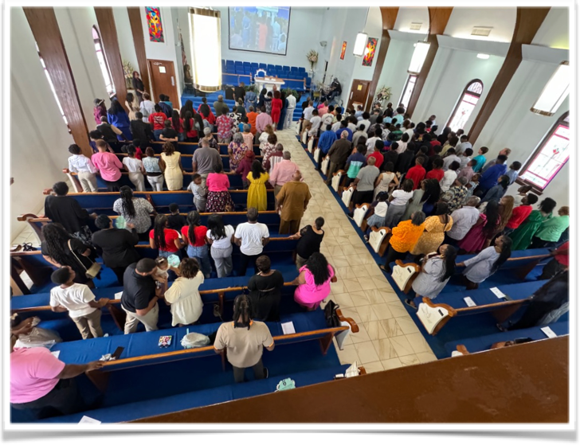



December 5, 2024

**“Hope In Darkness”**

**Dr. P. Randolph Hamilton, Sr., Pastor**

Genesis 1:14-19

And God said, Let there be lights in the firmament of the heaven to divide the day from the night; and let them be for signs, and for seasons, and for days, and years: And let them be for lights in the firmament of the heaven to give light upon the earth: and it was so. And God made two great lights; the greater light to rule the day, and the lesser light to rule the night: he made the stars also. And God set them in the firmament of the heaven to give light upon the earth, And to rule over the day and over the night, and to divide the light from the darkness: and God saw that it was good. And the evening and the morning were the fourth day.

When we first moved in our home, I would lay on the back on my truck at night, watching for shooting stars. I would point and laugh with excitement when we saw one. In between those flashes of light, I would grow quiet looking at all the stars that filled the sky. It had been some 10 years since I had really looked up and admired the creative work of God in the stars. I could still name some of the stars, well the big dipper and little dipper; oh and the north star.

In our reading from Genesis 1 today, the sun and moon get most of the attention. But we are told that God “also made the stars.” It’s as if God poked trillions of little holes in the backdrop of the night sky. Even on the darkest nights, when the moon is nowhere in sight, the stars remind us that God’s light is still present. The darkness will not overcome God’s light.

There have been times when I long for God’s presence in my life to be as bright as the sun, as clear as a full moon, or as awe-inspiring as a shooting star. How many times did I overlook God’s faithful presence in the background. The stars remind us that God is always there.

When we look up to the sky, it remind us that Jesus entered the world on star filled night and that God even used a bright star to announce his birth. How amazing it is to have to same stars watching over us. The same God is always present in our life watching over us. So when clouds cover your sky and the night is dark, remember there is hope in the darkness because God “also made the stars.”