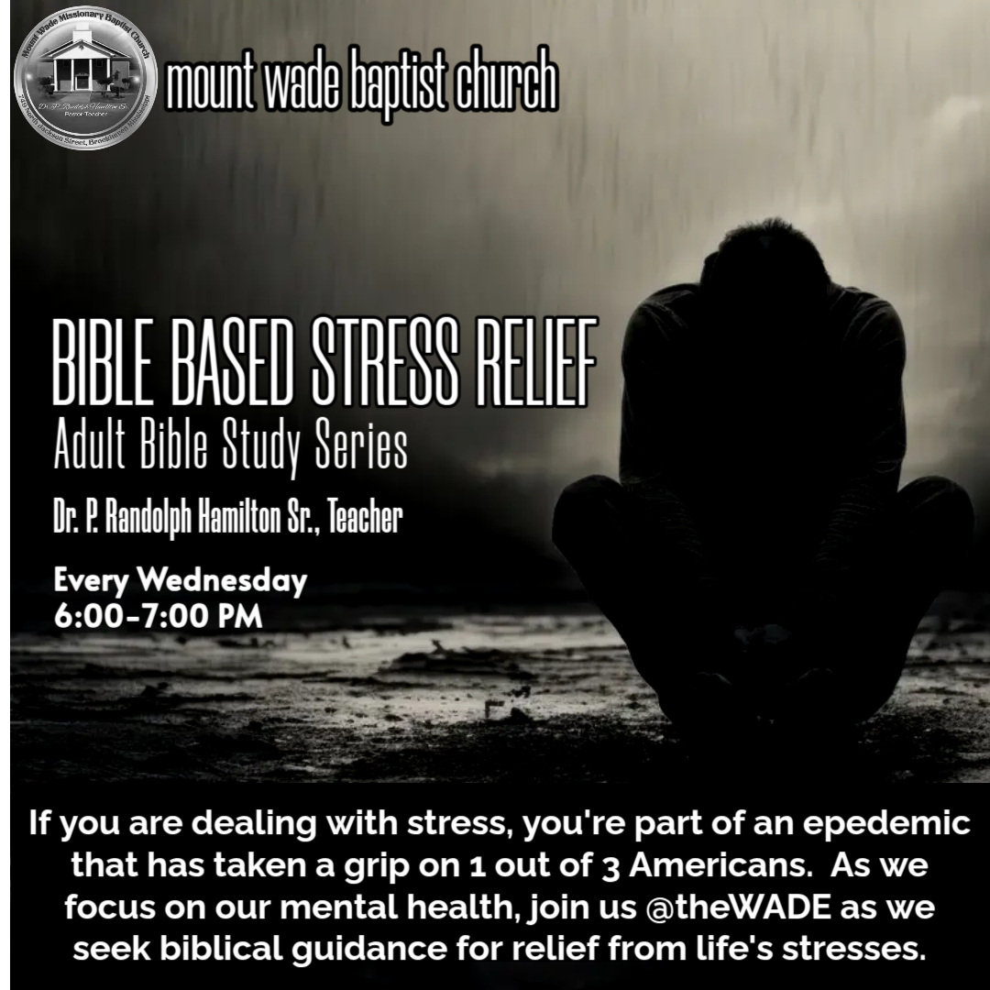
Part 2

Focus on the present moment: Matthew 6:34: "Therefore do not worry about tomorrow, for tomorrow will worry about itself. Each day has enough trouble of its own."
Focusing on the present moment is an important principle in the Bible, as it helps you to manage anxiety and stress. By directing your attention to the here and now, you can reduce unnecessary worry about the future and concentrate on what is within your control. Here are some ways to practice focusing on the present moment based on biblical teachings:
- Be mindful of God's presence: Acknowledge that God is with you in every moment, guiding and sustaining you (Psalm 46:1, “God is our refuge and strength, a very present help in trouble.”). By being aware of His presence, you can find comfort and strength in your daily life. A lame man relies on his cane to stabilize his walk. God stabilizes our life.
- Cultivate contentment: Learn to be content in your current circumstances, trusting that God will provide for your needs (Philippians 4:11-12, “Not that I speak in respect of want: for I have learned, in whatsoever state I am, therewith to be content. I know both how to be abased, and I know how to abound: every where and in all things I am instructed both to be full and to be hungry, both to abound and to suffer need”). Practice gratitude for the blessings you have and avoid comparing your situation to others (1 Thessalonians 5:18, “In every thing give thanks: for this is the will of God in Christ Jesus concerning you").
- Prioritize daily prayer and reflection: Spend time each day in prayer, meditation, or reflection, focusing on your relationship with God and seeking His guidance for the day ahead (Psalm 5:3, “My voice shalt thou hear in the morning, O LORD; in the morning will I direct my prayer unto thee, and will look up.”). Start your day with God and making your request known. Daily bread is available. We just have to ask for it.
- Break tasks into manageable steps: Most of us have busy lives filled with daily task and responsibilities. Instead of becoming overwhelmed by the magnitude of your responsibilities, break tasks into smaller, manageable steps, and focus on completing one task at a time (Ecclesiastes 9:10, “Whatsoever thy hand findeth to do, do it with thy might; for there is no work, nor device, nor knowledge, nor wisdom, in the grave, whither thou goest.” The New Living Translations says, “Whatever you do, do well. For when you go to the grave, there will be no work or planning or knowledge or wisdom.”). Death does not fix the problems of life. We must make decisions to make our life better with life decisions.
STOP/RESTART
- Embrace the present as a gift: The present moment is a gift from God, an opportunity to grow in faith, love, and service. Embrace each day as a new opportunity to fulfill God's purpose for your life (Psalm 118:24, “This is the day the LORD has made. We will rejoice and be glad in it.”). Life has purpose and we have to live out our purpose even through difficult times.
- Practice letting go of worry: When you find yourself worrying about the future, remind yourself of Jesus' teaching in Matthew 6:34 (“So don’t worry about tomorrow, for tomorrow will bring its own worries. Today’s trouble is enough for today.) Recognize that worrying about the future will not change the outcome, and instead, focus on trusting God and doing your best in the present.
- Seek God's will for each day: As you focus on the present, continually seek God's guidance and direction for your daily actions and decisions (Proverbs 3:5-6, “Trust in the LORD with all your heart; do not depend on your own understanding. Seek his will in all you do, and he will show you which path to take.”). By submitting to His will, you can find peace and purpose in the present moment. By implementing these practices, you can learn to focus on the present moment and reduce unnecessary stress and worry. While you cannot control everything that happens in life, you can choose how to respond to each situation and trust in God's guidance and provision.

