“Called To Be A Fisher Of Men”
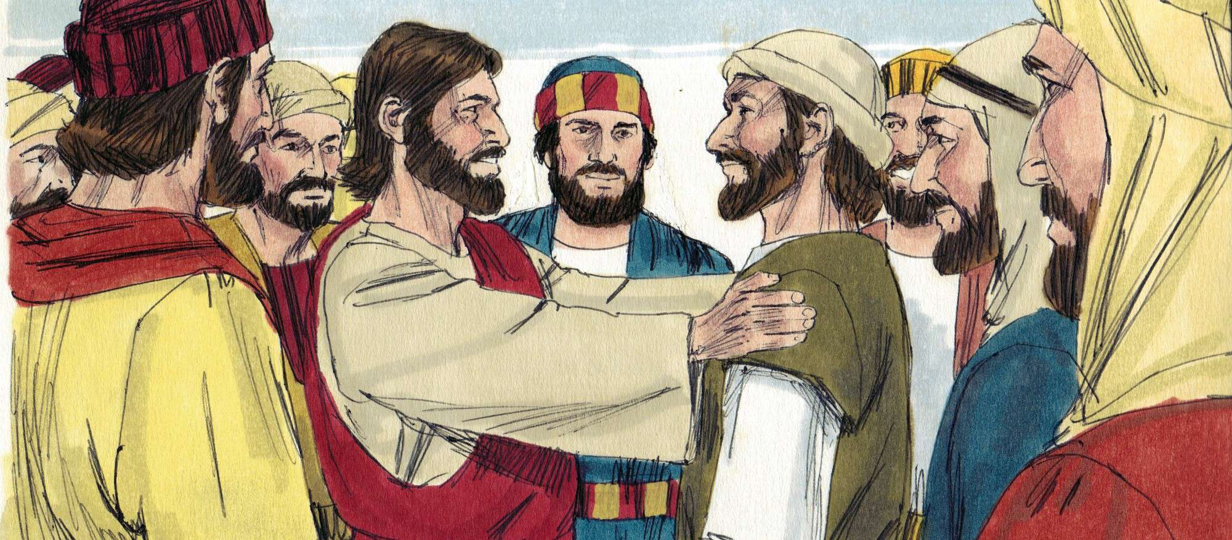Scripture: Luke 5:10
Age Group: 9-12
Key Verse
“Then Jesus said to Simon, ‘Don’t be afraid; from now on you will fish for people.’” Luke 5:10

The Lesson

One day a large crowd of people gather by the Sea of Galilee where Jesus was standing. They want to get as close to Him as possible. This cause a problem. Everyone in the crowd could not hear Jesus’ teaching.
There were some fishing boats at the edge of the water. Jesus asked the however of the boat, could He use His boat to sit and share His word with the crowd. Peter, who owned the boat said yes.

After Jesus finished, He ask Peter, “How many fish did you catch last night.” Peter said, “We didn’t catch anything and we fished all night.” Jesus said, “Let’s try again. Get your nets and throw them out into the deep water.” Peter and his brother Andrew decided to cast their nets once more as Jesus ask them to do.

Amazingly, they caught so many fish they had to call other near by boats come and help them. So many fish their boats were sinking down in the water.
When Peter and Andrew saw what happen, they knew Jesus caused the great catch of fish and the felt unworthy to be in His presence. Jesus said, "Don't be afraid. I did this so you would understand how to go and fish for people.” So may not always catch fish, but you have to keep on fishing.
Jesus said to them, “Come follow me.” The Bible says, they pulled their boats up onto the shore, left everything, and followed Jesus to "go fish" for people.
Lesson Conclusion
Jesus wants you and me to "go fish" for people too. If we tell people about Jesus and his love, we can trust Jesus to help us catch them!

Discusion Questions
- What kind of boat did Peter, Andrew, James and John own?
- Fishing boat
- Sail boat
- Shrimp boat

- How many fish did Peter and Andrew the night before Jesus got on their boat?

- They didn’t catch any fish all night
- Two fish and Jesus fed 5,000 people with them
- They caught some shrimp, but no fish

- Who told Peter to cast his nets into the deep water?
- Andrew
- Jesus
- Another fishermen

- Jesus asked Peter and Andrew to follow Him to become…
- Fishers of men
- Boat captains
- World travelers

Memory Verse
“Don’t be afraid; from now on you will fish for people.” Luke 5:10
Write the verse on a whiteboard. Erase one word at a time (from left to right) while kids repeat the verse until they can say it from memory.

Life Application & Conclusion
Jesus wants to use ordinary people like us to go out and tell others about God. He calls children and adults to follow Him, love others, and share His word with people all around the world. You may not know everything in the Bible, but you can share what you know about God.
Closing Prayer
Heavenly Father, Jesus, has told us to go fish for people. We will go and tell others about Jesus, and trusting him to bring them into the boat. Amen.

