“Called To Be A Fisher Of Men”
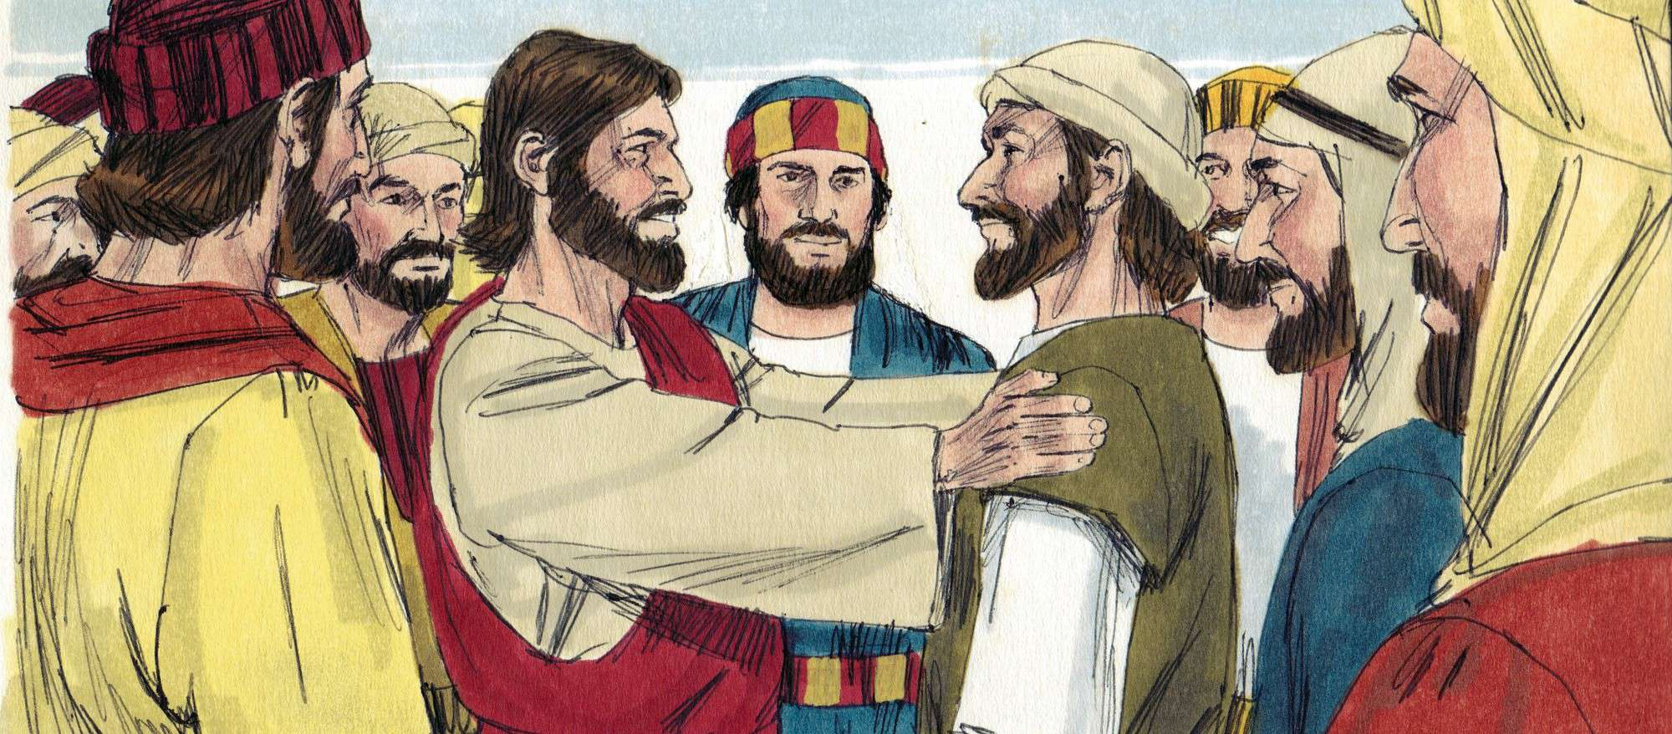Scripture: Luke 5:10
Age Group: 13-15
Key Verse
“Then Jesus said to Simon, ‘Don’t be afraid; from now on you will fish for people.’” Luke 5:10

The Lesson

Jesus was standing by the sea of Galilee and a large crowd of people began to gather around him. He saw some fishermen nearby who were cleaning and mending their nets so he climbed into one of the boats which belonged to a man whose name was Peter. Jesus told Peter to put the boat out a little way from the shore. Peter did as Jesus instructed him and Jesus sat in the boat teaching the people.
When he had finished teaching, Jesus said to Peter, "Put the boat further out into the deep water and let down your nets to catch some fish.” "We've been fishing all night long and haven't caught a thing, but if you say so, we will let down the nets one more time," Peter answered.
Do you know what happened? They started pulling the nets up and there were so many fish that the nets began to break. When they pulled the fish into the boat, there were so many fish that the boat began to sink. When Peter and his fellow fishermen saw this, they were afraid for they felt unworthy to be with Jesus.
Jesus said, "Don't be afraid," Jesus said. "From now on, I want you to go fish for people."
The Bible tells us that they pulled their boats up onto the shore, left everything, and followed Jesus to "go fish" for people.
Lesson Conclusion
Jesus wants you and me to "go fish" for people too. If we will be faithful in telling people about Jesus and his love, we can trust Jesus to bring in the catch!
Heavenly Father, Jesus, has told us to go fish for people. We will go and tell others about Jesus, and trusting him to bring them into the boat. Amen.

Discusion Questions
- What was Simon Peter’s job?
- A Carpenter
- A Fishermen
- An Insurance Salesmen

- How many fish did the fishermen catch after fishing all night?
- More than a hundred
- Only two and Jesus used them to feed 5,000
- The caught nothing all night

- Jesus asked them to trying catch fight once more. What happened when they obeyed Jesus?
- They caught so many fish they had
- They caught so many fish they had to call other boats to come help them.
- They didn’t catch any fish, but Jesus told them he would teach them how to fish.

- Jesus call them to come and follow Him and He would make them what?
- He will make them fishers of men
- He would make them the best fishers on the sea of Galilee
- He will continue to call others to come follow Him.

- What does it mean to follow Jesus today?
- It means to obey God’s word and accept Jesus as your Savior
- It means to go church and attend Sunday School, Bible Study and worship.
- It means to love everybody, be kind and forgiving; and have good behavior every day.

Memory Verse
“Don’t be afraid; from now on you will fish for people.” Luke 5:10
Write the verse on a whiteboard. Erase one word at a time (from left to right) while kids repeat the verse until they can say it from memory.

Life Application & Conclusion
Jesus called ordinary people to do extraordinary things. He still calls children and adults today to follow Him, love others, and share His word with people. You may not know everything in the Bible, but share what you know about God.
Closing Prayer

