BIBLE ADVENTURE WEEK
July 6-9, 2026

PASTOR=TEACHER
Dr. P. Randolph Hamilton Sr.

ADVENTURE DIRECTORS
Amanda Collins & Alex’Zandra Hamilton

THEME
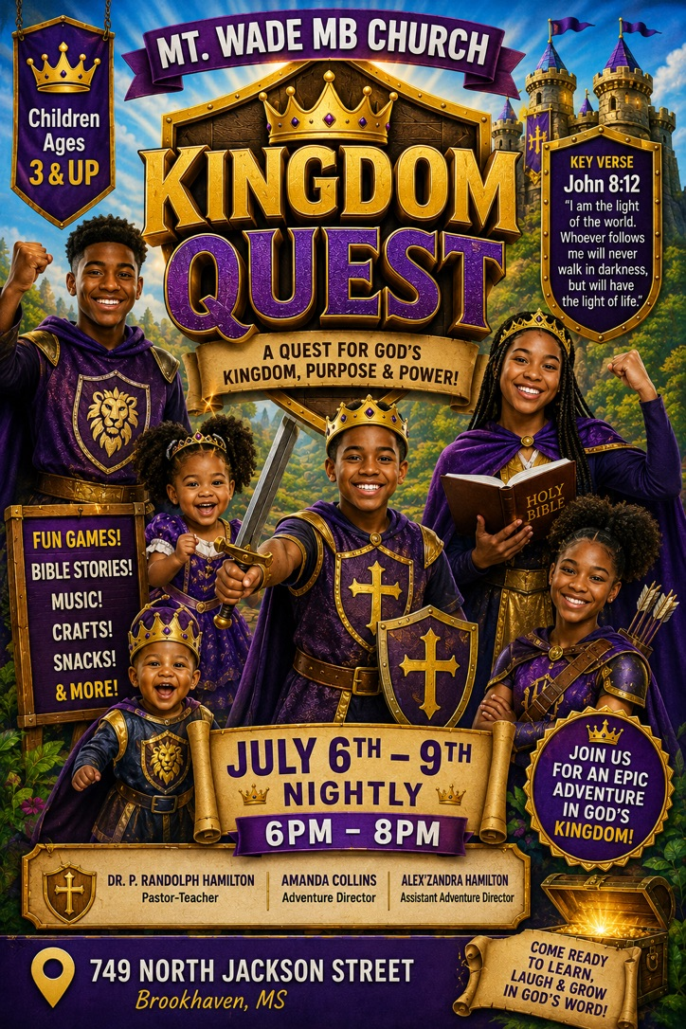
Kingdom Quest

VBS ADVENTURE STAFF

Registrar Kaniya McDaniel
Assistant Registrar Princess Richardson
Food & Fellowship Saundra Shannon & Helen Smith
Activities Team Kris Richardson & Aaron Smith

TEACHERS & ASSISTANT TEACHERS

CLASS TEACHER ASSISTANT

Class #1 (2-5) Barbara Crossley Kaniya McDaniel
Class #2 (6-8) Denise Jointer Courtney Dixon
Class #3 (9-12) Rhonda Collins Dorothy Harris
Class #4 (13-15) Fortina Henderson Bonnie Bates
Class #5 (16-18) Zandra Hamilton Erica Smith
Class #6 (19 & up) Jerry Rice Pastor P. Hamilton

