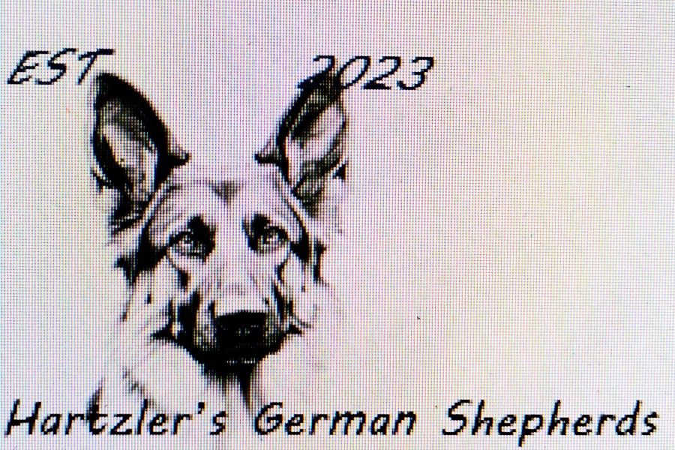

Welcome to the family and congratulations on your new puppy!

I want to make this contract for your puppy or dog to be as simple as possible, yet still binding. From the time your puppy was born I have cared for him/her as if they were mine. They have been in my home and around my family, which has exposed them to children, adults, other dogs, bunnies. Since they are raised in my house, they have also been exposed to normal household noises to hopefully make the transition easier.
All puppies NEED to be on puppy food until they are one year old. As the Buyer, this is your responsibility to ensure adequate nutrition for your growing puppy. The brand that you use needs to be high in protein and as natural as you can get. Stay clear of bi-products and fillers since these are not healthy for your puppy/dog. Your puppy has been on Blue Buffalo while he/she has been in my care.
Your new puppy has been dewormed every two weeks starting at just two weeks old. (so 2,4,6, and 8 weeks old)
He/she also received their first round of vaccines at their 8 week appointment. Your vet, like mine, may want to restart the vaccine series at your first appointment. As the Buyer, it is your responsibility to get your puppy into your vet for all the required puppy visits and then yearly afterwards.
I offer a full refund/health guarantee for the first 6 months if your vet deems your puppy/dog unhealthy. A letter from your vet is required with all necessary lab work and diagnosis as to why the puppy is deemed unfit.
As a German Shepherd owner, it is important that you let your new pup get all the hormones he/she needs for proper development. Dogs should never be spayed or neutered before two years of age. Please do not fix them any sooner so your dogs bones, ligaments, and muscles can grow as they should.
As a Breeder, I will stand behind my dogs for their entire life.
As a Breeder, my dogs will NEVER be in a shelter. As the Buyer, it is your responsibility to your new puppy, and to this contract, to keep him or her safe, loved, and healthy. By signing this contract you, the Buyer, agree to never neglect, abuse, mistreat, or put this puppy in any harm. Adequate shelter, food, fencing, and medical attention is required for the life of this dog. If this is not upheld by you, the Buyer, you will forfeit the puppy/dog and no refund will be given. Any legal fees or court costs that are acquired due to your neglect and not abiding by this contract, will be your sole responsibility as the Buyer.
A puppy is a lifelong commitment. Even if you get a new house, a new job, new family member or even a new spouse/partner. IF you, the Buyer, need to rehome this puppy/dog for a legitimate reason, I, the Breeder, MUST be contacted.
All puppies MUST be paid in full before leaving Hartzler’s German Shepherds.

Buyers please fill out your contact information below and sign at the bottom.

Buyers Name:

Buyers Phone Number:

Buyers Email:

Today's Date:

Buyer Signature:

