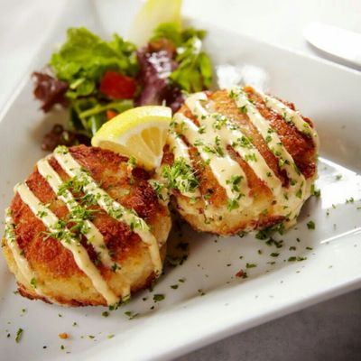

More Delicious Entree Choices
Entree Selections
- Roasted Rosemary Assorted Chicken
- Chicken Breast Marsala
- Sweet Italian Sausage with Peppers and Onions
- Medium Gulf Shrimp with Bow Tie Pasta Marinara
- Chicken Breast with Asiago Mushroom Cream Sauce
- Top Sirloin of Beef Tips in a Rich Burgundy Wine Sauce
- Breast of Chicken Piccata
- Atlantic Salmon with Dill Garlic Butter
- Bada Bing Cherry Pork or Chicken
- Rosemary Garlic Basil Pork
- Thai Style Sweet Chili Chicken
- Chipotle Tomato Chicken Breast with Penne Pasta
- Sliced Roast Beef in a Rich Natural Gravy
- Stuffed Fillet Of Flounder
- Chicken Cacciatore
- Roasted Sweet Baby Ray's Pork
- Classic Beef or Vegetable Lasagna
- Beef Bolognese with Pasta
- Top Sirloin of Beef Stew
- Maryland Style Crab Cakes

Continued Additional Entrée’s

- Bourbon Chicken
- Stuffed Shells with Meat Sauce
- Baked Parmesan Crusted Cod
- Rotisserie Style Assorted Chicken
- Chicken Fettuccine Alfredo
- Baked Basa White Fish
- Rosemary Herb Breaded Boneless Breast of Chicken
- Mojo Caribbean Assorted Chicken
- Garlic Lemon Breaded Boneless Breast of Chicken
- Baked Fillet of Lemon Pepper Tilapia
- Oven Roasted Sliced Breast of Turkey in Rich Gravy
- Sliced Virginia Ham Apple Wood Brown Sugar Glazed
- Bar-B-Que Smoke House Assorted Chicken
- Slow Smoked Spareribs
- Southern Fried Catfish
- Homemade Mighty Meatloaf
- Cuban Style Shredded Chicken
- Italian Eggplant Lasagna
- Montreal Lime Chicken Quarters
- Grilled Cowboy Pork Chops

