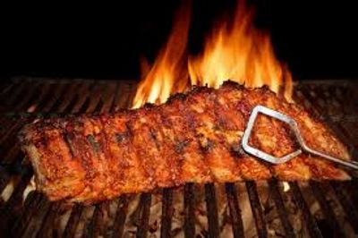

SOUTHERN SWEET TENDER BBQ

CREATE YOUR OWN BAR-B-QUE MENU INCLUDES
All Support Staff, Setup, Service of Guest Tables, Service of Buffet,
Stainless Chafing Dishes & More! All disposable clear plastic
dinnerware, including plates, napkins, eating utensils and cups.
(SEE OUR SELECTION OF CHINA PACKAGES)

Create Your Own BAR-B-QUE Menu
HOR D OEUVRES RECEPTION & COMPLETE DINNER BUFFET
1hr Hor d'oeuvre Reception Selections
CHOOSE 2 APPETIZERS
- CHEESE & CRACKER TRAY
- FRESH VEGETABLE TRAY WITH RANCH
- BBQ MEATBALLS
- FRIED CORN NUGGETS
- BBQ CHICKEN SLIDERS
- SWEET BABY RAY'S BBQ PORK SLIDERS
- BLACK BEAN & CORN SALSA W/ TORTILLA CHIPS
- ASSORTED VEGETABLE TRAY W/ RANCH DRESSING

CHOOSE 2 ENTREES
- SLICED ROAST BEEF IN CHOICE OF SAUCE
- ROTISSERIE STYLE ASSORTED CHICKEN
- SLOW ROASTED SWEET BABY RAY'S PORK
- BAR-B-QUE SMOKEHOUSE ASSORTED CHICKEN
- GRILLED PORK CHOPS
- SLOW SMOKED SPARERIBS
- SMOKED SAUSAGE WITH PEPPERS AND ONIONS
- SLICED SMOKED BREAST OF TURKEY IN GRAVY
- SLICED BROWN SUGAR SMOKED VIRGINIA HAM
- SOUTHERN FRIED CATFISH FILLETS

CHOICE OF 3 SIDES BELOW
- COLESLAW
- BLACK EYED PEAS
- COLLARD GREENS
- MASHED POTATOES
- SOUTHERN YELLOW RICE
- OVEN BROWNED POTATOES
- CORN ON THE COB
- BAKED BEANS
- CHEESE FRIED GRITS
- PASTA SALAD
- CLASSIC POTATO SALAD
- AU GRATIN POTATOES
- MACARONI & CHEESE
- BUTTERED SWEET CORN
- SEASONED GREEN BEANS
INCLUDES FRESH BAKED CORN BREAD W/ BUTTER
INCLUDED BEVERAGE STATION - CHOICE OF 2
SWEET TEA LEMONADE UNSWEETENED TEA
TROPICAL FRUIT PUNCH CHERRY LIMEADE
$21.75 Dinner Buffet without Hor d' oeuvre
$24.95 Dinner Buffet with Hor d' oeuvres
Prices per guest
(Plus Sales Tax & Full Service - 18% Service Charge)
(Plus Sales Tax & 18% Service Charge)

